准考证号 姓名

机密★启用前

江西省 2024 年初中学业水平考试

英 语 试 题 卷

说明:1. 本试题卷满分 120 分,考试时间 120 分钟。

2. 请按试题序号在答题卡相应位置作答,答在试题卷或其它位置无效。

一、听力理解( 本大题共 20 小题,每小题 1 分,共 20 分) 现在是试听时间。 请听一段对话,然后回答问题。 What is the boy going to buy?

A. Some juice. B. Some oranges. C. Some apples.

答案是 C。

A) 请听下面 5 段对话。 每段对话后有一小题,从题中所给的 A、B、C 三个选项中选出最 佳选项,并在答题卡上将该项涂黑。 听完每段对话后,你都将有 10 秒钟的时间回答有关小题 和阅读下一小题。 每段对话读两遍。

1. What time does Mike get up every day?

A. 6 ∶30. B. 7 ∶00. C. 7 ∶30.

1. What will the weather be like in Nanchang tomorrow?
   1. Cloudy. B. Rainy. C. Sunny.
2. What color is the cats hair?
   1. Brown. B. White. C. Black.
3. Whats the matter with Julie?
   1. She has a headache. B. She has a toothache. C. She has a stomachache.
4. What does Jack mean?
   1. Soccer is easy. B. He loves soccer. C. The girl is clever.

B) 请听下面 4 段对话。 每段对话后有几个小题,从题中所给的 A、B、C 三个选项中选出 最佳选项,并在答题卡上将该项涂黑。 听每段对话前,你将有时间阅读各个小题,每小题 5 秒 钟;听完后,各小题给出 5 秒钟的作答时间。 每段对话读两遍。

# 请听第 1 段对话,回答第 6、7 小题。

1. What book did Lily buy last week?
   1. A story book. B. A history book. C. A science book.
2. How soon will Lily finish reading it?
   1. In 3 days. B. In 5 days. C. In 7 days.

# 请听第 2 段对话,回答第 8、9 小题。

1. What will the girl have?
   1. Chicken. B. Beef. C. Duck.
2. Whats the relationship between the two speakers?
   1. Waiter and customer. B. Father and daughter. C. Friends.

# 请听第 3 段对话,回答第 10 至第 12 小题。

1. What does the man do?
   1. A doctor. B. A pilot. C. An engineer.
2. How long does the man work every week?
   1. 20 hours. B. 30 hours. C. 40 hours.
3. What do we know about the man?
   1. He likes his work.
   2. He works in Beijing.
   3. He takes a plane every week.

# 请听第 4 段对话,回答第 13 至第 15 小题。

1. Whats happening on Saturday?
   1. Frank is taking a trip.
   2. Frank is having a party.
   3. Frank is cleaning a park.
2. Where does Frank live?
   1. At 118 Green Street. B. At 127 North Street. C. At 131 First Street.
3. What can we get from the conversation?
   1. Sally knows where the park is.
   2. Sally often visits Franks home.
   3. Sally has refused Franks invitation.

C) 请听下面一段独白,根据独白内容完成下列句子,每个空格不超过 3 个单词。 将答案 填写到答题卡的相应位置。 听独白前你将有 50 秒钟的时间阅读句子内容。 独白读两遍。

1. We can travel around Dublin or on foot.
2. The library in Trinity College closes at p. m.
3. There are a lot of in Temple Bar.
4. We can listen to a player in the restaurant.
5. Theres also a shop with great .

二、单项填空( 本大题共 8 小题,每小题 1 分,共 8 分)

请阅读下面各小题,从题中所给的 A、B、C、D 四个选项中选出可以填入空白处的最佳选 项,并在答题卡上将该项涂黑。

|  |  |  |  |  |
| --- | --- | --- | --- | --- |
| 21. | I like acting and Im in the | group at school. |  | |
|  | A. theater B. chess | C. speech | D. | ping-pong |

1. —Has Bob arrived yet?

—No, hes on his way. Hell be here .

* 1. daily B. easily C. first D. soon

1. —Tom, can you help me with the housework?

—Sure, but Im right now.

* 1. lost B. busy C. worried D. lonely

1. —Where is Helen?

—Im not sure. Maybe she her baseball lesson.

* 1. had B. was having C. is having D. will have

1. Ted preferred pop music when he about his favorite music in the interview.
   1. was asked B. asked C. is asked D. asks
2. —Look! The lake is clean. I never throw litter into it.

—If everyone does this, it would be .

* 1. dirtier B. the dirtiest C. cleaner D. the cleanest

1. Oh, I get it—you want me to do all the work you sit at home doing nothing.
   1. or B. while C. until D. unless
2. —Oh hi, Im looking for a pair of shoes.

—Well, you to the right place. We have a lot of shoes in our shop.

* 1. came B. were coming C. will come D. have come

三、完形填空( 本大题共 26 小题,每小题 1 分,共 26 分)

A) 请先阅读下面短文,掌握其大意,然后从各小题所给的 A、B、C、D 四个选项中选出可 以填入相应空白处的最佳选项,并在答题卡上将该项涂黑。

Anansi the Wise

Some people think they know everything. Anansi the spider didnt think that. He was a 29 spider. And he knew to have real wisdom ( 智慧). He had to learn more.

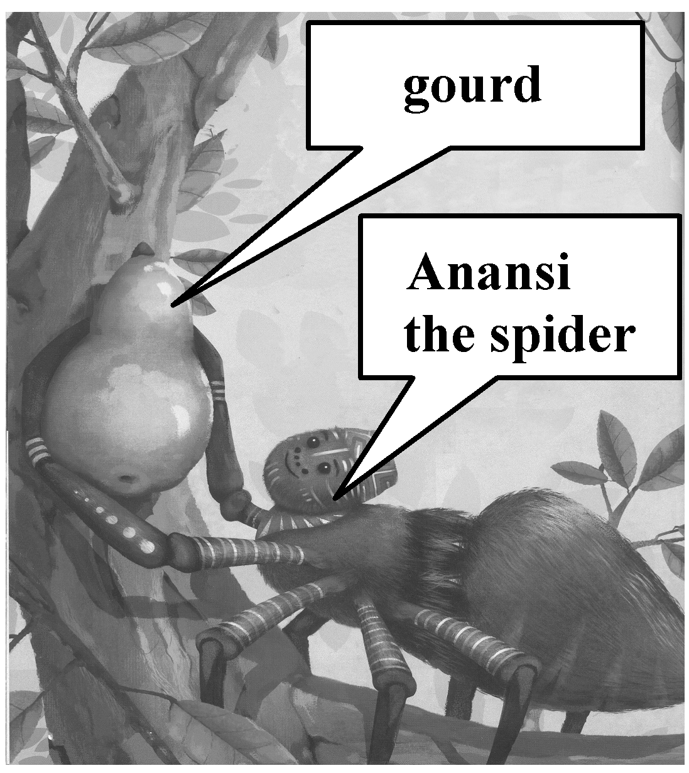

One day, Anansi found a( an) 30 gourd on the ground and he had an idea. “ 31 I get advice from others and put it in this gourd, then Ill be wiser than anyone else in the world. ”

So, he went from house to house and asked the other creatures ( 生 物) , “ Whats your best piece of 32 ?” And they were all happy to share their wisdom, because they could see that Anansi 33 it.

The snail ( 蜗牛) said, “ Dont be in a hurry. 34 is not a 100-meter race. ” The butterfly said, “ Life is short. Enjoy every day. ”

The ant said, “ Youll 35 be great on your own. Everyone needs the help of others. ”

Anansi was very happy with all this advice. He took it and put it in 36 gourd. And when hed filled the gourd, he thought to himself, “ Now, I have more wisdom than anyone else. I must

37 the wisdom, so no one can steal it. ” He 38 and saw a hole high up in a tree, and he had an idea.

Anansi held the gourd in two legs and tried to 39 the tree with his other six legs. But the gourd was too big and he couldnt climb. His son was nearby watching him. “ Daddy,” he said, “ why dont you 40 the gourd to your back and then climb the tree?” “ Thats very good advice,” said Anansi. “ Thank you for sharing it with me. ” And then Anansi realized that advice is only 41 when we share it with someone.

So, he climbed the tree with the gourd on his back. And when Anansi reached the 42 , he held the gourd up to the wind. All the advice flew into the sky and traveled 43 the land. And wisdom came to everyone.

|  |  |  |  |  |  |  |  |  |
| --- | --- | --- | --- | --- | --- | --- | --- | --- |
| 29. | A. | quiet | B. | crazy | C. | poor | D. | clever |
| 30. | A. | empty | B. | small | C. | soft | D. | broken |
| 31. | A. | So | B. | If | C. | Before | D. | Although |
| 32. | A. | news | B. | work | C. | advice | D. | wood |
| 33. | A. | stood | B. | forgot | C. | missed | D. | needed |
| 34. | A. | Action | B. | Sport | C. | Life | D. | Health |
| 35. | A. | always | B. | often | C. | never | D. | usually |
| 36. | A. | his | B. | her | C. | its | D. | their |
| 37. | A. | find | B. | sell | C. | hide | D. | collect |
| 38. | A. | fell asleep | B. | showed up | C. | ran away | D. | looked around |
| 39. | A. | hit | B. | climb | C. | pull | D. | shake |
| 40. | A. | send | B. | hand | C. | turn | D. | tie |
| 41. | A. | simple | B. | useful | C. | interesting | D. | real |
| 42. | A. | top | B. | house | C. | ground | D. | mountain |
| 43. | A. | across | B. | with | C. | into | D. | under |

B) 请先阅读下面短文,掌握其大意,然后用方框中所给词的适当形式填空,并将答案填写

到答题卡的相应位置。 每个词限用一次。

even as start story order such tons different dish popular rises

In East Chinas Jiangxi province, noodles are more than just a

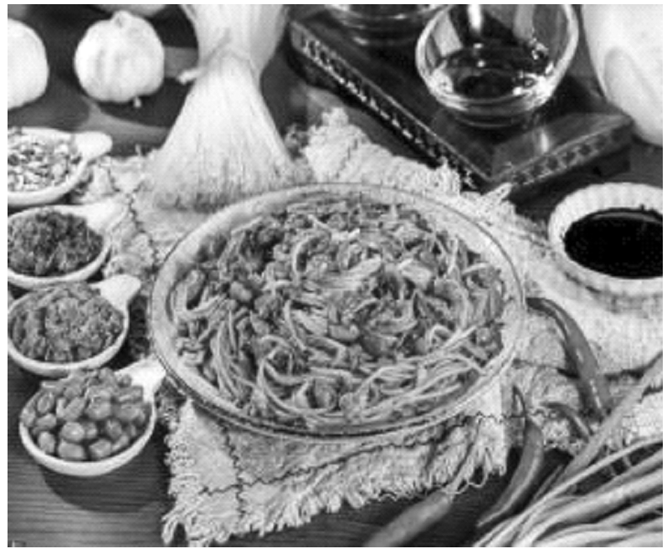

44 — theyre almost a way of life.

In fact, most people here 45 the day with a bowl of rice noodles in the morning. This dish is so popular that some locals have 46 compared having rice noodles to enjoying fresh sea food.

Jiangxi is home to nearly 30, 000 rice noodle restaurants. According to a report, Jiangxi produced more than 1.4 million 47 of rice noodles in 2020. More than 60% of the foreign sales of Chinas rice noodles are from Jiangxi.

This dish is also 48 among people from other parts of China. The report shows that people aged between 18 and 24 make up about 33% of customers. They often 49 rice noodles and takeaway meals online. The percentage (百分比) 50 to over 65% for customers under 30 years old. “ Enjoying 51 a specialty ( 特产) is one way to get a real experience of local cooking culture,” said a local food expert. He added that more efforts should be made to find out the

52 behind Jiangxi rice noodles. The charm ( 魅力) of this common dish comes from its stories and 53 tastes — the noodles are prepared differently in each of Jiangxis 11 cities.

54 these noodles are such an important part of Jiangxi culture, locals have done their best to protect its reputation( 声誉) as a local specialty.

四、阅读理解( 本大题共 23 小题,每小题 2 分,共 46 分)

A) 请阅读下面短文,根据短文内容从每小题所给的 A、B、C、D 四个选项中选出最佳选 项,并在答题卡上将该项涂黑。

A

|  |
| --- |
| Riverside B&B  Price: from ＄30 per night  Bedrooms: single, twin or double rooms  View: river  Location: 20 minutes from city center ( taxi)  Facilities: private bathroom, WiFi, air-con, fridge, TV, restaurant |
| Beautiful Apartment Price: from ＄60 per night  Number of rooms: whole apartment with living room, kitchen, bathrooms  Bedrooms: 2 ( sleeps 4)  View: park  Location: 5 minutes from city center ( taxi)  Facilities: WiFi, air-con, TV |
| Capsule Hotel  Price: from ＄13 per night Size: 2. 5 square meters Bed: all single  View: none  Location: city center  Facilities: shared bathroom and entertainment room, USB, WiFi, TV |

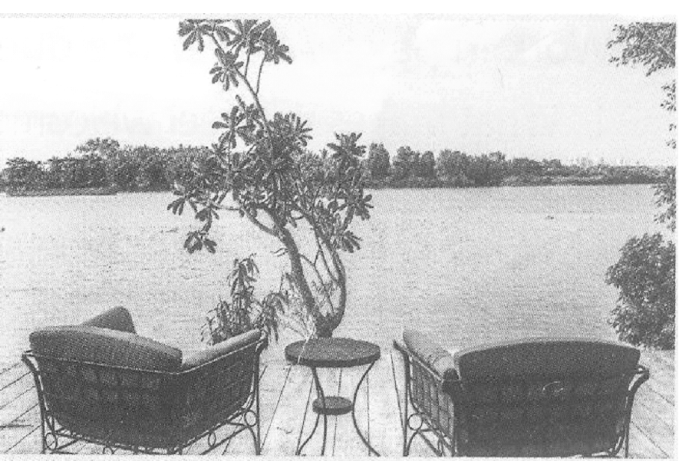

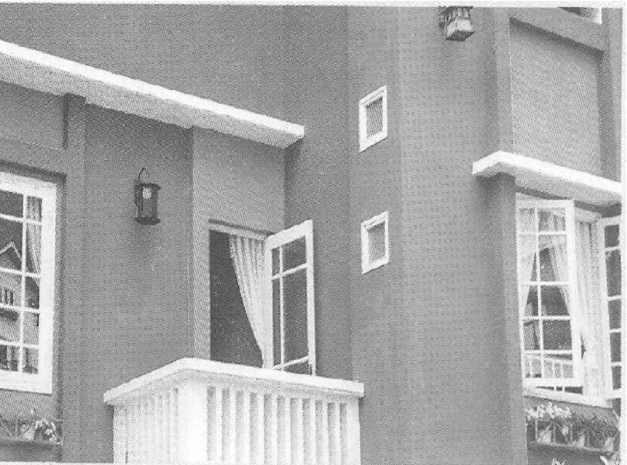

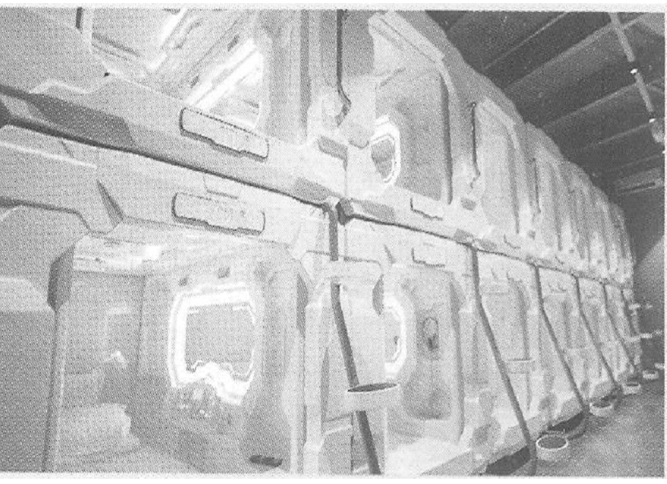

1. How much does a bed at Capsule Hotel cost per night?
   1. From ＄13. B. From ＄30. C. From ＄60. D. From ＄90.
2. Which hotel is the farthest from the city center?
   1. Park Hotel. B. Capsule Hotel.

C. Riverside B&B. D. Beautiful Apartment.

1. Which of the following is TRUE according to the ads above?
   1. You can get double rooms at Capsule Hotel.
   2. You can cook meals at Beautiful Apartment.
   3. You can use public bathrooms at Riverside B&B.
   4. You can stay in any of the hotels with a beautiful view.

B

Ed was a professional football player, but in 2017 he had an accident in a swimming pool.

After that, he couldnt move his body from the shoulders down.

Doctors told him that hed probably never walk again, but Ed didnt want to believe this. He had recently got engaged ( 订婚) to the woman who is now his wife and he said that she was the main reason he wanted to get better. He spent six days staring at his toes ( 脚趾) and trying to make them move—and, finally, he succeeded! This was the start of a long journey.

While in hospital, Ed met Paul, a man in his late thirties. Doctors had also told Paul he would never walk again, but Ed encouraged him not to give up and six months later, Paul told Ed he was walking with a stick.

Only a year after his accident, Ed climbed the highest mountain in Wales. Since then he has also climbed a 6,500-meter mountain in Nepal and he said that after each big climb he noticed his body could do new movements.

Two years later, 31-year-old Ed climbed 8, 848 meters, the height of the worlds highest mountain, by going up and down his parents stairs 2,783 times. When he finished, he told a news reporter he had loved it although it sometimes was “ painful” and “ boring”. He also raised ￡ 46,000 for charity.

Ed hopes his story can help people. Thats why he started his own charity, M2M, which aims to support “ people facing challenges in life. ”

1. Who did Ed want to get better mainly for?
   1. His parents. B. His doctor. C. His friend. D. His wife.
2. What is Ed like according to Paragraph 3?
   1. Brave. B. Helpful. C. Honest. D. Hard-working.
3. What does the underlined word “ it” in Paragraph 5 refer to?
   1. Raising money. B. Doing new movements.

C. Visiting parents. D. Going up and down stairs.

1. Put the events about Ed into the correct order according to the passage.
2. Ed started M2M.
3. Ed succeeded in making his toes move.
4. Ed had an accident in a swimming pool.
5. Ed climbed the highest mountain in Wales.
6. Ed climbed his parents stairs 2,783 times.
   1. c-e-b-d-a B. c-b-d-e-a C. e-a-b-d-c D. e-b-d-c-a
7. What would be the best title for the passage?
   1. A Football Player. B. A Challenge Lover.

C. A Charity Worker. D. A Mountain Climber.

C

The Maori arrived in New Zealand from Polynesian ( 波利尼 西亚) islands about a thousand years ago. They were the first people to live in New Zealand.



In the late 18 th century, Europeans came to live in New Zealand. At that time, the population of the Maori was maybe 250,000 in New Zealand. Over the next one hundred years, wars

and disease killed many Maori people. By the end of the 19 th century, there were only about 40,000 Maori people left. During this time, the Maori also lost much of their land to the Europeans. Many of them were afraid that they might lose their traditions and language too, but this did not happen.

Today the Maori population is increasing. There are about 500, 000 Maori people in New

Zealand. Most live like other New Zealanders, but they are keeping the Maori language and traditions alive. There are now Maori radio and television stations. Many schools teach in the Maori language. Nearly one half of Maori language speakers are 25 years old or younger.

Maori culture is also alive and well. At the center of Maori culture is the “ marae”. This is a special place for ceremonies and meetings. Today the number of marae in New Zealand is increasing. Many of the new marae are in the cities. Now people in the cities can meet and learn about their Maori traditions.

Today most New Zealand cities have Maori festivals each year. Among festival activities are competitions in speaking, dancing and singing. Children practice for months. Then all the Maori in the area arrive to watch the competitions and see who wins.

The Maori have gone through hard times. Today they live a comfortable, modern life. They keep their cultural traditions alive, because they have passed and are passing them on to their children.

1. When did the Maori first arrive in New Zealand?
   1. Around 11th century. B. Around 14th century.

C. Around 16th century. D. Around 18th century.

1. What happened to the Maori during the 19th century?
   1. They owned more land. B. They lost their language.

C. They left New Zealand. D. They had a smaller population.

1. How do the Maori keep their traditions alive? Check and choose the right answer.
2. Increase the number of marae.
3. Move to the center of New Zealand.
4. Set up Maori radio and TV stations.
5. Teach in the Maori language in many schools.
6. Hold competitions in speaking, dancing and singing.
   1. bcde B. abcd C. abde D. acde
7. Whats the theme of the passage?
   1. Art. B. Culture. C. Travel. D. Technology.
8. What would be the best structure of the passage?

A. 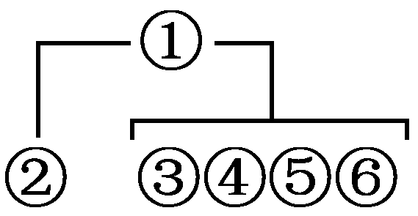 B. 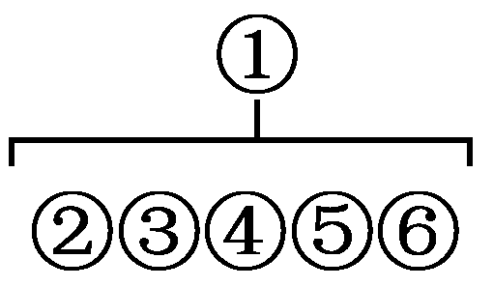 C. 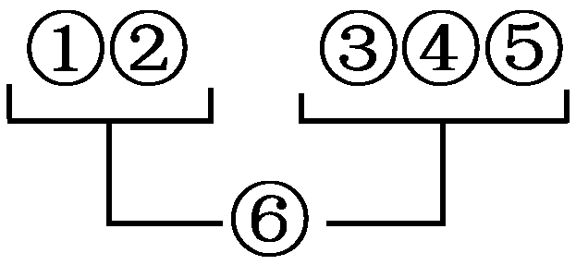 D. 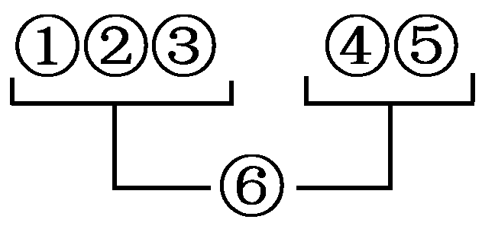

D

In October 2018, someone in South Carolina won ＄1.5 billion. The nearly impossible odds ( 概 率) of winning were 1 in 302. 5 million! Many people probably wish theyd been the lucky ones happily accepting the prize.

Its not hard to imagine the things one could do with this newfound wealth, but would this money actually make someone happy? The experiences of several lottery ( 抽奖) winners show that it probably wouldnt. Suddenly coming into big money can change a persons life in unexpected and sometimes unpleasant ways. Take William Post, for example, who had only ＄2.46 in the bank when he won ＄16.2 million in a New York lottery in 1998. Within 3 months, he was poor again because of careless spending. He wasnt as happy as he felt before winning the prize.

Then there was Callie Rogers, a British teenager from a common family, won ＄3 million in 2003. She bought her family and friends lavish gifts and bought herself expensive clothes. After six years, Callie lost all her money and realized that money didnt make her happy. In fact, she became worried that people were friendly with her only to get her money.

Lottery winners are not the only ones who can end up unhappy. People who get big money for

some other reasons, e. g. receiving money from others, are also at risk. They may not know how to deal with money and do not ask experts for advice. They waste money on things they dont need and give away too much money to friends and relatives.

Researchers found that people are happy when they are able to pay for their basic needs, such as food, clothes, a safe place to live, and health care. People are also happy when they give reasonable( 合理的) amounts of money to charities. Giving makes them feel as if theyre making a difference. Lavish things, such as expensive clothes and cars, only make people happy for a moment.

People can hope and wish to suddenly come into lots of money to improve their lives, but perhaps there are better ways to find happiness.

1. How does the writer support his opinion in Paragraph 2?
   1. By giving an example. B. By listing numbers.

C. By telling the differences. D. By asking a question.

1. What did William and Callie have in common according to the passage?
   1. They came from the same country.
   2. They won the lotteries in the same year.
   3. They were poor before winning the lotteries.
   4. They spent their money quickly and carelessly.
2. What does the underlined word “ lavish” in Paragraph 3 mean?
   1. Expensive. B. Funny. C. Surprising. D. Lucky.
3. Which of the following can be inferred from the passage?
   1. Big money brings lasting happiness.
   2. Peoples lives depend on lottery prizes.
   3. Reasonable spending makes people happy.
   4. The basic needs of people are easily satisfied.
4. Whats the writers purpose for writing the passage?
   1. To encourage readers to make big money.
   2. To advise people to stay away from lotteries.
   3. To show his opinion about money and happiness.
   4. To share some success stories about finding happiness.

B) 请先阅读下面短文,掌握其大意,然后根据短文内容从下面方框内的七个选项中选择 五个还原到文中,使短文意思通顺、结构完整,并在答题卡上将其序号涂黑。 一空一句。

Five Tips to Improve Your Memory

Most of us know that our brains become smaller in size as we get older, but did you know that diet and lifestyle have an effect on how well our brains work?

Research shows that eating lots of fruit, vegetables and proteins ( 蛋白质) improves memory.

73 Eating oily fish or dark chocolate ( with over 70% cocoa) and taking Vitamin D3 can also help make your memory stronger.

74 A 2011 study showed that regular exercise actually increases brain size. Another study found that exercise improved memory in some older people; surprisingly it found that one single training period had the same effect on memory as regular, long exercise period!

One study found that eight weeks of short, daily meditation ( 默想) improved memory. Other ways to relax can also improve our short-term memory. Try taking 5 - 10 minutes of your day to meditate or listen to music. 75

Experts say that age reduces our ability to learn, but sleep can help. 76 A 2019 study found that students learned things better before and after a short sleep!

77 Try to memorize information like phone numbers and addresses rather than putting the

information in your phone. You could also learn a language or do brain training like crosswords ( 填 字游戏).

1. Or even just take a shower!
2. Its important to keep a healthy body.
3. The role of exercise is really important too.
4. Use your phone to help you memorize things.
5. To keep your brain in good condition, you need to use it.
6. Try to avoid sugary foods such as cakes and milk chocolate.
7. For your brain to work well, 7-9 hours of sleep is necessary.

五、补全对话( 本大题共 5 小题,每小题 1 分,共 5 分)

请阅读下面对话,根据对话内容从下面方框内的七个选项中选择五个填入空白处,使对话 通顺、合理,意思完整,并在答题卡上将其序号涂黑。 一空一句。

( *William is calling to make an appointment* ( 预约) *with the receptionist* ( 接待员) *to see Dr.*

*Kim. William* = *W*, *receptionist* = *R*)

R: Good morning. Dr. Kims office. 78

W: Hello. Id like to make an appointment to see Dr. Kim. R: 79

W: William Jenson.

R: 80 Can you come in at 11 ∶15?

W: Um ... Id prefer something in the afternoon. I work in the morning. R: 81 Are you free then?

W: Let me see ... yes, thats fine.

R: OK. So your appointment is with Dr. Kim at 15 ∶30 on Friday. 82 W: Great! Thank you!

1. Dr. Kim speaking.
2. How can I help you?
3. What is your name, please?
4. How about 10 ∶30 on Friday?
5. Please come about 15 minutes early.
6. I can get you an appointment this Thursday.
7. Would you be able to come in on Friday at 15 ∶30?

六、书面表达(15 分)

我国义务教育阶段实施“ 双减” 政策以来,学生拥有更多的课余时间。 为了引导学生更好 地利用课余时间,增强时间管理意识,学校英语社团以“ Making Better Use of Time” 为题向学生 征文,请你根据下列写作要点写一篇短文投稿。

# 写作要点:

1. When do you have free time?
2. What do you often do in your free time? ( Give 3 examples)
3. Do you think your free time is better used? Why or why not?

# 要求:

1. 短文应包括所有的写作要点,条理清楚,行文连贯,可适当发挥;

2. 短文中不能出现真实的人名、校名、地名等信息;

3. 词数 80-120,短文开头已给出,不计入总词数。

Making Better Use of Time

As a junior high school student, I have got more free time in recent years.