达州市2012年高中阶段教育学校招生统一考试
英 语
本试卷分为第Ⅰ卷（选择题）和第Ⅱ卷（非选择题）两部分。第Ⅰ卷1至8页，第Ⅱ卷9至10页。考试时间100分钟，满分100分。
第Ⅰ卷（选择题，共79分）
注意事项：
1.答第Ⅰ卷前，考生务必将姓名、准考证号、考试科目按要求填涂在答题卡上。
2.每小题选出答案后，用铅笔把答题卡上对应题号的答案标号涂黑，不能将答案答在试卷上。
3.考试结束，将本试卷和答题卡一并收回。
第一部分 听力（共两节，满分20分）
第一节 (本题共5小题。每小题1分，计5分)
听下面五段对话，每段对话后有一个小题，从题中所给的Ａ、B、C三幅图片中选出最佳选项,并将答题卡上对应题号的答案标号涂黑。每段对话读两遍。
1. Where is Alice’s pen pal from?
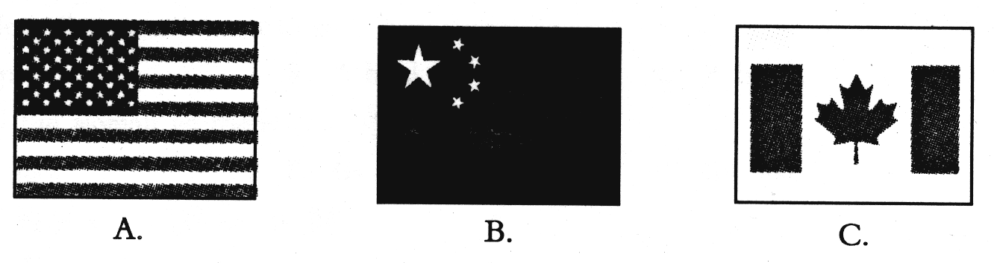
2. What was Helen doing when the accident happened?
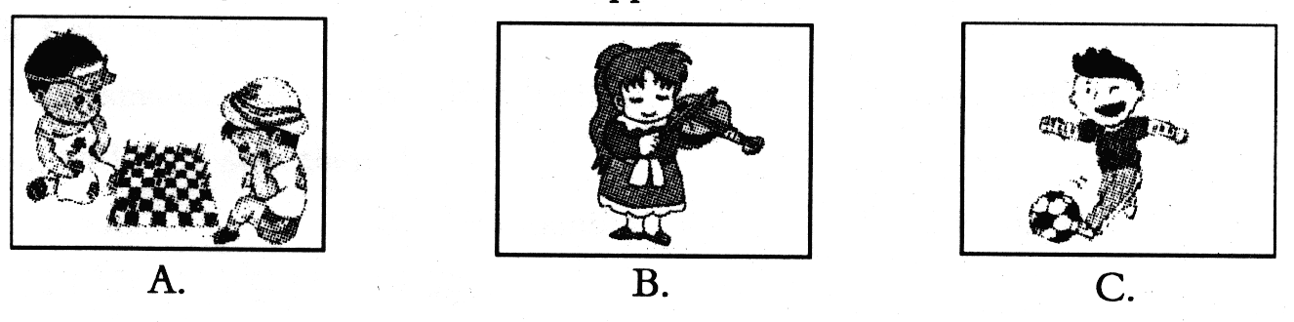
3. When will the man have his birthday party?
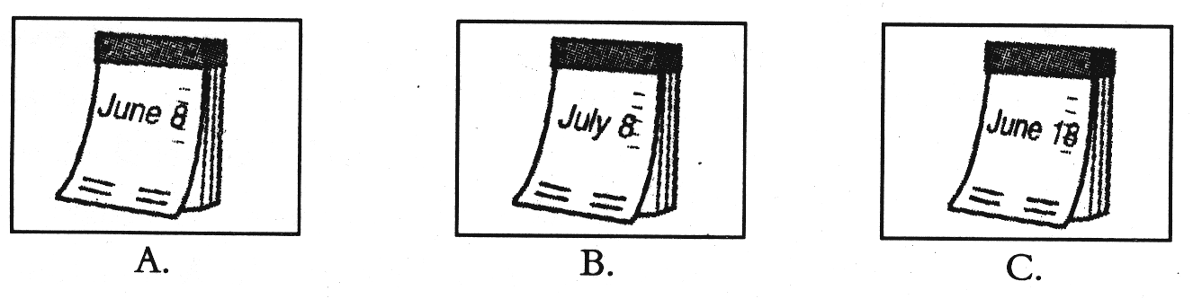
4. What is the man going to buy for his father?
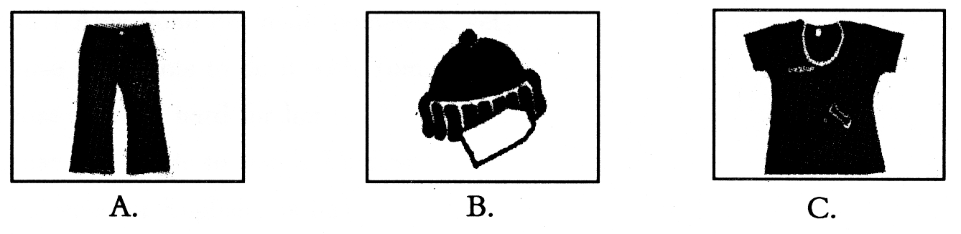
5. What’s the weather like now?
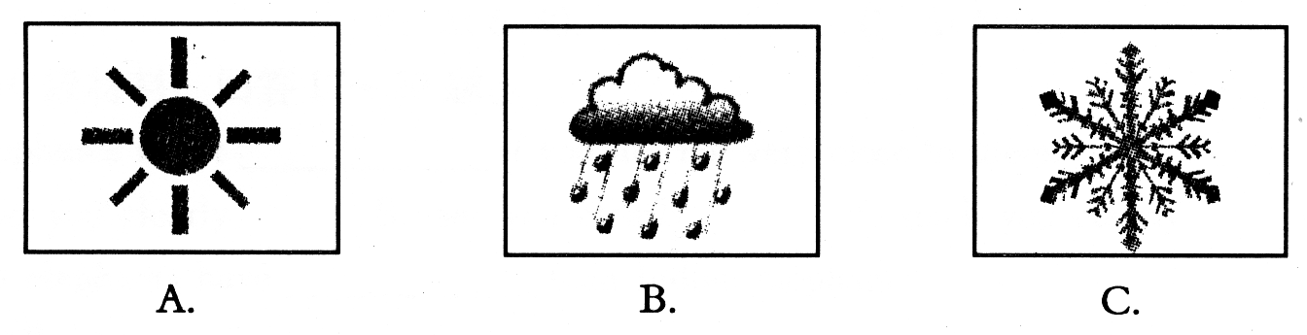
第二节 (本题共15小题。每小题1分，计15分)]
听下面5段对话或短文，每段对话或短文后有几个小题，从题中所给的A、B、C三个选项中选出最佳选项,并将答题卡上对应题号的答案标号涂黑。每段对话或短文读三遍。
听第6段材料，回答6-7题。
6. Where does the woman want to go?
A. A park. B. A bank. C. A hotel.
7. How will the woman go there?
A. On foot. B. By bus. C. By bike.
听第7段材料，回答8-10题。
8. Where is Kate going for her summer vacation?
A. Beijing. B. Taiwan. C. Sichuan.
9.Who will Kate go with?
A. Her classmates. B.Her friends. C. Her family.
10. How long will they stay there ?
A. Two weeks B. Two months C. Two days
听第8段材料，回答11-13题。
11.What does Ann think of being a doctor?
A. Easy. B. Difficult. C. Interesting.
12.What does Ann want to be?
A. A nurse. B. A doctor. C. A reporter.
13. Which of the following is TRUE?
A. Bob’s father is a western medicine doctor.
B. Li Shizhen is Ann’s favorite famous person.
C. Bob must learn a lot about herbs if he wants to be a Chinese medicine doctor.
听第9段材料，回答14-16题。
14.Why hasn’t Amy done her math homework yet?
A..Because she wants to do it with Tom.
B..Because it’s too difficult for her.
C..Because she wants to watch TV first.
15.Tom is not good at English, is he?
A..Yes, he is. B.No, he isn’t C.Yes, he isn’t.
16.When are they going to meet in order to do homework?
A. At 5:30. B. At 6:30. C. At 5:00.
听第10段材料，回答17-20题。
17. The elephants can’t if you are not very close to them.
A. hear you clearly B. see you clearly C smell you clearly
18. African elephants have than Indian elephants.
A. smaller ears and shorter teeth
B. bigger ears and longer teeth
C. smaller eyes and shorter teeth
19. The elephants are easily caught in .
A. India B. Africa C. India and Africa
20. The elephants in India can .
A. work for people B. learn to know a man’s voice C. A and B
第二部分 基础知识运用（共两节，满分25分）
第一节 单项选择（共10小题。每小题1分，计10分）
从每小题所给的A、B、C、D四个选项中选出可以填入空白处的最佳答案。
21. —What cold weather！
—Yes. But it’s unusual experience for us, we normally live in a hot place.
A. /; a B. a; an C. / ; an D. a; the
22. —We can see the sign  in the public places. What does it mean?
—It means________.
A. NO PHOTOS B. NO FISHING
C. NO PARKING D. NO SMOKING
23. —Do you enjoy My heart will go on?
—No, I prefer songs loud.
A. that is B. which is C. that are D. what are
24. —I like drinking wine. But people who drink wine aren’t allowed to drive.
—If I you, I would give up wine.
A. were; drinking B. am; drinking
C. were; drink D. was;to drink
25. — Is there in today’s magazine?
—Yes. Premier Wen Jiabao saw “stay-home children” May,25th.
A. anything special; hundreds of; on B. something special; hundred of; at
C. special anything; hundreds; on D. anything special; hundreds of; in
26．—That actor often joins in dfferent activities in Beijing. Do you know ?
—For 5 years.
A. how soon he will come back B.how long he has stayed there
C. how long has he stayed there C. how often does he go there
27. —Peter has changed a lot, hasn’t he?
—Yes. He used to the guitar,but now he is more in playing soccer.
A. plays; interested B. play; interested
C. play; interesting D. playing; interest
28. —I have never been to Hawaii. What about Mike?
— .
A. So has he B. So he does C. Neither he has D. Neither has he
29. — John, you go out to play until your homework .
—OK, Mum.
A. must; finishes B. can’t; is finished
C. can’t; has finished D. needn’t; finishes
30. —Would you please help me with my writing skills?
— ________.You can come to my office every Saturday.
A. That’s all right B. Not at all C. No problem D. No,thanks
第二节 完形填空（共15小题。每小题1分，计15分）
先通读下面的短文，掌握其大意，然后从后面各题所给的A、B、C、D四个选项中选出可以填入相应空白处的最佳答案。
(A)

Panda Express is a fast food restaurant chain(连锁店)in the United States. It sells Chinese food. When you go to 31 malls, supermarkets, airports, train stations, parks, stadiums, college campuses and 32 other places, you can see Panda Express. It is 33 chain of Chinese fast food restaurants in the United States. Panda Express 34 in 1983 by Andrew Cherng, Peggy Cherng and Ming Tsai Cherng. They were from Yangzhou, Jiangsu, China. Now Panda Express has 1,321 restaurants in 38 states and Puerto Rico，and the top-selling food of Panda Express 35 Orange Chicken and Beijing Beef.
31. A. shop B. shopping C. shops D. shoping
32. A. many B. a lot C. much D. lots
33. A. large B. larger C. the largest D. largest
34. A. was opened B. opened C. is opened D. opens
35. A. are B. will be C. was D.is
（B）
Chairman Mao once said,“It is not hard to do one good deed. It is hard to do good deeds all your life.” Guo Mingyi, a 52-year-old worker in Anshan, Liaoning did just that. Over the past 20 years, Guo 36 60,000 mL of blood(血). That is the blood of 10 people put together.
Once, 37 the cold winter of 2009,Guo got a call from the hospital. The doctors told him 38 a patient needed a blood donation. Guo didn’t have time to have lunch. He traveled in the snow to 39 the hospital. When he finished donating the blood, he was 40 tired that he fell asleep on the hospital bed.
Guo and his family live a 41 life. They live in a house of only 40 square meters. 42 they don’t have a lot of money, Guo saves money to support poor children. In the past 16 years, he has given away over 100,000yuan to more than 180 poor students. When the parents met him, many cried,“He looks 43 than us.”they said.
Guo has also offered help to thousands of workers, friends and strangers. His warm heart has moved many people. They 44 him a “Modern-Day Lei Feng”.
Recently, Chinese leaders called on people to learn from Guo. They say young people especially should learn his selfless devotion (奉献). But Guo said he did these things in order not to get famous. “It’s just that some people need some help, and there should be someone standing out to give 45 a hand.” he said.
36. A. had donated B. has donated C. have donated D. donates
37. A. in B. on C. at D. above
38. A. which B. that C. what D. who
39. A. arrive B. reach at C. get to D. get
40. A. such B. very C. too D. so
41. A. simple B. unhappy C. rich D. happily
42. A. So B. And C. Because D. Though
43. A. richer B. poorer C. better D. kinder
44. A. say B. shout C. call D. speak
45. A. them B. him C. her D. their

第三部分 阅读理解（共15小题。每小题2分，满分30分）
阅读下面的短文，根据短文内容，从每题所给的A、B、C、D四个选项中选出最佳答案。
（A）
Steven Jobs, the CEO of Apple, was not a good student when he was in school. At that time, he always got into trouble with his schoolmates. When he went to college, he didn’t change a lot. Then he dropped out(退学). But he was full of new ideas.
After that, Steven Jobs worked as a video game designer in a company. He worked there only for a few months and then he went to India. He hoped that the trip would give him some new ideas and a new chance to change his life.
Steven Jobs lived on a farm in California for a year after he returned from India. In 1975, he began to make a new type of computer. He designed the first Apple Computer with his friend in his garage. He chose the name“Apple”just because it reminded him of a happy summer he once spent in an apple orchard.
His first Apple Computer was a great success. Because of this, Steven Jobs soon became famous all over the world.
46. Steven Jobs always got into trouble with in school.
A. his schoolmates B. his parents C. his teachers D.his brothers
47. Steven Jobs designed the first Apple Computer with his friend .
A. in his school B. in his company C. in his garage D. at home
48. Which of the following statements is NOT true?
A. Steven Jobs didn’t finish his college.
B. Steven Jobs worked as a video game designer in a company for a few months.
C. Steven Jobs soon became famous all over the world because of his first Apple Computer.
D. Steven Jobs chose the name“Apple”just because he liked eating apples.
（B）
If you usually take the school bus or sometimes need to take public buses to school, there are some important rules you should know.
·When you are waiting for the bus, you should wait at the bus stop, and stand well back.
·When you get off the bus, make sure you and the driver can see each other, and wait for the driver to signal you before you cross the road in front of the bus.
·Never go back for anything you may leave on the bus when it is starting.
·Never bend down near the bus when you walk to or from the bus stop.
·You should cross the street at a crosswalk or a street corner, and wait for the light to turn green or for the WALK crossing signal.
·It is important to look carefully to the left, the right and the left again when you cross the street.
·Remember that it is dangerous to stay in the areas around buses where the driver can’t see you. Don’t run between parked cars or buses.
·Do not run across the street or through parking areas to catch up with your friends.
49. When you are waiting for the bus, you should wait .
A. at the bus stop B. on the street C. at a crosswalk D. a street corner
50. It is important to when you cross the street.
A. run quickly B. wait for the light to turn green
C. look carefully to the left D. look carefully to the right
51.If you walk to or from the bus stop, you mustn’t .
A. bend down on the bus
B. cross the street at a crosswalk or a street corner
C. bend down near the bus
D. look carefully to the left, the right and the left again
52. This passage is mainly about .
A. safety rules for students by bus
B. safety rules for drivers
C. safety rules for children by train
D. how to cross the street
C
Mom and Dad are two of the most important people in your life. Over your lifetime, they may influence you more than anyone else you will meet. So if your mom loves to read, you just might grow up carrying a book wherever you go, just as she does.But parents do a lot more than just pass on their hobbies. Moms and Dads need to care for their kids the minute their kids are born. Most parents will do this as long as they live.
Here are some ways you can stay close, get along well, and build a strong relationship( 关系)with your parents.
Spend time together. Instead of playing computer games or watching TV, ask your mom and dad to play with you. Go outside together, or do some reading.
Be kind. Little things might mean a lot to your mom or dad. You can brighten a parent’s day with a hug（拥抱）, a card , or a joke. It’s also lovely when a kid cleans up his or her room without being asked. And if you try not to fight with your brothers or sisters, your parents will be so happy!
Do your best at whatever you do. You don’t have to be perfect, but when you do your best, you make your parents proud. It makes them happy to see how you’re turning into a great kid. Why? Because it lets them know they’re doing a good job.
53.Who may influence you more than anyone else you will meet according to the passage?
A.Teachers B. Friends C. Parents D. Grandparents
54.Which of the following can’t help you build a strong relationship with your parents?
A. Spending time together B. Being kind.
C. Doing your best at whatever you do. D. playing computer games or watching TV
55.Your parents will be unhappy if you .
A. clean up his or her room without being asked
B. fight with your brothers or sisters
C. try your best to do something
D. give them a hug
56.What does the underlined part in the passage mean? It means .
A. they make you become a good kid
B. they work hard]
C. they are perfect
D. they do well in their office work
(D)
What’s the most important thing for you to have in your life? Somebody mentions hard-work, others suggest knowledge, love and luck.
If you arrange（排列） the 26 English letters in order and use numbers to represent each of them, for example, 1 for a, 2 for b, 3 for c…26 for z, you can change an English word into a number. So hard-work becomes 8+1+18+4+23+15+18+11=98, meaning 98 is its mark. Knowledge: 11+14+15+23+12+5+4+7+5=96, love:12+15+22+5=54, and luck: 12+21+3+11=47, a small mark. None of these words can give one a full mark. What about money? It can’t , either.
Then what else? Don’t be worried. You can always find an answer to a problem in your life, when you change your way of looking at things or doing things, or your attitude.Yes, attitude is the word. See for yourself: attitude:1+20+20+9+20+21+4+5=100，a full mark.
Different attitudes lead to different courses of life. Most time people hope for a better life. It is possible that they will have a better life if they chang their attitudes. When you change your manner and became friendly towards others, you’ll meet more smiling faces towards you. In the same way, if you take a positive attitude towards failure, you’ll find it’s also rewarding（有益的）though it has caused you losses（损失）.
57.The writer thinks _________ is the most important thing in a person’s life.
A. hard-work. B. knowledge C. money D. attitude
58.What is the mark of the word money according to the passage?
A. 73 B. 72 C. 75 D. 62
59. According to the passage, if you meet with problems, the best way is to ___________.
A. ask for help from others B. hope to be lucky
C. change your attitude D. try math-solving ways
60. From the passage we can learn that ______________.
A. diffrent attitudes come from different courses of life
B. sometimes failure can bring you good if you take a positive attitude
C. math can solve every problem easily in our daily life
D. none of the English words except “attitude” is 100 or more
第四部分 口语应用（共4小题。每小题1分，满分4分）
从对话后的方框中选择适当的选项补全对话。
A: 61
B: I’m not feeling well.
A: You’ve been like this since you got here, haven’t you?
B: 62
A: Do you know why?
B: 63 It’s awful. One day it’s hot, but the next day it’s rainy. No matter what I wear, I’m never dressed properly.
A: You haven’t learned to predict the weather here. I’ve been here for eight years, and I never get sick .
B: 64
A: Well, there’s a weather hotline. Every morning you can call it to find out what the weather will be like during the day.
B: I know that hotline, but I’ve never called it. I’ve heard it’s expensive.

A.What’s the matter?
B: What should I do then?
C: Yes, for about four weeks.
D: The weather in this city changes so often.

达州市2012年高中阶段教育学校招生统一考试
英 语
注意事项：
1.用蓝黑色钢笔或圆珠笔直接将答案写在试卷上。
2.答卷前将密封线内各项目填写清楚。
题号 | 第一节 | 第二节 | 第三节] | 总分 | 总分人
题号 | 任务型阅读 | 短文填空 | 书面表达 | 总分 | 总分人
得分

第Ⅱ卷（非选择题, 共21分）
第五部分 写（共三节，满分21分）
得分 | 评卷人
第一节 任务型阅读（共5小题。每小题1分，计5分）
根据短文后所给的任务，完成65-69小题.
Now the idea of “car sharing” has become popular in Europe and the United States. That’s to say, people share（分享） one car, not each person has one . (65)As we know, most cars are parked in garages for much time. In fact, we drive our own cars as long as one or two hours a day on average. When we don’t use them, We have to pay for parking and other things. (66)We spend too much money on that. If we share a car, we’ll only pay when we use it. (67)Because some people want to save money, they come up with the idea of “car sharing”. Now many people are starting to do car sharing. In Switzerland, almost 40,000 people have joined it. Japan is also trying to make “car sharing” popular around the country. (68)car, is, of, new, sharing, transportation, beginning, a, idea, the, in .（69）This is also very easy for us to travel here and there without buying cars. Do you love to share a car with others?
任务1：请将（65）处的句子翻译成汉语。
65.
任务2：在下面的空白处填上一个适当的单词，使句意与（66）处相同。
66. That us too much money.
任务3：对（67）处的划线部分提问。
67. ?
任务4：请将（68）处的单词组合成一个完整的句子。
68.
任务5：(69)处有一处错误，请找出错误并改在下面的横线上。（可用文字叙述）
69.
得分 | 评卷人
第二节 短文填空（共6小题。每小题1分，计6分）
根据短文内容和首字母的提示，把所缺单词填写在短文后面的横线上。
Robot s 70 are not just trying to make robots look like people. For example, there are already robots w 71 in factories.These robots look more like huge arms.They do simple jobs over and over again.People would not like to do such jobs and would get bored. But robots will never get bored. In the future, there will be more robots e 72 , and humans will have l73 work to do. New robots will have many different shapes. Some will look like humans, and others might look like snakes. After an earthquake, a snake robot could help look for people under b 74 . That may not seem possible now, but computers, space rockets and even electric toothbrushes seemed i 75 a hundred years ago.We never know what will happene in the future.

70. s 71. w 72. e
73. l 74. b 75. i

得分 | 评卷人
第三节 书面表达（满分10分）
76．目前中学生学习任务重，压力大。而丰富多彩的业余生活，有利于开拓视野，调节身心，提高学习效率。请结合下面的提示词，以My Spare Time为题写一篇80词左右的短文，谈谈你的业余生活。看书、看电视、玩电脑、做运动、参加社会活动等。你喜欢做什么？你是如何合理安排的呢？说说你的想法和理由。
提示词语：busy, play, healthy, knowledge, houswork， relax，volunteer, colorful
要求：
1. 短文内容应包括以上提示的内容，可适当发挥。
2. 书写工整，句式规范，条理清楚。有表达自己观点的句子。
3. 不得出现真实的姓名和地名。
My Spare Time

达州市2012年高中阶段教育学校招生统一考试
英语听力录音材料
听力部分，共两节，满分20分
第一节(本题共5小题。每小题1分，计5分)
听下面五段对话，每段对话后有一个小题，从题中所给的Ａ、B、C三幅图片中选出最佳选项,并将答题卡上对应题号的答案标号涂黑。每段对话读两遍。
1. M: Where is your pen pal from, Alice?
W: She is from China.
2. M: What were you doing when the accident happened, Helen?
W:. I was playing chess..
3. M: Jenny, could you please come to my birthday party on June 8th?
W:.Sure.I’d love to.
4. M: Father’s Day is coming. I’m going to buy a present for my father.
W: Have you decided what to buy?
M: I think I can buy him a T-shirt.His is too old.
5. M: It’s raining outside now.How can you go home without an umbreller, Jane?
W: Don’t worry. I’ll call a taxi.
第二节(本题共15小题。每小题1分，计15分)
听下面5段对话或短文，每段对话或短文后有几个小题，从题中所给的A、B、C三个选项中选出最佳选项,并将答题卡上对应题号的答案标号涂黑。每段对话或短文读三遍。

听第6段材料，回答6—7题。
W: Excuse me, where is the bank?
M: The bank? Oh, it’s not far from here.
W: Shall I take a bus?
M: No. Just go straight down this street and turn right. Then you can see a restaurant.The bank is across from it. It takes you about five minute’s walk.
W: Thank you very much.
M: You’re welcome.

听第7段材料，回答8—10题。
M: So, Kate, summer vacation is coming.Shall we go to Beijing or Taiwan for our vacation?
W: Oh, no. Dad.
M: Why not?
W: You know I have an e-pal in Sichuan.
M: What do you mean?
W: It is just three years since the terrible earthquake. I really want to see what her life is like now.
M: Good idea. We can go there this summer, and we will stay there for two weeks. Maybe we can do something more for her.
W: I’m glad to hear that.Thank you! Dad.

听第8段材料，回答11—13题。
W: What do you want to be when you grow up ,Bob?
M: I want to be a traditional Chinese medicine doctor.
W: Why?
M: Because my favorite famous person is Li Shizhen, andI think it’s important for people to keep healthy.
W: But it’s very hard. You have to learn a lot about herbs.
M: My father is a doctor of traditional Chinese medicine. He has taught me many things.
W: Really? That’s great .
M: How about you ,Ann?
W:I want to be a nurse.

听第9段材料，回答14—16题。
M: Hi, Tom .Have you finished your math homework?
M: Not yet .I’m going to finish it tonight .How about you ,Amy?
W: I haven’t started yet .I feel it’s too difficult for me .Can you help me with it?
M: Sure. I’m glad to help you .Why not come to my house after school ? We can do our homework together .
W: That’s a good idea .I’ll arrive at half past five .
M: What about your English ? Have you done that ?
W: Oh ,yes .I’ve finished it. It’s easy .
M: Oh, I’ve done only a bit of that .I’m having trouble with it .Maybe you can help me .
W: Of course .We’ll help each other this afternoon. I’ll help you with your English ,and then you can help me with my math homework.
M: All right .We can watch cartoons on TV after that .

听第10段材料，回答17—20题。
There are two kinds of elephants in the world, the elephants in India and the elephants in Africa. Both kinds of elephants can’t see anything clearly if things are not close to them, but they have good hearing and smell. The two kinds of elephants have different ears and teeth. Indian elephants have smaller ears and shorter teeth than African elephants. The elephants in India are easily caught, but the elephants in Africa aren’t. People can easily teach the elephants in India to work after they catch them. So you often see elephants working for people in India. These elephants can also quickly learn to know a man’s voice. They even know whether the man is pleased or angry by his voice.

达州市2012年高中阶段教育学校招生统一考试
英语参考答案及评分意见

第Ⅰ卷 （选择题 共79分）
1-5. BBACB 6-10. BACCA 11-15. BACBB 16-20 ABBAC
21-25. CDCAA 26-30. BBDBC 31-35. BACAD 36-40.BABCD
41-45．ADBCA 46-50. ACDAB 51-55. CACDB 56-60. ADBCB
61-64: ACDB
第Ⅱ卷 （非选择题 共21分）

65. 正如我们所知，很多时候大多数车（被）停在车库里。
66. costs
67. Why do they come up with the idea of “car sharing”?
68. Car sharing is the beginning of a new idea in transportation.
69.将This改为 It 或This ----- It
70. scientists 71. working 72. everywhere
73. less 74. buildings 75. impossible
76. One possible version:
My Spare Time
I am a middle school student. Though I’m busy with my lessons, my spare time is still colorful.. After school I usually play sports. I like basketball and football very much. Sports help me to keep healthy and study better. I often do some reading in the evening. I think books are our best friends. They give us much knowledge that we can’t learn at school. So reading books is the best way of spending my spare time. Sometimes I watch TV or surf the Internet. I find it’s a good way to relax myself. At the same time it can also help me open up my eyes to the outside world. At the weekends I often help my parents with the housework. I clean the house, wash clothes and learn to cook. Duing the summer or winter vacation, I have enough time to do things like volunteering. I help those people who are in need.It’s a good experience for me. I enjoy myself in my spare time.


书面表达评分原则及标准
一、评分原则
1.本题总分为10分，按四个档次给分，至少包含以下要点：业余时间做什么？如何合理安排的？有表达自己观点的句子。短文内容应包括所提示的内容，可适当发挥。
2.评分时，先根据短文的内容和语言初步确定其所属档次，然后以该档次的要求来衡量，确定或调整档次，最后给分。
3. 文中若出现真实的人名、地名，酌情扣分。
4. 所给提示性词语不受范围和顺序的限制。相同的错误不重复计算。
二、评分标准
一档 | 9-10分 | 包含了所有要点, 能围绕内容适当发挥,内容具体、丰富。应用了较丰富的语言结构和词汇, 用词准确、句子通顺、行文连贯、表达清楚，没有或几乎没有语言错误，具备较强的语言运用能力，完全达到了预期的写作目的。
二档 | 6-8分 | 包含了所有要点，并能有所发挥，内容欠丰富。应用的语言结构和词汇能满足任务要求，句子较通顺，表达较清楚，有少量语言错误，达到了预期的写作目的。
三档 | 4-5分 | 漏掉部分要点或只是简单说明要点，内容不够丰富、具体，字数较少。语言表达过于简单，句子不够通顺，行文不够连贯，有部分语言错误。
四档 | 0-3分 | 漏掉多个要点或所写内容明显偏离所给要点，内容过少。语言不规范，句子无条理，行文不连贯，语言错误较多。


