2012年普通高等学校招生全国统一考试（湖南卷）
英 语

PartⅠ Listening Comprehension(30 marks)
Section A （22.5 marks）
Directions: In this section, you will hear six conversations between two speakers. For each conversation, there are several questions and each question is followed by three choices marked A, B and C. Listen carefully and then choose the best answer for each question.
You will hear each conversation TWICE.
Example:
When will the magazine probably arrive?
A. Wednesday B. Thursday C. Friday
The answer is B.
Conversation 1
- When does the woman finish work?
A. At 6:00 B.At 7:00 C.At 8:00
2. What is the man going to do tonight?
A. See his parents B. Watch a new movie C. Go for an appointment
Conversation 2
3. Where does the man play tennis?
A. At the university B. At the club C. At the community center
4. How often does the woman swim?
A. Once a week B. Three times a week C. Five times a week
Conversation 3
5. What is the man doing?
A. Getting dressed B. Having an interview C. Celebrating a birthday
6. What is the probable relationship between the two speaker?
A. Parent and child B. Husband and wife C. Customer and salewoman
Conversation 4
7. Why did the man come back late ?
A. He went to the bar.
B. He met his teacher.
C. He played basketball.
8. What did the woman do this morning?
A. She took a physics test. B. She had a meeting C. She held a party
9. What will the woman probably do after the conversation?
A. See her friends B. Go to the school C. Prepare dinner
Conversation 5
10. Where did the woman grow up?
A. In Switzerland. B.In the UK. C. In France.
11. Which of the following does the woman like best about Weybridge?
A. Its scenery B. Its people C.Its facilities
12. What does the man do?
A.A teacher B.A host C.A tour guide
Conversation 6
13. Why is the woman upset?
A. The man didn’t apologize
B. The man didn’t turn up.
C. The man didn’t call.
14. Who is the man speaking to?
A. A waitress. B.A professor C.A doctor
15. When will the two speakers see each other?
A. On Tuesday B. On Thursday C. On Friday
Sectin B（7.5 marks）
Directions: In this section, you will hear a short passage.listen carefully and then fill in the numbered blanks with the information you have heard. Fill in each blank with NO MORE THAN THREE WORDS.
You will hear the short passage TWICE
School Library
Locations  And resources | ·1stfloor : 80,000 books  ·2nd floor: 16 90 kinds of newspapers and magazines
Rules | ·Books for lending can be kept for a 17 month by full-time students.  · 18 Reference books, newspapers and magazines can never be taken out.
Opening time | ·All day long  ·All year round except Christmas Day and 19 New Year’s Day
Access | ·By 20 ID card

Part Ⅱ Language Knowledge （45 marks）
Section A （15 marks）
Directions: For each of the following unfinished sentences there are four choices marker A,B,C and D. Choose the one that best couplets the sentences.
Example:
The wild flowers looked like a soft orange blanket the desert.
A. covering B. covered C. cover D. to cover
The answer is A
21. We’ve had a good start, but next, more work needs to achieve the final success.
A. being done B. do C. to be done D. to do
22. Don’t worry. The hard work that you do now later in life.
A. will be repaid B. was being repaid C. has been repaid D. was repaid
23. Time, correctly, is money in the bank.
A. to use B. used C. using D. use
24. Bicycling is good exercise; ,it does not pollute the air.
A. nevertheless B. besides C. otherwise D. therefore
25. Close the door of fear behind you, and you the door of faith open before you.
A. saw B. have seen C. will see D. are seeing
26. Everyone in the village is very friendly. It doesn’t matter you have lived there for a short or a long time.
A. why B. how C. whether D. when
27. “The moment soon,” he thought to himself, waiting nervously.
A. came B. has come C. was coming D. is coming
28. I always felt I would pass the exam, I never thought I would get an A.
A. While B. Once C. If D. Until
29. Sorry, I am too busy now, if I time, I would certainly go for an outing with you.
A. have had B. had had C. have D. had
30. It was not until I came here I realized this place was famous for not only its beauty but also its weather.
A. who B. that C. where D. before
31. The lecture, at 7:00 pm last night,was followed by an observation of the moon with telescopes.
A. starting B. being started C. to start D. to be started
32. hard you try, it is difficult to lose weight without cutting down the amount you eat.
A. However B. Whatever C. Whichever D. Whenever
33. - I remember you were a talented pianist at college. Can you play the piano for me?
-Sorry, I the piano for years.
A. don’t play B. wasn’t playing C. haven’t played D. hadn’t played
34. Care of the soul is a gradual process even the small details of life should be considered.
A. what B. in what C. which D. in which
35. All the scientific evidence that increasing use of chemicals in farming
Damaging our health.
A. show; are B. shows; are C. show; is D. shows; is
Section B（18 marks）
Directions: For each of the following passage there are four words or phrases marker A,B,C and D. Fill in each blank with the word or phrase that best fits the context.

“What’s it like to have a gap between a gap between your teeth?” a girl asked me one day.
Nobody had ever 36 before. My hand unconsciously rose to cover my mouth. But, as she looked at me, sincerely waiting for 37 , I realized she was not trying to be rude. “I never think about it,” I truthfully replied. She nodded and turned away. I was left wondering if people 38 me and saw only gappy teeth.
Later that day at home, I began to 39 my teeth again. I felt upset, I thought my life would be somehow better if my teeth were not gappy. How I wanted the perfect teeth that everyone else seemed to have!
Of course, Mom 40 everything. She has lived her entire life with gappy teeth, and tried to convince me that there was noting to 41 . When I refused to listen, she told me I could get the surgery to close the gap if it was that important.‘“Let’s be , though,”she said.“If everyone got surgeries to become pretty, everyone would be exactly the same. There is beauty in differences.”
Her 43 made me consider my teeth seriously. The thought of losing my gap was more terrible than the reality than the reality that people were going to notice it. I realized how important it was to me. It is part of my 44 .
Nowadays many people do ridiculous things to realize their dream of “perfection.” The 45 is that no one is perfect. When all potential for ugliness is removed, so is all of the potential for 46 .
So if that girl ever asked about my teeth 47 , I would truthfully answer, “You know? It’s really cute.”
36. A. faced B. guessed C. asked D. imagined
37. A. an offer B. an answer C. a suggestion D. a result
38. A. heard of B. thought of C. talked about D. looked at
39. A. consider B. Brush C. cover D. appreciate
40. A. admitted B. noticed C. controlled D. changed
41. A. worry about B. put off C. give up D. wipe out
42. A. friendly B. lovely C. honest D. helpful
43. A. words B. jokes C. dreams D. acts
44. A. ability B. decision C. goal D. identity
45. A. possibility B. purpose C. truth D. choice
46. A. courage B. wisdom C. kindness D. beauty
47. A. once B. again C. too D. instead
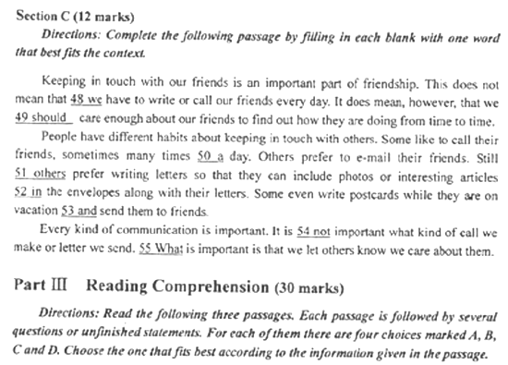
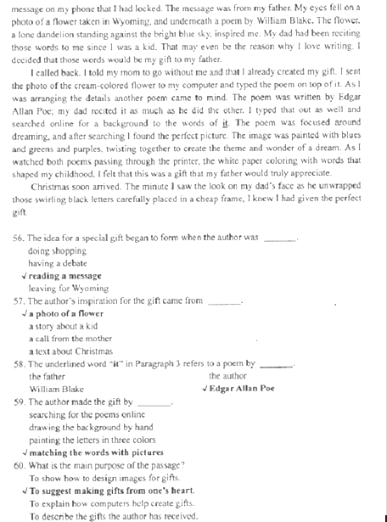
Still seeking a destination for your weekend break? There are some places which are probably a mere walk away from your college.
King’s Art Centre
A day at the Centre could mean a visit to an exhibition of the work of one of the most interesting contemporary artists on show anywhere. This weekend sees the opening of an exhibition of four local artists.
You could attend a class teaching you how to ‘ leam from the masters’ or get more crative with paint –free of charge.
The Centre also runs two life drawing classes for which there is a small fee.

The Botanic Garden
The Garden has over 8,000plant species; it holds the research and teaching ,collection of living plants for Cambridge University.
The multi-branched Torch Aloe here is impressive. The African plant Produces red flowers above blue-green leaves, and is not one to miss.
Get to the display house to see Dionaea muscipula , a plant more commonly known as the Venus Flytrap that feeds on insects and other small animaks.
The Garden is also a place for wildife-enthusiasts. Look for grass snakes in the lake.A snake called ’Hissing Sid ’is regularly seen lying in the heat of the warm sun.

Byron’s Pool
Many stories surround Lord Byron’s time as a student of Cambridge University. Arriving in 1805,he wrote a letter complaining that is was a place of “mess and drunkenness”.However,it seems as though Byron did manage to pass the time pleasantly enough. I’m not just talking about the pet bear he kept in his rooms .He spent a great deal of time walking in the village.
It is also said that on occasion Byron swam naked by moonlight in the lake,which is now known as Byron’s Pool. A couple of miles past Grantchester in the south fields The cries of invisible birds make the trip a lovely experience and on the way home you can drop into the village for aftemoon tea.if you don’t trust me ,then perhaps you’ll take if from Virginia Woolf—over a century after Byron,she reportedly took a trip to swin in the same pool.
62. “Torch Aloe ” and “Venus Flytrap” are_______.
A. common insects
B. impressive plants
C. rarely-seen snakes
D. wildlife-enthusiasts
63.We can infer fron the passage thet Byron seemed_______.
A. to fear pet bears
B. to like walking
C. to be a heavy drinker
D. to finish university in 1805
64. In the passage Byron’s Pool is described as a lake ________.
A. surrounded by fields
B. owned by Lord Byron
C. located in Grantchester
D. discovered by Virginia Woolf
65.What is the passage mainly about?
A. Some places for weekend break.
B. A way to become creative in art.
C. The colourful life in the countryside.
D. Unknown stories of Cambridge University.

C
Harvard researchers have created a tough, low-cost, biodegradable(可生物降解的) material inspired by insects’ hard outer shells. The material’s inventors say it has a number of possible uses and someday could provide a more environmentally friendly altermative to plastic. The material, made from shrimp(虾) shells and proteins produced from silk,is called “shrilk .” It is thin, clear ,flexible and strong.
A major benefit of the material is ist biodegradability. Plastic’s toughness and flexibility represented a revolution in materials science during the 1950s and ‘60s. Decales later, however. plastic’s very durability(耐用性) is raisting questions about how appropriate it is for one-time products such as plastic bags, or short-lived consumer goods,used in the home for a few years and then cast into a landfill where they will degrade for centuries. What is the point of making something that lasts 1,000 years?
Shrilk not only will degrade in a landfill, but its basic coponents are used as fertilizer(肥料)，and so will enrich the soil.
Shrilk has great potential, the inventors said. Materials from which ist is made are plentiful in nature, found in everyting ranging from shrimp shells, insect bodies to living plant. That makes shrilk low cost, and its mass production possible should it be used for products demanding a lot of material.
Work on shrilk is continuing in the lab. The inventors said the material becomes flexible
When wet ,so they’re exploring ways to use it in wet environments. They’re also developing simpler production processes, which could be used for non-medical products, like for computer cases and other products inside the home.They’re even exploring combining ist with other materials, like carbon fibers, to give it new properties.
66.Paragraph I of the passage is mainly about shril’s_______.
A. remarkable design
B. intrersting name
C. major features
D. basic elements
67. What has become a concem about plastic?
A. Using it properly
B. Producing it cheaply.
C. Developing its properties quickly.
D. Evaluating its contributions fairly.
68.According to the inventors, shrilk has great potential partly because_______.

68.According to the inventors ,shrilk has great potential partly because________.
A. it can help plastic degrade
B. it can be found in living things
C. its mass production has been realized
D. its raw materials are abundant in nature
69.What are the inventors doing in the lab?
A. Replacing carbon fibers with shrilk.
B. Testing shrilk’s use in wet conditions.
C. Making shrilk out of used household goods.
D. Improving shrilk’s flexibility for medical purposes.
70. Which of the following can be the best title for the passage?
A. Recent Progress in Environmental Protection
B. Benefits of Insects in Scientific Research
C. The Harm of One-time Products
D.A Possible Alternative to plastic

Part IV Writing(45marks)
Section A(10marks)
Directions: read the following passage. Fill in the numbered blanks by using the information from the passage.
Write NO MORE THAN THREE WORDS for each answer.
Since the earliest civilizations, people have controlled rivers to meet society’s demands. Tody , rivers are controlled for many reasons, primarily to maintain reliable water supplies for daily, agricultural and industrial needs, for power generation, for navigation (航行),and

To prevent flooding.
Rivr control is achieved by channelization, a term that covers a range of river engineerin works, including widening, deepening,straightening and stabilization of banks, and by the construction of dams.
An important period of channelization took place in Europe during the 19th century, when many large rivers were straightened and their beds deepened. One of the most dramatically changed was the Tisza, designed to reduce flooding and make land for agriculture,included cutting off more than 100 meanders (河曲)，shortening the river’s length by nearly400 kilometers.
One of the most common ways in which people control rivers is by damming them.The past 50 years or so has seen an increase in dam construction worldwide, and at the beginning of the 21st century, there were atout 800,000 dams globally,some towering more than 200 meters in height.
Despits their success, many dams also cause significant environmental changes that prove harmful. Some particularly deep reservoirs (水库) can bring about earthquakes due to the stress on their bottom rocks caused by huge volumes of water. Downstream of a reservoir,the river is certainly influenced in many ways:water volume, speed and quality are all affected ,leading to changes in the landscape and among plants and animals.

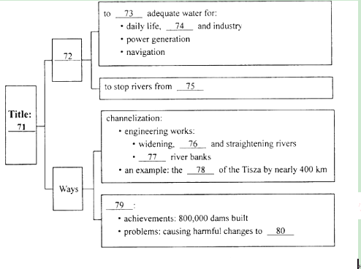

71.River control 72.Reasons
73.supply 74.agriculture
75.flooding 76.deepening
77.stabilizing 78.shortening
79. dam construction 80. the environment

Section B(10marks)
DIRECTIONS:Read the follwing passage.Answer the questions according to the information given in the passage.
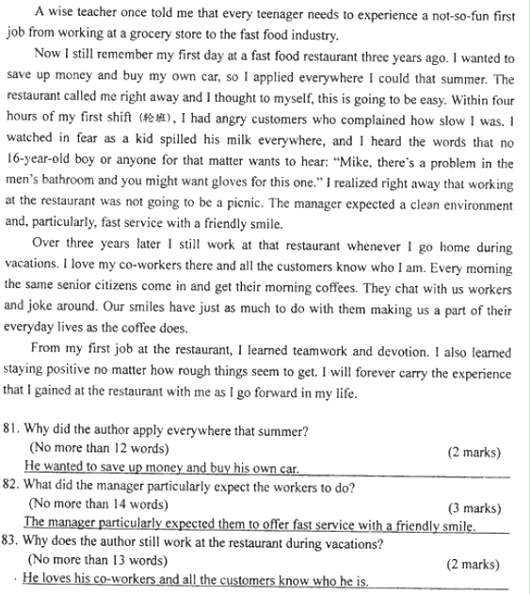
84. What did the author leam from his first job?
(No more than 11 words) (3 marks)
He leamed teamwork,devotion,and staying positive in rough situations.
Seetion C (25,marks )
Directions:Write an English composition uccording to the instructions given below in Chinese.

生活中，你自己人或他人曾有过物品不慎丢失而又找回的经历，其间有烦脑、有惊喜、有感慨……请就此写一篇英语短文。
主要内容包括：1）丢失的物品： 2）物品失而得得的经过；3）你的感想。
注意：
1.词数不少于120个
2.不能使用真实姓名和学校名称。
答案略。

