2002年全国中学生英语能力竞赛（NEPCS）初赛初二组试题笔试部分（共八大题，计120分）
I．单项选择（Multiple-choice test）（共20小题，计20分）
A）从各题的A、B、C、D四个选项中选出一个与划线部分意思相同或相近的选项。（答案涂在答题纸上）
1．The elephant wanted one more banana． A．other B．the other C．a D．another
2．The girl next door married a doctor．
A．lived with B．got married to C．was married with D．went to see
3．Judy sometimes drinks coffee before lunch．
A．sometime B．all the time C．at times D．some times
4．—I have no time．Hurry up！ —Hold your horses．It takes time to open it．
A．耐心点儿。 B．牵好马。 C．管好自己。 D．别松劲儿。
5．Dad brought me a doggy bag when he got home．
A．袋装狗食 B．打包袋 C．难吃的食物 D．有小狗图案的袋子
B）选出下列各题的最佳答案。（答案涂在答题纸上）
6．There __________ only one desk and three chairs in that room last night．
A．was B．were C．to be D．are
7．My sister always says she is too thin．But I think she is just __________ thin．
A．more B．much C．a few D．a little
8．We all laughed __________ Johnny when he made faces．
A．on B．at C．for D．of
9．—What are you doing here？
—I don't like this skirt．I'm trying to find __________ to wear．
A．else anything B．everything C．something else D．new something
10．—__________ ？ —I caught a bad cold．
A．What do you do？ B．What did you catch？
C．Why are you here？ D．What's the matter？
11．The boy is short __________ fat．
A．with B．or C．so D．but
12．—__________ do you like China？ —Oh，very much．
A．Why B．How C．What D．When
13．There is __________ boy playing __________ football under the tree．__________ boy lives near __________ Changjiang River．
A．a；不填；The；不填 B．a；the；A；the C．不填；the；The；the D．不填；a；The；不填
14．The bus kept the people __________ for so long．
A．to think B．waiting C．be worried D．healthy
15．—Help yourself to some fruit！ —__________
A．Oh，I'm hungry． B．Yes，please． C．No，I can't． D．Oh，thank you．
16．—I'm sorry about that． —__________
A．That's all right． B．I'm OK． C．Thank you． D．No，you needn't．
17．—Which umbrella is yours？ —The __________ one is __________ ．
A．second；mine B．four；my C．fifth；me D．two；mine
18．In __________，“the ground floor”has the same meaning as“the first floor”in China．
A．the USA B．Chinese C．England D．English
19．Mel looks __________ of the two boys．
A．older B．liker C．the best D．the younger
20．Fred's daughter __________ the machine over there．She wants to __________ how it works．
A．looks at；find B．is watching；find out C．is looking for；know D．finds；look out
II．阅读理解（Reading comprehension）（共30小题，计30分）
阅读下面短文或图表，按要求完成文后各题。
（A）
Foot ball
Football，or soccer，is one of the most popular games around the world．It is played on a field．There are goalposts（球门柱）at either end．There is a net（网） behind the goalposts．This net catches the ball when it goes into the goal．The ball is round and is inflated with（充满）air．
There are two teams of eleven players．A team scores（得分）a goal when one of its players kicks the football into the net．This would be easier if there were no goalkeepers．The goalkeepers'job is to stop the ball going over the goal line between the posts．He is the only player who can touch the ball with his hands．All the others have to play only with their feet or their heads，except when throwing it in after it has gone out of play．
Every player in the team has a job to do．The goalkeeper stops the ball going into his goal with the help of his defenders（后卫）．Midfield（中场）players help the defenders and pass the ball to the forwards（前锋）．The forwards'job is to score goals．
Football is played by boys and girls，men and women all over the world．It is an Olympic sport．The most famous football event in the world is the World Cup．When teams play，many millions of people watch the matches on television．
Choose the best answer．（答案涂在答题纸上）
21．Where is a net used（被用）in football？
A．In front of the goalposts． B．Behind the goalposts． C．On the midfield． D．In the goals．
22．What is the most famous football event in the world？
A．The Chinese Cup． B．The Olympic Games． C．The World Cup． D．The World Championship．
23．Why is it difficult to score a goal？
A．Because the goalkeeper makes it difficult． B．Because the defenders don't help．
C．Because the goal isn't empty． D．Because a lot of people watch the matches．
24．What is the forwards'job？
A．To stop the ball． B．To hold the ball． C．To help the goalkeeper． D．To score goals．
25．What does“Olympic sport”mean？
A．A sport played by everyone． B．A football game．
C．A sport played at the Olympic Games． D．A popular sport．
（B）
Most children today go to a school where each class has its own room．It was different many years ago．Most children went to a one-room schoolhouse．In a one-room schoolhouse all the children learned in one room from the same teacher．A fourth grader might have sat next to a ninth grader．Possibly you have seen（已经见过）a one-room schoolhouse on a television program（节目）．
There was a good reason for many of the one-room schoolhouses．They were often in the countryside，where there were only ten or twenty children going to school．Then one room was big enough for everyone！Today there are many more children going to school．The one-room schoolhouse has just about disappeared（消失）．
Choose the best answer．（答案涂在答题纸上）
26．The best title is __________ ．
A．Today's Schoolhouses B．The One-room Schoolhouse
C．Big Enough for Everyone D．Fourth and Ninth Graders
27．Children going to a one-room schoolhouse had __________ ．
A．the same teacher B．different teachers C．no lunch period D．no homework
28．Schoolhouses today usually have __________ ．
A．one room B．one teacher C．twenty pupils D．more than one room
29．One-room schoolhouses were not used where __________ ．
A．there were farms nearby B．people lived far apart
C．there were many pupils D．there was one teacher
30．The word“possibly”in line four means __________ ．
A．usually B．maybe C．luckily D．often
（C）
This is a story in ten parts，but the parts are in the wrong order．Read the ten parts and then put them in the rig ht order．The two pictures are there to help you．（答案写在答题纸上）
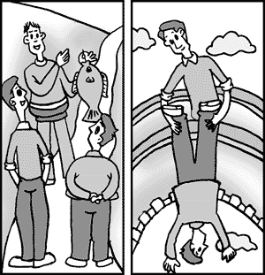

□a）The two men walk on □f）An hour later Bert suddenly shouts，
down the road until they “Quick，quick．Pull me up！
come to a bridge． QUICK！”
□b）Fred and Bert ask him □g）“It's great！！The fish there are
where he get the fish．He jumping so high you can catch
tells them，“I got it from a them in your hands—from the
river near here．” bridge！”
□c）Two men，Fred and Bert， □h）“Have you got a fish？”Fred asks．
are walking along a road． “How big is it？Enormous？”
□d）Fred says to Bert，“When
you catch a fish，shout and □i）Fred holds Bert's feet while he
I can pull（拉）you up．” hangs（吊）over the bridge．
□e）They meet another man．
He's coming in the □j）“No，I haven't got a fish，”
opposite direction（相反的方向）， Bert answers．“There's a
carrying a very big fish． train coming！！”
The right order is：c-（31）__________ -b-（32）__________ -a-（33）__________ d-（34）__________ -h-（35）__________
（D） Dominic's Day Out
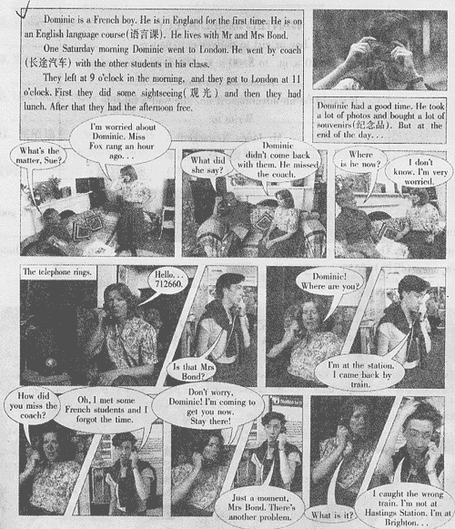
Answer the following questions．（答案写在答题纸上）
36．Where does Dominic come from ？ _________________________________________________
37．What did they do in London？ _________________________________________________
38．Why did Dominic miss the coach？_________________________________________________
39．How did Dominic plan to go home at first？_______________________________________
40．Where did the train go？ _________________________________________________
（E）
WANTED IMMEDIATELY
A boy or girl to deliver newspapers
Hours—6：30 a．m．to 8．00 a．m．Mondays to Saturdays
Wages ￡4per day
It would be an advantage if he／she had a bicycle
Write to：
Mr Jones Newsagent
Pensby Rd Moreton
Complete the passage according to the poster（海报）．（答案写在答题纸上）
Mr Jones wants a boy or a girl to deliver（投递）（41）__________ ．It would be a good thing if the boy／girl has a（42）__________ ．He needs the boy／girl to work（43）__________ hours a week．The boy／girl will get（44）￡__________ a week．You can write to Mr Jones Newsagent（报摊），（45）__________ ．
（F）
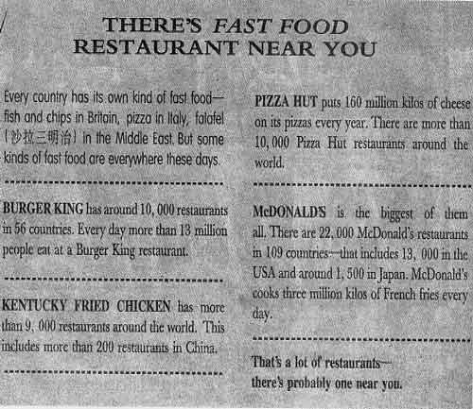
Answer the following questions．（答案写在答题纸上）
46．How many people eat at Burger King every day？
_____________________________________________________________
47．Which company is the biggest？
_____________________________________________________________
48．Where do people eat falafel？
_____________________________________________________________
49．Which company has 200 restaurants in China？
_____________________________________________________________
50．How many Pizza Hut restaurants are there around the world？
_____________________________________________________________
III．完形填空（Cloze test）（共15小题，计15分）
A）从所给出的词或词组中选出最恰当的8个，并用其适当形式完成下文。（每个词或词组只可使用一次）（答案写在答题纸上）
hour，don't，in a hurry，move，so，Monday，have，get up，day，
because，today，at，after，be，about
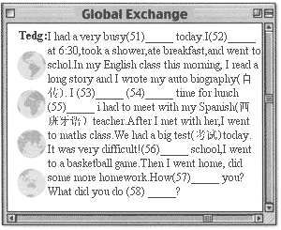

B）根据对话内容，用最恰当的词完成下文。（答案写在答题纸上）
Deirdre：（59）__________ ？
Jim：Hello，is（60）__________ Deirdre？
Deirdre：Yes，（61）__________ is speaking，please？
Jim：It's Jim．Is George there？
Deirdre：No，I'm（62）__________ ．He's at the library．Can I（63）__________ a message？
Jim：Yes，please．It's about our meeting tomorrow．Can he phone me（64）__________ before
7：00 this evening？I'm going out then．
Deirdre：OK，just let me get a pen．Right．．．before 7：00．What（65）__________ can he
reach you at？
Jim：334 6885．
Deirdre：That's 334 6885．Fine．
Jim：Great．Thanks，Deirdre．Bye．
Deirdre：OK．Bye．
IV．句型转换（Sentence pattern transformation）（共10小题，计10分）
A）按要求转换下列句型，每空一词。（答案写在答题纸上）
66．I like apples very much．（用oranges改写成选择疑问句）
Which do you like __________ ，apples __________ oranges？
67．That is a woman doctor．（改为复数句子）
__________ are __________ doctors．
68．Look out of the window．（改为否定句）
__________ __________ out of the window．
69．The new superm arket is three kilometres away from here．（对划线部分提问）
__________ __________ is the new superm arket from here？
70．Allan woke up on the back seat of the police car．（改为否定疑问句，并作肯定回答）
—__________ Allan __________ up on the back seat of the police car？
—__________ ，he __________ ．
B）根据上句完成下句，使两句表达的意思基本相同，每空一词。（答案写在答题纸上）
71．Why not go to visit Bill Gates'house near Seattle？
__________ __________ we go to visit Bill Gates'house near Seattle？
72．We're sure to have some fun at the party this evening．
We're sure to __________ __________ at the party this evening．
73．It's best to get down from the tree at once．
__________ __________ get down from the tree at once．
74．The wom an stopped the car when the policem an came over to her．
The wom an __________ stop the car __________ the policem an came over to her．
75．Sam always gets to school earliest in his class．
Sam is always the __________ __________ to get to school in his class．
V．动词填空（Fill in the blanks with verbs in their proper for ms）（共8小题，计10分）用括号内动词的适当形式填空。（答案写在答题纸上）
76．Please remember __________（clean）the floor，or Mrs Klip may __________（be）angry．
77．My father __________（buy）some new books for me every year．
78．Erid is good at __________（make）kites．
79．—It's a fine day today．Why __________ __________（not go）on a field trip？
—Good idea！
80．We __________（learn）how __________（feed）the animals these days．
81．There __________ __________ __________ __________（be）a New Year's party the day after tomorrow．
82．The students really enjoyed __________（work）on the farm．
83．Ed __________（be）always late for class last term．
VI．翻译（Translation）（共5小题，计10分）
把短文中的划线部分译成汉语。（答案写在答题纸上）
（84）It was two weeks before Christmas，and Mrs West was very busy．She bought a lot of Christmas cards to send to her friends and to her husband's friends，and put them on the table in the living-room．Then，when her husband came home from work，she said to him，“Here are the Christmas cards for our friends，and here are some stamps，a pen and our book of addresses．（85）Will you please write the cards while I am cooking the dinner？”
（86）Mr West did not say anything，but walked out of the living-room and went to his study．Mrs West was very angry with him，but did not say anything either．
（87）Then a minute later he came back with a box full of Christmas cards．All of them had addresses and stamps on them．
（88）“These are from last year，”he said．“I forgot to post them．”
VII．智力测试（Intelligence test）（共5小题，计5分）
按要求完成下列各题。（答案写在答题纸上）
89．Which city is different from the others？
London Rome Beijing Tokyo
New York Moscow Brussels Ottowa
90．Which number should replace（代替）the question mark？
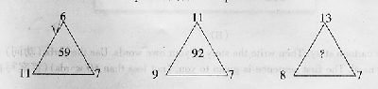
91．
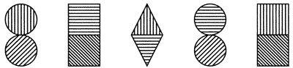
What comes next in the above sequence?
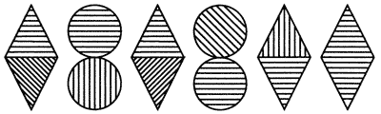
A B C D E F
92．Which letter is two to the left of the letter immediately to the right of the letter which is three to the left of the letter immediately to the right of the letter E？
A B C D E F G H
93．Which word becom es SMALLER when you ADD（增加）two letters to it？
VIII．写作（Writing）（共2小题，每小题10分，计20分）
要求：1．根据提供的图示或信息，适当拓展想象空间，将提供的内容灵活体现在文章中；
2．条理清楚，意思连贯，语句通顺，标点正确，书写清晰、规范；
3．不得少于规定的词数。
（A）
Rewrite（重写）the message by using complete sentences（完整的句子）．（not less than 20 words）（答案写在答题纸上）
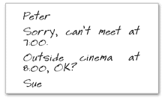
（B）
Read this cartoon story．Then write the story in your own words．Use the verbs（动词）in the box if you need．The first sentence is given to you．（not less than 60words）（答案写在答题纸上）
look for，meet，ask，try，sell，go on，see，let，get in
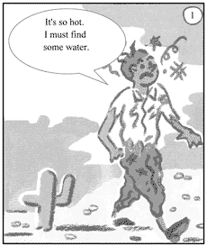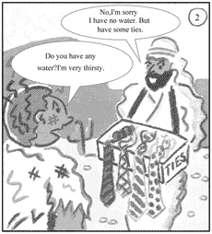
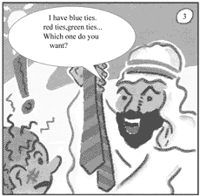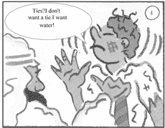
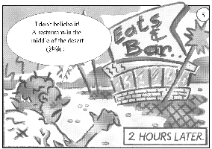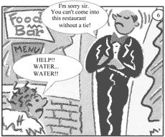
A man was very thirsty when he was walking in the desert．______________________________
__________________________________________________________________________________________
__________________________________________________________________________________________
__________________________________________________________________________________________
__________________________________________________________________________________________
__________________________________________________________________________________________
_________________________________________________________________________________________

