I. 听辨单词 (Words) (共5小题,计5分)
听句子,选出句子中出现的单词。每个句子只读一遍。(答案涂在答题纸上)
1. A. question B. visiting C. inventing D. invitation 2. A. excellent B. exercise C. accident D. advice
3. A. inside B. record C. closed D. replied 4. A. during B. bring C. dealing D. holding
5. A. brought B. without C. thought D. except
II. 句子理解 (Sentences) (共5小题,计5分)
听句子,选择与所听句子意思相同或最相近的选项。每个句子只读一遍。(答案涂在答题纸上)
6. A. She is dreaming and she is a famous woman. B. She is not famous and she doesn’t want to be famous either.
C. Her dream is to be famous one day. D. She never dreams about being a famous person.
7. A. She agrees on December 1st. B. She is the first to meet me.
C. I will meet her on the first day of December. D. I agree to meet her first.
8. A. She felt she was eating something. B. She didn’t want to eat anything.
C. She felt she liked eating. D. She didn’t like to feel anything.
9. A. Today and yesterday are warm. B. Yesterday was warmer than today.
C. It will be warmer tomorrow. D. Today is warmer, but yesterday was much colder.
10. A. You have to finish that work in time. B. You will finish that work in time.
C. You will have that work in time. D. You finished that work in time.
III. 对话理解 (Dialogues) (共10小题,计10分)
A) 听五组对话和对话后的问题,选择最佳选项回答问题。对话和问题读两遍。(答案涂在答题纸上)
11. A. A park. B. Their home. C. Their school. D. A shop.
12. A. Sunny. B. Cloudy. C. Windy. D. Rainy.
13. A. Twenty. B. Thirty. C. Fourty. D. Fifty.
14. A. Every weekend. B. Three times a week. C. Once a week. D. Twice a week.
15. A. The red one. B. The black one. C. The white one. D. The blue one.
B) 听一组长对话,根据其内容选择最佳选项回答下列问题。对话读两遍。(答案涂在答题纸上)
16. What is Mary going to do on Saturday morning?
A. She is going to stay at home. B. She is going to see a film.
C. She is going to visit the museum. D. She is going to do some shopping.
17. Will they have lunch together on Saturday?
A. Yes, they will. B. No, they won’t. C. Maybe. D. We don’t know.
18. Where will they possibly eat on Saturday evening?
A. In Mary’s home. B. In Eric’s home. C. In a Chinese restaurant. D. In an Indian restaurant.
19. Where is the pub they want to go for lunch on Sunday?
A. Near the river. B. Near the cinema.
C. In the city centre. D. Near Mary’s home.
20. Why can’t they see the film on Sunday afternoon?
A. Mary has to go shopping. B. Eric doesn’t like the film.
C. Carlos has to catch the train. D. There is no film that day.
IV. 短文理解(Passages)(共10小题,计10分)
A) 根据所听短文内容,选择描述正确的图片回答问题。短文读两遍。(答案涂在答题纸上)
21. When will they have dinner together?
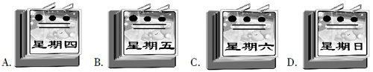
22. What is difficult to find near the school?
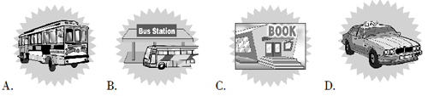
23. Which map is mentioned (被提及的) in the passage?
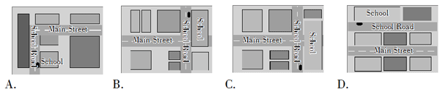
24. Where is the bank?
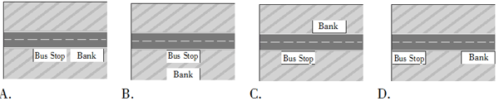
25. What’s the house number of the writer?
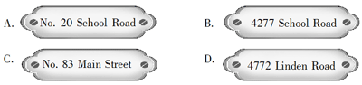
B) 听短文,根据其内容选择最佳选项回答下列各题。短文读两遍。(答案涂在答题纸上)
26. Which of the following statements is RIGHT?
A. I like neither shopping nor window shopping. B. I like shopping but not window shopping.
C. I like window shopping but not real shopping. D. I like both shopping and window shopping.
27. How do I learn about new changes in fashion and style?
A. By opening a shop. B. By window shopping. C. By talking to people. D. By watching people.
28. What can I sometimes buy when I’m out window shopping?
A. Something at a good price. B. Something very expensive. C. Something beautiful. D. Something easy to find.
29. For the same thing, what differs from shop to shop according to the passage?
A. Names. B. Prices. C. Colours. D. Numbers.
30. What can I always get in Smith’s?
A. Beautiful clothes. B. Nice pens. C. Fresh fruit and vegetables. D. Interesting books.
笔试部分(共七大题,计120分)
I. 单项选择 (Vocabulary and structure) (共20小题,计20分)
A) 选择能够替换划线部分的最佳选项。(答案涂在答题纸上)
31. His sister is much older than he.
A. so B. well C. very D. far
32. Louise is nearly as tall as her mother.
A. about B. almost C. next to D. near
33. She lay down on her bed and shut her eyes.
A. opened B. closed C. turned off D. rested
34. Sorry, I can’t stop, I’m in a hurry.
A. in a rush B. hurry up C. walking quickly D. running
35. In many countries people share a common language.
A. a not good B. a different C. the same D. an interesting
B) 选出下列各题的最佳选项。(答案涂在答题纸上)
36. This is the ________ time in ________ days he has made the same mistake.
A. second; third B. two; three C. two; third D. second; three
37. Helen goes to visit his friends in town ________ she can.
A. as often as B. as more often as C. often D. very often
38. I’ll eat a piece of cake to ________ until dinner time.
A. feel hungry B. keep me going C. make me fill D. letting me full
39. An ________ cupboard stood ________ the window.
A. orange small; in the front of B. empty new; at the front of
C. old wooden; in front of D. big black; in front
40. He ________ catch up with the top students all by himself, and he ________.
A. can’t; needn’t help B. must; doesn’t need to help C. mustn’t; needn’t to help D. can; doesn’t need any help
41. The south should be ________, but everywhere else will have ________ rain.
A. rainy; big B. wet; many C. sunny; large D. dry; heavy
42. The boy is busy ________ tomorrow’s lesson.
A. worked on B. preparing for C. to work for D. getting preparing to
43. This is ________ the time to discuss ________ problems.
A. hardly; such B. not; so C. good; these D. almost; that
44. ________ a successful party ________ a lot of energy.
A. To have; taking B. Holding; takes C. Take; take D. Gave; is taking
45. I like this room so much. It’s clean and comfortable, and ________ of all, it’s very cheap.
A. worst B. better C. best D. worse
C) 情景会话。(答案涂在答题纸上)
46. —What’s the matter with you? —________ —Oh, dear! Have you called the police?
A. I lost my purse. B. Nothing serious. C. I missed the train. D. I broke my leg.
47. —Could you take your coat off, please? —________ —No, just roll up your sleeve (袖子).
A. Shall I take my coat off, Doctor Wilson? B. Where is my coat, Doctor Wilson?
C. Would you like me to take my shirt off, too? D. My coat is very beautiful, isn’t it?
48. —Where is Qiangqiang? —Forget him. His teacher is making him copy the text one hundred times.
—________ —Yeah.
A. We are strong. B. Qiangqiang is a good teacher. C. His pen is nice. D. Poor boy.
49. —I met David Beckham yesterday. —________ —Of course I am.
A. Does he look good? B. Are you sure it’s Beck? C. What’s the matter? D. What’s his name?
50. —________ —No. What terrible weather! —Yeah. Rain again.
A. Not very nice weather, is it? B. How are you today? C. What’s the weather like today? D. Is it terrible weather?
II. 阅读理解(Reading comprehension)(共20小题,计30分;51—60小题每题1分, 61—70小题每题2分)
A
Welcome to White Pines Forest. This is one of the most beautiful places in the state. But it can also be dangerous. If you’re planning a hike:  1. Wear comfortable shoes or boots, and take along an extra (额外的) pair of socks. That way you’ll have dry socks to change into if you need them.  2. Wear clothing in layers(多层) that you can put on and take off. As you walk, you’ll probably get warmer. Then you can just take off a layer or two. Don’t forget to carry a waterproof (防水的) jacket. The weather can change quickly here.  3. Take some lightweight food along. Dried fruits, nuts, and crackers are good energy snacks. Be sure to carry plenty of drinking water. There are no water supplies(供应) along the trails. | 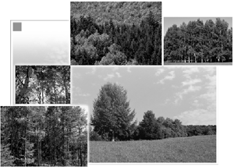
4. There are some poisonous(有毒的) snakes in the forest, but you won’t meet them if you stick to the trails. Remember, the snakes won’t bother you if you don’t disturb them.
5. Allow yourself enough time to get back to the campground(营地) before dark. So that you won’t get lost, make some marks along the way you go.
Happy hiking.
阅读短文,根据其内容选择最佳答案完成下列各题。(答案涂在答题纸上)
51. Which would be the best title for this passage?
A. Tips for Hikers B. What’s in the Forest? C. What to Eat D. Watch out for Snakes!
52. What is the best reason for hikers to carry extra socks?
A. They can use the socks as shoes if the weather turns cold. B. They can always have dry socks to change into.
C. They can use the socks for carrying food. D. They might get bitten by a snake.
53. Which of the following statements is TRUE according to the passage?
A. There are some snakes in the forest but they are not poisonous. B. You can find clear water along the trail.
C. There is no danger in this beautiful forest. D. The weather changes quickly in the forest.
54. What do you think “trail” might mean in this passage?
A. 林间小道 B. 脚印 C. 山涧 D. 原始森林
55. The person who wrote these things mainly wants hikers to ________.
A. be careful B. love the forest C. eat plenty of food D. be kind
B
Many high school students in the United States take part in school activities such as sports, bands, math clubs, science clubs, and theater activities. But after-school activities are not just for high school students. Many elementary schools also have after-school programs for students.
Most of the students in elementary after-school programs cannot go home when school ends because both parents work. These students are too young to stay at home alone. So the main purpose (目的) of these programs is just to look after the children until their parents can take them home. And the best part is that many of the activities in elementary schools are free for parents, unlike some daycare centers that are usually very expensive.
The teachers in charge of(负责) the programs want the children to learn while they are there. So the programs may have a special time for children to do their homework. And many schools also keep the school libraries open for students. Students can go to the libraries to read books or to use the libraries’ computers. But after-school programs are not “all work”. There is also plenty of time for children to play in the school’s playground.
A) 阅读上面的短文,选择最佳选项完成56题。 (答案涂在答题纸上)
56. What’s the passage mainly about?
A. After-school activities for elementary school students. B. Elementary school students and their parents.
C. It is about how parents look after their children. D. Teachers should not let students work all day.
B) 根据短文内容,从A,B,C,D中选择最恰当的一项补全下列各句。(答案涂在答题纸上)
57. Students usually go to after-school activities...
58. Some after-school activities...
59. Children in after-school programs...
60. Students have lots of time to play...
A. can use libraries and computers freely.
B. because both parents have to work.
C. because they cannot always work.
D. are better than daycare programs.
C
A Man and Many Wolves
The government(政府) wanted to know more about wolves so they sent Farley to learn about wolves.
They put Farley on a plane and sent him to a place in the far north. There were no houses or people in this place. But there were lots of animals—and lots of wolves.
People tell terrible stories about wolves. They say wolves like to kill and eat people. Farley remembered these stories, and he was afraid. He had his gun (枪) with him all the time.
Then one day, he saw a group of wolves. There was a mother wolf with four baby wolves. A father wolf and another young wolf lived with them.
Farley watched these wolves every day. The mother was a very good mother. She gave milk to her babies. She gave them lessons about life. They learned how to get food. The father wolf got food for the mother. They were a nice and happy family—a wolf family!
Farley watched them for five months. He learned many new things about wolves. Wolves don’t eat people, and they don’t eat many large animals. The large animals they eat are often old or sick.
What do they eat most of the time? Lots of small animals. For example, they eat lots and lots of mice.
Now, Farley did not need his gun any more.
阅读短文,根据其内容回答下列各题。(答案写在答题纸上)
61. Why did Farley have his gun with him all the time?
62. Who got food for the mother wolf?
63. What kind of large animals did wolves usually eat?
D
You can buy clothing and other items by mail.
Many shops will send you catalogs (目录) of the items they sell. Look and read.
A. Colourful women’s shirts.  Cotton, machine washable.  In blue, yellow, red and white.  DE 3345 Sizes 4—6  WERE $21.99 NOW $19.99  B. Women’s pants.  Front and back pockets.  In black, brown, blue, and white.  DE 3346 Sizes 4—16  WERE $36.99 NOW $24.99  C. Warm, wool sweaters for cold winter days.  Sizes and styles for both men and women.  In blue and white.  DE 3347 Women’s S, M, L  DE 3348 Men’s S, M, L  WERE $24.99 NOW $21.99 | 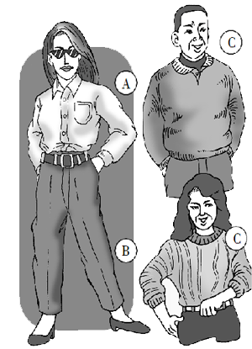
阅读上文,根据图片提示和文字内容,完成下列订购表格。(答案写在答题纸上)
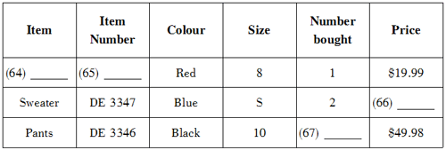
E
Sense of Touch
Touching
Touch is very important to us. It helps us collect information about things around us. When we touch something we know if it is hard like a stone, soft like cotton wool, rough(粗糙的) like the bark of a tree or sharp like a pin. | 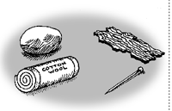
Keeping us safe
We know through touch when things are hot and cold. If something is very hot, a message is sent to your brain to pull your hand away quickly so that you won’t get burnt.
Blind people
Touch is very important to blind people because they can’t see. They rely on touching things to find out what they are. Blind people read by running their fingers over a page and feeling little lumps (凸起) that spell out the words.
根据短文内容,完成下列各句,每空词数不限。(答案写在答题纸上)
68. “Sense of touch” is the main heading. The sub-headings of this passage are ________. 69. Because ________________, touch is important to everyone.
70. If something is very hot a message will be sent to ________.
III. 完形填空(Cloze)(共20小题,计20分)
A) 阅读信件,根据其内容从方框中挑选合适的动词(组),并用其适当形式填空完成信件。每个词(组)只能使用一次。(答案写在答题纸上)
like, feel, have, go, hear, be, take care of, travel, say, worry about
Dear Mum,
How are you? We’re fine. Our trip (71)________ well. The only thing we (72)________(not) much is the food. For example, last night we (73) ________ dinner at six o’clock. That’s too early. Then I (74)________ very hungry at night. Apart from that (除此之外), everything (75)________ fine. People are very friendly. At home, we (76)________ much bad news about this country, but in fact it’s a great place.
We (77)________ to another country tomorrow. (78)________ (not) us. We can (79)________ ourselves.
By the way, Mary (80)________ she is stronger than before. ^_*
Much love,
Mick and Mary
B) 阅读短文,根据其上下文和首字母提示,在文中空白处填入适当的单词补全短文。每空一词。(答案写在答题纸上)
Answerphone:
Hello. This is the South Seas Travel Agency (旅行社). I’m sorry, n________(81) can speak to you right now. We moved to a________(82) part of town last month. We a________(83) have a new phone number. Please ring us a________(84) 847 2297. Our new a________(85) is 98 Warnock Road. It’s easy to f________(86)—it’s near the park, at the end of the road. We will open for business at our n________(87) office on 21st December. We have many exciting trips for holidays. And we have a p________(88) for anyone who spends (花费) $350 or m________(89) on a holiday. That is if your holiday costs more than $350, we will give you a travel bag f________(90). Thank you for calling the South Seas Travel Agency.
IV. 句型转换 (Patterns transformation)(共10小题,计10分)
A) 按要求转换下列各句。每空一词。(答案写在答题纸上)
91. Those foreigners liked hot pot very much. (对划线部分提问)
________ ________ those foreigners like hot pot?
92. Pass the note back to me. (改用委婉客气的表达方式)
________ you pass the note back to me, ________?
93. None of them agree to meet again. (改为反意疑问句)
None of them agree to meet again, ________ ________?
94. It’s going to be very sunny this afternoon. (对划线部分提问)
________ the ________ going to be like this afternoon?
95. It is a beautiful shot. (改为感叹句)
________ a beautiful shot it ________!
B) 根据上句改写下句,使两句意思相同或相近。每空一词。(答案写在答题纸上)96. The children must close their eyes now.
The children ________ ________ their eyes ________ now.
97. I don’t know where we can grow some vegetables.
I don’t know ________ ________ ________ some vegetables.
98. Holly’s best friend likes to do the same things as she does.
________ Holly ________ her friend ________ to do the same things.
99. Which apple should we give her, the bigger one or the smaller one?
________ we ________ her the bigger apple ________ the smaller apple?
100. The Smiths drive five hours to and from work every day.
________ ________ the Smiths five hours ________ drive to and from work every day.
V. 翻译(Translation)(共10小题,计10分)
A) 阅读短文,通过上下文语境提示,将划线部分的句子翻译成汉语。(答案写在答题纸上)
Different cultures have different ways to meet and greet (问候) people. (101) For example, in many Asian countries, it is polite to shake hands as a greeting. In Western countries between close friends, people greet each other with a kiss on the cheek. (102) When travelling in another country, just do as the Romans do.
(103) After greeting another person you need to find something good to talk about. The best thing is to look around and talk about your situation. Are you at a party? Talk about the party. Are you in school? Talk about the school. (104) It is not a good idea to ask very personal (私人的) questions when you meet someone for the first time. (105) When you know a person very well you may bring up questions like a person’s age.
B) 根据所给提示词,将下列句子翻译成汉语。(答案写在答题纸上)
106. 你认为谁能赢得这场比赛?(do you think)
________________________________________________________
107. 由于天气很遭,那天我们玩得一点儿都不好。(because of)
________________________________________________________
108. 他发现很难让她理解他。(very hard)
________________________________________________________
109. 我们现在都靠他在周五前完成工作。(depend on)
________________________________________________________
110. 他们能听到不远处水的声音。(far away)
______________________________________________________
VI. 智力测试(IQ)(共5小题,计5分)
按要求完成下列各题。(答案写在答题纸上)
111. What letter should replace the question mark?
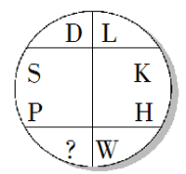
112. Change one letter only from each word to spell out an idiom (习语).
ACE FOUR ACE
113. Move one letter from the first word to the second word to make two new words.
Example: FEAR, CAN→FAR, CANE
① DREAR, SPOT → ________, ________
② STEAM, EAT → ________, ________
③ PLAIN, ATE → ________, ________
114. Four students live on the same road. Max lives 2 miles from the school. Claire lives twice as far away as Max. Jim lives between Max and Sue. Sue lives 1 mile from the school. Who lives farthest from the school?
115. Mike’s girlfriend left him. Their love was washed up. What does “washed up” here mean? You may answer it in Chinese or in English.
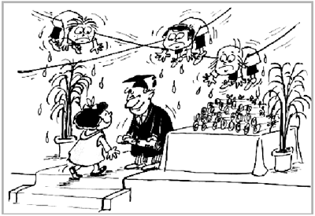
VII. 写作(Writing)(共2小题,计25分)
A) Tim Woods想要找一份兼职工作。以下是Woods在一份招聘单上做的标记以及他写在记事本上提醒自己要写在求职信里的几个要点。根据图片提示信息,以Tim Woods的口吻给Activity Centre写一封求职信,介绍自己的情况,信的开头和落款已给出。(作文写在答题纸上)
要求:1. 将图片中的信息体现在文章中;
2. 行文流畅,语法正确,单词拼写规范正确;
3. 单词数不少于60。
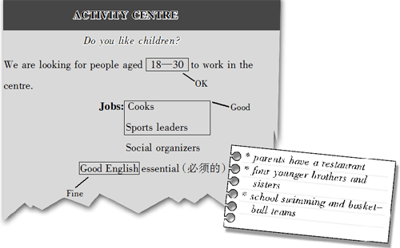
Dear Sir,
I’m a college (大学) student. I’m 20 years old...
______________________________________________________________________
______________________________________________________________________
______________________________________________________________________
______________________________________________________________________
Yours,
Tim Woods
B) 阅读下面一段叙述,针对其中提出的问题写出你的看法。(作文写在答题纸上)
James is your friend. He is not a very good student. He is not interested in school. Now he has an opportunity (机会) to get a full-time job, and his family needs money.
James wants to drop out of school (辍学) and go to work. He says he can learn more if
he stops going to school. But James is not very sure and he comes to learn about your ideas about leaving school.
要求:1. 叙述有条理,符合逻辑;
2. 用词得当,语法正确;
3. 书写清晰,规范;
4. 词数: 80—100。

