I. 单项选择（Vocabulary and structure）(共20小题，计20分)
A)选择能够替换划线部分的最佳选项。
31. Must I give the book back tomorrow morning?
A. return the book B. buy the book C. get the book D. find the book
32. There are more than five thousand people at the market.
A. over B. under C. below D. on
33. —When will we go to visit our grandmother? —What about tomorrow evening?
A. How long B. How far C. How about D. How often
34. I am still hungry. I want to eat two more hamburgers.
A. another two B. two another C. many two D. two others
35. Usually he leaves for school at around six.
A. goes to B. comes from C. flies to D. rides to
B) 选出下列各题的最佳选项。
36. Lucy can't go shopping, because she has _________ work to do.
A. much too B. too many C. too much D. a lot
37. There is _________ else in the box. It's empty.
A. something B. anything C. nothing D. everything
38. I had a _________ sleep last night. Did you sleep _________, Gina?
A. good; well B. good; good C. well; well D. well; good
39. Bruce likes playing _________ football, but his sister likes playing _________ piano.
A. / ; the B. the; / C. the; the D. / ; /
40. This city isn't the same _________ that city. They are different _________ each other.
A. from; as B. as; with C. with; as D. as; from
41. Sandy works very hard. They are sure that she will _________ in the end.
A. win B. came C. goes D. winner
42. Don't copy _________ homework. Do it by yourself.
A. each others' B. each other' C. each other's D. each other
43. _________ it was so cold, _________ he went out without a coat.
A. Although; but B. Although; / C. Because; so D. Because; /
44. Keep your window _________ when you sleep.
A. close B. closed C. opened D. opens
45. Mary is Tina's new friend, so Tina wants to know _________.
A. where does Mary live B. where do Mary lives C. where Mary lives D. where Mary lives in
C) 情景会话。
46. —Oh, I'm not feeling well. I've got a cold. —_________.
A. It's my pleasure B. Well, I'm sure to get well soon C. I'm sorry to hear that D. Fine. I'm glad to
47. —I like eating at a KFC restaurant. Food there is delicious and healthy!
—_________. Eating too much junk food is bad for your health.
A. That's right B. That's all right C. I really can't agree with you D. It doesn't matter
48. —What's your best friend like —_________.
A. She is fine. Thank you B. She is a doctor C. She likes watching TV D. She is helpful and kind
49. —Thank you very much for helping us. —_________.
A. That sounds great B. You're good C. Don't thank me D. You're welcome
50. —Would you like a cup of coffee? —_________.
A. Sorry, I won't B. Yes, give me a cup of tea C. Yes, please D. That's nothing
II. 阅读理解(Reading comprehension)（共20小题，计30分；51-60小题每题1分，61-70小题每题2分）
A
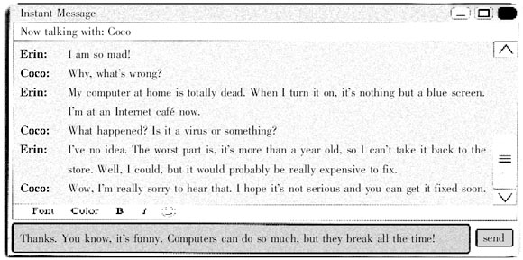
阅读上面的即时消息， 根据其内容选择最佳选项完成下列各题。
51. Why is Erin at an Internet café? Because _________.
A. it's the cheapest place to go onto the Internet B. her computer at home has a virus
C. she wants to drink coffee D. her computer at home isn't working
52. What's the problem with the computer?
A. It doesn't work at all. B. It works, but it can't go onto the Internet.
C. It runs slowly. D. The pictures of people are blue.
53. What does Coco think of Erin's problems?
A. She makes fun of Erin. B. She feels sorry for Erin.
C. She thinks it is not a bad thing. D. She tells Erin to be more careful in the future.
54. _________, so she can't take the computer back to the store.
A. The store closed over a year ago B. The store doesn't do a very good job
C. Erin has had the computer for over a year D. The store is full of busy people
55. _________ thinks computers are so good but that they don't often work.
A. Erin B. Coco C. Neither of them D. Either of them
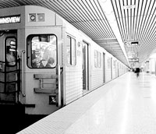
B
From London to New York, from Hong Kong to Moscow, subways are an important way of transportation. Traffic in modern cities is often quite heavy, and it can sometimes take hours to cross a busy city in a car or bus. Subways help solve that problem, since they don't have to stop at traffic lights, and hundreds of people can take a subway train together.
In larger subway systems， such as Mexico City's, there are lines that go far beyond the city centre. In this way, people living in the suburbs can take a train to work. This reduces(减少) the traffic entering and leaving a city. It also helps reduce air pollution, a big problem in many cities. Finally, subways are usually cheaper. Basically, in a city with a subway, everybody wins!
根据短文内容，从A，B，C，D, E中选择最恰当的一项补全下列各句。
56. Subways around the world __________________
57. Traffic in modern cities __________________
58. In larger subway systems people living in the suburbs __________________
59. Thousands of cars entering and leaving the city __________________
60. Travelling by subway doesn't take a long time __________________
A. increase (增加) air pollution.
B. can take the subway train to work.
C. are an important means of transportation.
D. because subways don't have to stop at traffic lights.
E. is often very heavy and it sometimes takes a long time to cross the city in a car or bus.
C
Mary
I lose things every day, but never very important things. I always find them again. The trouble is, when I find them it's too late. I don't need them any more! It really is annoying. For example, I need to post a letter so I look for the stamps I bought yesterday. Of course, I can't find them so I buy some more. (61) Every morning I spend at least ten minutes looking for my handbag. I get really angry because it's always in a stupid place.

Mike
I am usually very careful with my things. (62) However, there are some things which I can't keep. Umbrellas, for example. I buy two umbrellas every year. I put them down in shops, restaurants or in the cinema and I forget them. When I go back to get them, they're never there. Now I always buy very cheap umbrellas!

Jack
I always lose papers and keys—usually important papers. I also leave my phone card in the telephone. Last month I left my bag at the supermarket. Luckily, they phoned me and I went back to get it. Another thing I often lose is my car keys. Last week I lost them so I took the bus to work. When I got home I found them in the rubbish bin!
(A) 将文中划线的61、62小题的两个句子分别翻译成汉语。
(B) 根据文章内容回答下列各题。
63. Why is Mary angry every morning?
64. Where did Jack find his car keys last week?
D
How to Find out about the Weather
1. “Read ” the sky—look at the clouds. If they are fluffy (绒毛似的) and like cotton, the weather may be good that day. If they are dark and heavy, there may be rain or snow soon.
2. Notice the wind—look at the trees to see how hard the wind is blowing. Are the leaves falling?Are the branches moving or breaking? Is the wind blowing the trees down? If you can't see any trees, hold up a flag or a cloth to see how much it moves.
3. Check the rainfall—put out a jar to catch the rain. Add a ruler to its outside to see how much water is in it.
4. See how hot or cold it is—hang an outdoor thermometer outside a window on the north side of your house, because the north side of your house gets less direct sunlight. Make sure it is in the shade.
阅读短文，根据其内容完成下列各句，每空一词。
65. The passage is about how to find out about _________ _________.
66. Fluffy cotton-like clouds mean _________ weather.
67. An outdoor thermometer tells you how _________ or _________ it is.
E
Town Park
Opening hours:
8 am to 8 pm from 1st October to 30th April
10 am to 10 pm from 1st May to 30th September
Rules:
put litter in bins
no golfing
no cycling
keep your dog on a lead （绳索）
You are not allowed to:
—sleep overnight on the benches
—stay inside after closing time
—walk on the flower beds
—climb the trees

Swimming Pool
Opening hours:
10 am to 7:30 pm on weekdays
9 am to 9:30 pm at weekends
Rules:
—you must wear proper swimsuits
—shorts are not allowed
—an adult must stay with children under six at all times
—no running or jumping
—no smoking in the pool area
—food and drink are not allowed near the pool
阅读上面的公告，根据其内容回答下列各题。
68. When is the town park open on 30th July?
69. If Tom wants to take his dog to the town park, what should he do?
70. Lisa would like to have a drink when she goes swimming. Can she take drinks near the pool?
III. 完形填空(Cloze)(共20小题，计20分)
A) 用所给动词的适当形式填空。
Rebecca and Kerry （71）_________ （be） best friends. They sat next to each other in class. Rebecca and Kerry were both tall, with long dark hair. Everyone （72）_________ （think） they were sisters.
One day Rebecca couldn't go to school because she （73）_________ （have） a bad cold. So Kerry had to sit on her own in class, but not for long.
“Good morning, everybody. Today we have a new pupil. Her name is Sarah,” （74）_________ （say） the teacher, Mr Blake. “Sit next to Kerry, Sarah. Kerry will tell you all about your new school.”
Kerry and Sarah soon became friends. They were both very good at （75）_________ （dance） and Mr Blake asked them to make up a dance for the school show.
After a few days, Rebecca was better and （76）_________ （come） back to school.
“So what are we going to do for the school show, Kerry?” asked Rebecca.
Kerry （77）_________ （go） very red. “Well, I'm dancing with Sarah,” said Kerry.
Rebecca walked off and gave Sarah a nasty （令人不快的） look. Rebecca and Kerry didn't talk to each other all morning.
Later that day, Kerry （78）_________ （find） Rebecca talking to Sarah in the playground. They were both smiling.
“Sarah has a great idea,” said Rebecca. “She （79）_________ （want） to ask Mr Blake if the three of us can make up a dance for the school show.”
“So are we friends again?” （80）_________ （ask） Kerry happily.
“You bet!” said Rebecca, smiling.
B) 阅读短文，根据其上下文语境提示，用方框中所给单词的适当形式填空，每词只可用一次。其中有5个词多余。
quiet; back; too; others; but; at; funny; wrong; game; begin; either; watch; must; right; help
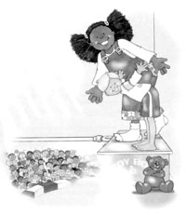
“Would you like to play another （81）_________?” asked the baby-sitter.
“No,” said Jacob.“I want Mom and Dad to come （82）_________.”
“I know,” said the baby-sitter. “（83）_________ for now, I am going to play circus（马戏团）.” She held out her arms and began to walk across an imaginary tightrope（护绷索）. “I want Mom and Dad to come back,” said Jacob. But he （84）_________ to walk across the imaginary tightrope, too. At last they reached the （85）_________ side.
“Hooray for us!” said the baby-sitter.
“Hooray for us!” said Jacob. The audience cheered while they took a bow.
Jacob heard the keys in the lock. He ran to the door and gave his parents a big hug（拥抱）.
“It's good to see you, （86）_________,” said his mother, smiling.
“Good-bye, Jacob,” said the baby-sitter. “I had （87）_________.”
A little while later, Jacob sat （88）_________, watching his father cook dinner.“What's （89）_________, Jacob?” his father asked.
“I want the baby-sitter to come back,” said Jacob. “But you and Mom （90）_________ stay at home, too.”
IV. 句式转换 (Pattern transformation) （共10小题，计10分）
A) 按要求转换下列各句。每空一词。
91. Mannuel often goes to school by bus. (就画线部分提问)
_________ does Mannuel often _________ to school?
92. Do it quickly. (改为否定句)
_________ _________ it quickly.
93. She spends a lot of time at weekends watching TV.(改为一般疑问句)
_________ she _________ a lot of time at weekends watching TV?
94. It will take Sam about fifty minutes to get there. (就画线部分提问)
_________ _________ will it take Sam to get there?
95. It is a nice watch.（改为感叹句）
_________ a _________ watch it is!
B) 根据上句改写下句，使两句意思相同或相近。每空一词。
96. What's wrong with you?
_________ the _________ with you?
97. Why don't we go to the seaside? It's very beautiful.
_________ _________ go to the seaside? It's very beautiful.
98. Book B is easier than Book A.
Book A is _________ _________ than Book B.
99. How do you like Chinese food, Ann?
_________ do you _________ of Chinese food, Ann?
100. Mr Black usually takes a train to work.
Mr Black usually _________ to work _________ train.
V. 翻译(Translation) （共5小题，计10分）
根据提示，将下列汉语句子翻译成英语。
101. 我可以问你一些有关你假期计划的问题吗？（ask... some questions about...）
_____________________________________________________________________
102. 也许你应该去看医生。（go to the doctor）
_____________________________________________________________________
103. 我想学习怎样使用电脑。（learn how to... ）
_____________________________________________________________________
104. 昨天他不得不帮妈妈做家务活。（ help ... with...）
_____________________________________________________________________
105. 汤姆喜欢听音乐吗？（enjoy）
_____________________________________________________________________
VI. 智力测试(IQ) （共5小题，计5分）
按要求完成下列各题。
106. In two years I will be four times older than my brother is now. My brother is 5 now. How old will I be when I am twice as old as my brother?
107. In each picture there is a hidden (隐藏的) number. Please find all of these hidden numbers.
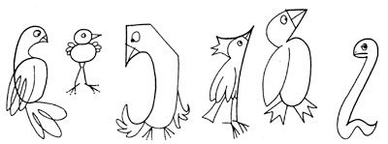
108. Which picture is different from the others？
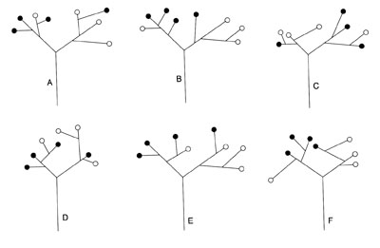
109. Which day is two days before the day after the day three days after the day before Tuesday?
Sunday | Monday | Tuesday | Wednesday | Thursday | Friday | Saturday
110. Tom wanted to pay for his meal at the restaurant, but the waiter said, “No, you don't have to do that. Today is my publican's (店主的) birthday, so all the food you had is on the house.” What does “on the house” mean here? You may answer it in English or Chinese.
VII. 写作(Writing) （共2小题，计25分；A部分10分，B部分15分）
A) 根据图片及文字提示编写一段短文。
要求：1. 将文字和图片中的信息体现在短文中；
2. 行文流畅；语句通顺；语法正确；
3. 词数在60左右。
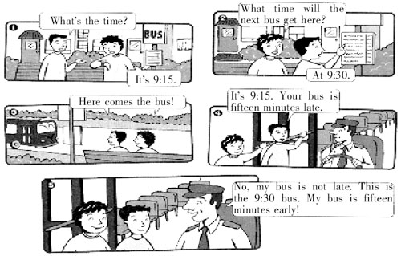
B) 针对下面的话题，结合自己的实际情况，写一篇短文。
Do you have a healthy lifestyle? What is your healthy lifestyle?
要求： 1. 叙述清楚，有条理性;
2. 语句通顺、自然；语法正确，使用多种句式；
3. 词数在80左右。
.

