思迪英语学校2010-2010学年第一学期四年级期中考试C卷
Name: Class: Score:
（时间：60分钟 满分：100分）
一、选出你所听的单词。（10%）
（ ）1、A、classroom B、wall C、floor
（ ）2、A、desk B、car C、hand
（ ）3、A、ant B、story-book C、boy
（ ）4、A、door B、sports C、picture
（ ）5、A、wall B、light C、floor
（ ）6、A、window B、wind C、math
（ ）7、A、seat B、many C、near
（ ）8、A、lights B、right C、eight
（ ）9、A、j B、b C、l
（ ）10、A、e m B、s v C、w q
二、听音，标号，将下面的句子按正确的顺序排序：（8%）
( ) Hello! Zhang Peng. Let’s go and see our new classroom.
( ) Hi, Mike. This is Zhang Peng, our new classmate.
( ) OK. Let’s go. Wow! It’s so big! Where is my seat?
( ) It’s near the window.
三、我的选择最正确。听录音，把正确答案的序号填进括号里。（10%）
( ) 1.My schoolbag is heavy.
( ) 2. The wall is blue.
( ) 3.I have many English books.
( ) 4.May I have a look?
( ) 5. What’s in the classroom?
( ) 6. This is Zhang Peng, our new classmate.
( ) 7. How many math books do you have?
( ) 8. Put your notebook in your desk.
笔试部分
- 默写26个字母,并圈出元音字母。（13%）

五、看图，写出各图单词中缺少的字母。)(5%)
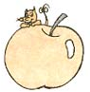
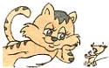
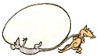
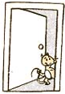
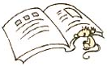

gg at pple ook oor
六、把单词补充完整，并写出中文意思。（15分）
1. c__mp__ter __________ 6.b__ __rd __________
2. p__cture __________ 7.cl__ssroom __________
3.w__ll __________ 8.fl__ __r __________
4.__ngl__sh book __________ 9.ru__er __________
5.f__fty __________ 10.fo__ty-one __________
七、我会选。将序号填到相应的空格内。（5分）
- nice B. have C. story-book D. May E. colour

1.Hello,Chen Jie.I _______a new schoolbag.
2.Really?What ___________is it?
3.I have many_________..
4. ___________I have a look?
5.How ____________!
八、根据图意,把句子补充完整。（16分）
1. Look this is my new_____________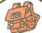.
- I have a ____________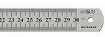,two ____________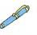and three_________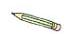in my pencil-case.
- In my desk,there are many___________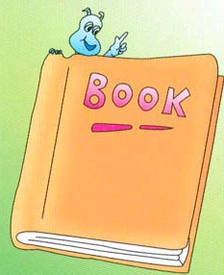.
- My___________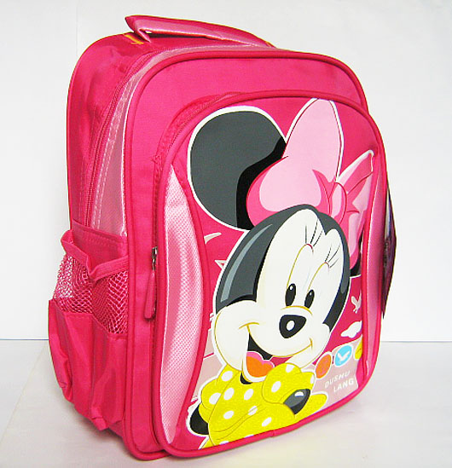is heavy.
- There are 20_______________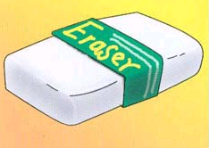and 38_____________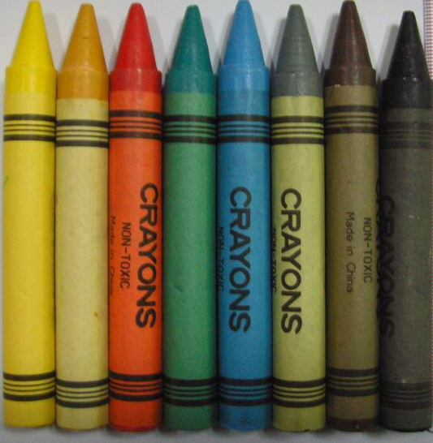.
八、用正确的格式书写下列句子。(5%)
We have 7 new lights..

Where is my seat?

Let me clean the window.

Look, 20 story-books,30 sharpeners and 40 pictures.

Tom, please turn on the light.

九、单项选择题。（15分）
( ) 1. --------How many __________do you have?
A. books B. books C. a book
( ) 2. Amy: May I have a look
A. Sure . B. Good idea! C.Good job!
( ) 3. __________clean the board.
A. Let’s me B. Let me C. Let us
( ) 4. My schoolbag ____________heavy.
A. is B. are C. am
( ) 5. Forty and one is_____________.
A. forty B. forty-one C. fifty-one

