柏恩英语四年级PEP上册Unit 5 练习题
姓名_____________ 日期____________
- 翻译
would like=___________ how much___________
five yuan_________ help yourself__________ cheers_______
let me try________ great________ soup________
- 选择正确答案
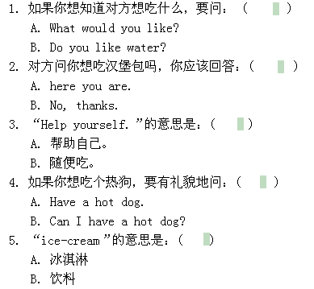
柏恩英语四年级PEP上册Unit 5 练习题
姓名_____________ 日期____________
- 翻译
would like=___________ how much___________
five yuan_________ help yourself__________ cheers_______
let me try________ great________ soup________
- 选择正确答案
三、补全对话
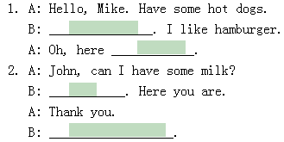
四、翻译句子
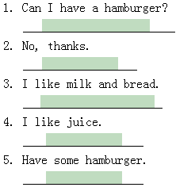
五、连词成句
have, chicken, I , can, some. ( ? )
- 补全对话
- 翻译句子
- 连词成句
have, chicken, I , can, some. ( ? )

