柏恩英语四年级PEP上册Unit 4 练习题
日期___________ 姓名______________
- 翻译
- isn’t=__________ 2.it’s=____________ 3.aren’t=_____________
4.they’re=_____________ 5.chair_________ 6.phone___________
7.bed__________ 8.沙发_____________9.书架_________
10.冰箱___________11.桌子___________ 12.钥匙______________
二、把下列句子变成一般疑问句并做肯定和否定回答。
1.They are cats.____________________________________
Yes, /No,they .
- Mom is in the living room.____________________________
_________________________________________
- I’m in the bedroom.____________________________________
__________________________________________
- It is a nice room._____________________________________
__________________________________________
- This is my home._______________________________________
________________________________________________
- You can see a bedroom.__________________________________
_________________________________________
- Zip is in the bathroom.___________________________________
_______________________________________
- We are friends._________________________________________
____________________________________________
- I’m a good boy.______________________________________
________________________________________
- They are in the door.____________________________________
___________________________________________
- 写出下列词汇的缩写形式
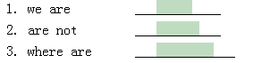
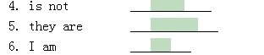
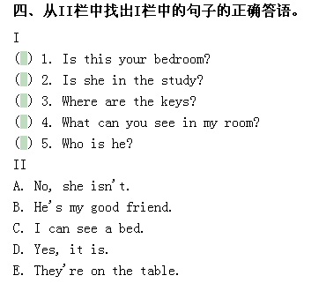
五、补全下列对话
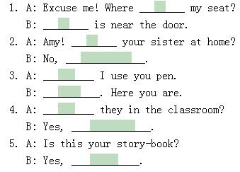
六、看图完成对话
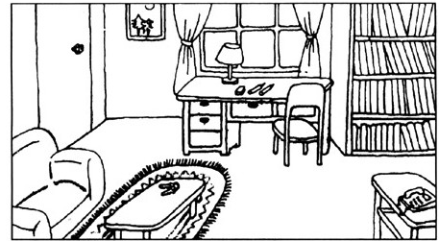
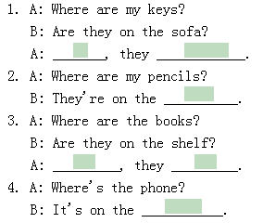
七、按格式要求抄写下列单词，并翻译
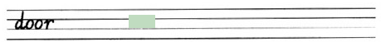
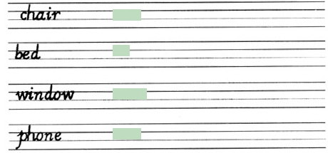
八、填上所缺动词
1._______ on the sofa.
2.________the bed.
3._________ TV.
4._____________ the phone.
5._________ the fridge.
6.________ the table.
7._________ the floor.
8._________ the window.
9._____ ____the light.
10._______the door.
九、补全Let’s chant
Mom’s in the ________ __________.
Dad is _______.
I’m in the __________.
Where ________ you ?

Brother’s in the _________.
Sister ____ too.
I ___ in the bedroom.
Where are you ?

