柏恩英语PEP三年级上册总复习题 1
姓名____________ 日期____________
- 看算式，用英语写得数
4＋5＝ 10－3＝ 2×3＝
24÷3＝ 4＋1＝ 7－2＝
1×6＝ 12÷6＝
二、填上合适的词，每空一词
1. are you?
2. ----- eat the cake.
----- !
3. Four and six is .
4. -----This is you.
----- !
三、读一读，把对话重新排列
A. Thank you.
B. I’m 10.
C. Let’s eat the birthday cake.
D. Hello, Mike.
E. Nice to meet you, too.
F. This is my friend, John.
G. How old are you?
H. Nice to meet you!
I. Happy birthday!
J. Great!
____________________________________________
四、在四线格上写出26个字母的小写形式
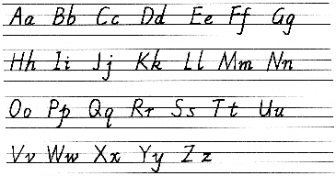

五、找出下列每一组中不同类的单词
( )1 A ruler B pen C bird D eraser
( ) 2 A car B coffee B tea D milk
( ) 3 A duck B cat C monkey D orange
( ) 4 A blue B yellow C white D hand
( ) 5 A Coke B six C one D three
六、选择正确的应答语，在括号内打“√”
1、Here you are. 2、what’s your name?
（ ）Thank you. ( ) I’m nine.
（ ）Yes,Jim. ( ) I’m Wang Dawei.
3、Nice to meet you. 4、how old are you?
（ ）Thank you. ( ) I’m ten.
（ ）Nice to meet you. ( ) Ok,Miss Zhou.

5、what’s this?
（ ）It’s a monkey. （ ）Ok,Let’s go.
七、Read and circle.(读单词，圈一圈)
（ ）(1) red A.红色的 B.黄色的 C.蓝色的
（ ）(2) brown A.熊猫 B.棕色的 C.面包
（ ）(3) green A.手指 B.粉红的 C.绿色的
（ ）(4) purple A.紫色的 B.钢笔 C.眼睛
（ ）(5) arm A.蛋糕 B.手臂 C.腿
八、Look and choose.（读读选选）请你给下列单词找出相应的图画，并将编号填入括号内
1. finger 2.eraser 3.head 4.mouth 5.rabbit
6. panda 7.eye 8. crayon 9.monkey 10.elephant
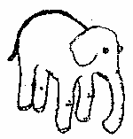



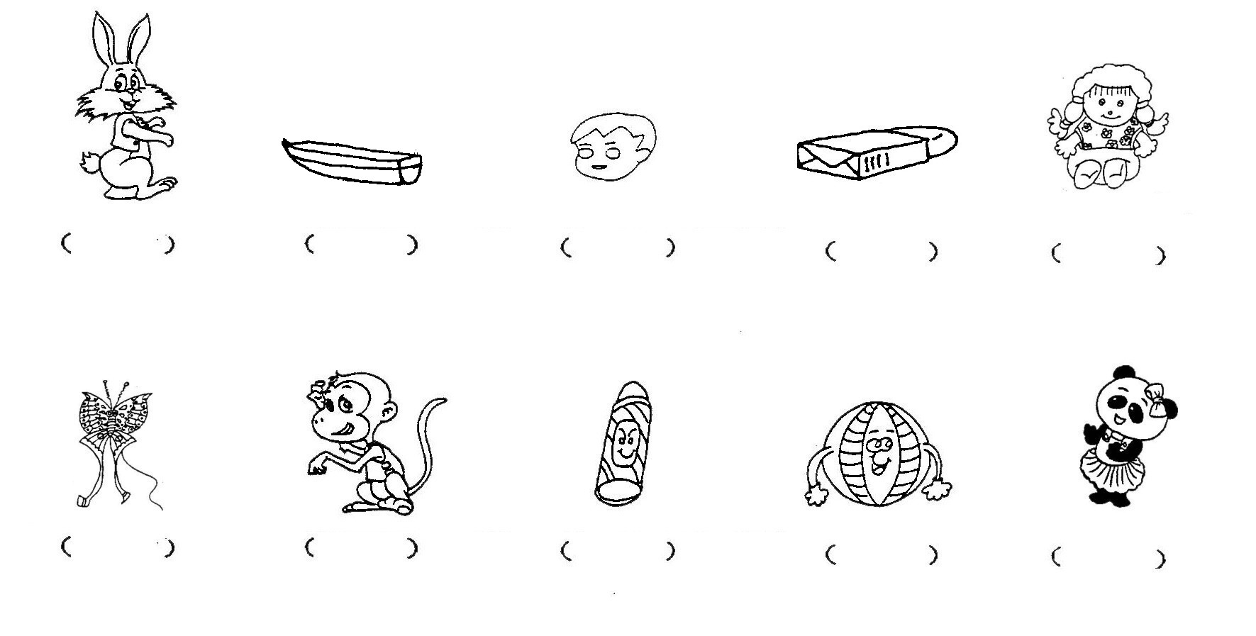
九、看图片，写单词
