Unit 2 What's the matter? 课外任务
广东省教育厅教研室

A. 阅读Anna 的信，在下面的地图上找出从火车站到她家的路线，并标明她的寓所、足球场、银行和学校。把序号写在横线上。
57 River Street
London
NW 74 EA
Dear Linda,
Thanks for your letter. I'm very happy that you can come on Sunday. When you drive to my house, It's easy to find the station. It's a little difficult after that. Here are some instructions. Drive past the station. You can't turn left into Garden Road. Go across the traffic lights into New Street. There's a football ground on your left. Go straight ahead past the bank, and turn left into Green Road. Turn left again into the High Street and River Street is the first on the right. My house is on the right opposite the school.
See you on Sunday!
Love,
Anna

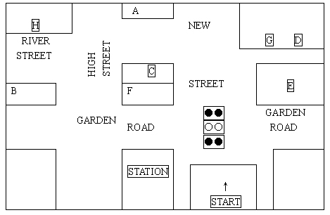

1. 在图中标出行走路线，用箭头指向Anna 的寓所。
2. Anna's House:
3. Football Ground:
4. Bank:
5. School:

B. 根据信的内容回答问题：
1. Who's the letter from?
2. When will Linda come to visit Anna?
3. Who doesn't live at River Street, Anna or Linda?
4. Is it easy or difficult to find the station?
5. How will Linda get to Anna's house?

Unit 2 What's the matter? 读写综合
根据所给提示编写对话。
Lily 得了重感冒、头痛和发烧，正在医生的诊所就诊，医生在给她看病并提出了一些很好的建议。

参考答案：
D: What's the matter, Lily?
L: Oh! Doctor. I have a bad cold and a headache.
D: When did it start?
L: Ever since last night.
D: Have you got a fever?
L: Maybe, but I didn't take my temperature.
D: I think you should lie down and have a good rest. Please have more water.
L: All right! And how soon will I be well?
D: In a few days.
L: Thank you very much.
D: You're welcome.

Unit 2 What's the matter? 语言要点

1. --- What's the matter?
--- I have a headache. You should go to bed.
--- He has a stomachache. He shouldn't eat anything for 24 hours.
--- She has a toothache. She should see a dentist.

2. see a doctor / dentist, get / have a cold, give advice, have a toothache, have a headache, have a stomachache, have a backache, have a sore throat, have a fever, lie down and rest, drink lots of water, drink hot tea with honey, a few, stressed out, listen to music, get tired, stay / keep healthy, at the moment, on the other hand, a balanced diet

Unit 2 What's the matter? 文化背景知识介绍

In the U. S., the medical treatment that you receive and the doctor or hospital that you can visit depends on the health insurance coverage that you have.

The two kinds of insurance are fee-for-service and managed care.

Fee-for-service: You go to the doctor of your choice. Your insurance company only pays for specific services, not for everything.

Managed Care: There are three types of managed care.

A. HMO (Health Maintenance Organization): You can only receive care from one hospital, for example.

B. PPO (Preferred Provider Organization): You can only receive care from specific doctors, for example.

C. POS (Point-of -Service): This plan is a combination of an HMO and PPO.

To see a doctor, you should call the doctor's office or the hospital to make an appointment. If it is an emergency, you can visit the emergency room of a hospital or make an emergency appointment with a doctor, according to your insurance coverage.

When you see a doctor, the doctor will give you a prescription for your medication. You must go to a pharmacy and give the prescription to the pharmacist in order to receive your medication. The pharmacist will often explain to you how to take the medication.

You can also purchase medication, which does not require a prescription. Such medication is also referred to as over-the-counter (OTC) drugs.

