内容 | Unit 5 Internatioal Charities  Check Out (8 B) |  |  |  |  | 命题人
姓名 |  | 班级 |  | 作业日期 |  | 等第
A. 课内训练巩固：
一、听力选择
A,根据你所听到的对话内容，选出能回答所提问题的最佳答案。（5分）
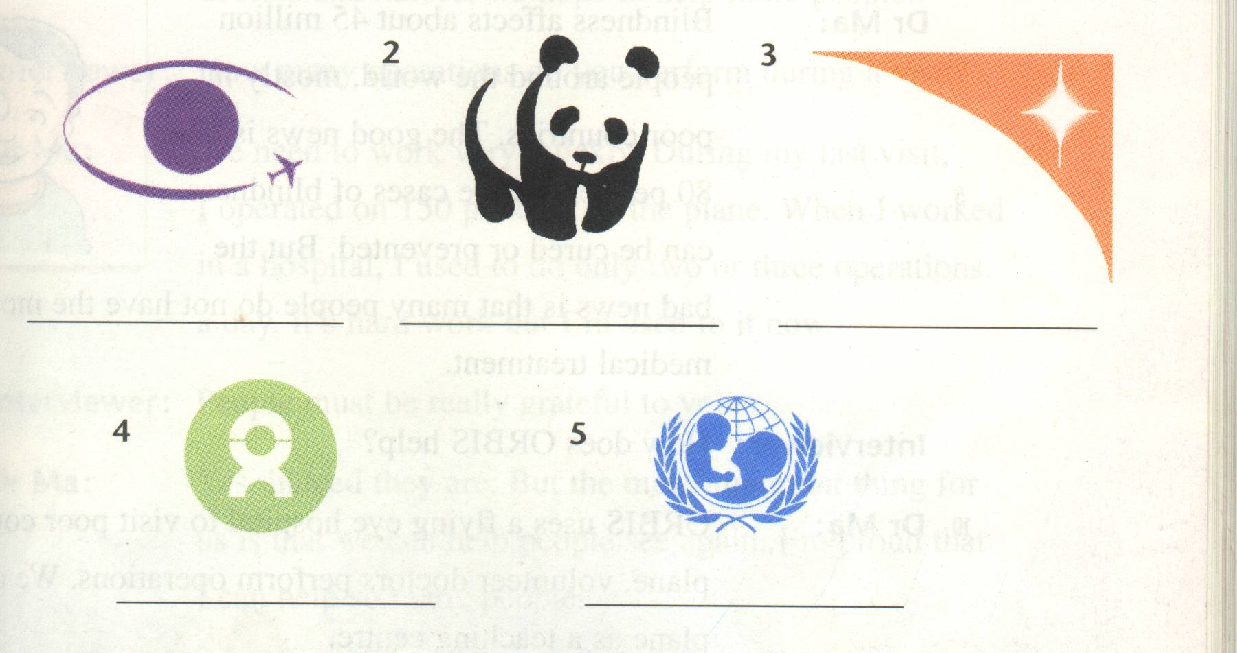
( )1. A. B. C.

( )2. A. It’s heavy and small. B. It’s small and light. C. It’s big and light.
( )3. A. Li Ping. B. Tom. C. Mary.
( )4. A. He hasn’t read the story. B. He doesn’t like the story at all.
C. He knows something about the story.
( )5, A. On Monday morning. B. On Tuesday afternoon. C. On Tuesday morning.
B. 根据所听到的短文及问题选择正确答案。（5分）
( )6. To whom did Grandpa Wu write this letter?
A. A journalist. B. A newspaper. C. The taxi company.
( )7, What did Grandpa Wu want to do last Thursday morning?
A. To take some exercise in the park. B. To call a taxi to the park.
C. To go to the nearest hospital.
( )8,. What happened to Grandpa Wu when he was crossing the road?
A. A taxi hit her and he fell on the road. B. He was knocked down by a young man.
C. He stepped on something and fell.
( )9, How long did Grandpa Wu have to stay in hospital?
A. For a few hours. B. For a day or two. C. For several days.
( )10. Which of these explains why Grandpa Wu wrote this letter?
A. He wanted to say his thanks to the doctors in the hospital.
B. He wanted to ask for help to find the taxi driver.
C. He wanted to find the taxi which had hit him.
二、单项选择：
( )1. When he lived in the country, he ____________ taking a walk after supper.
A. was used to B. used to C. is used to D. use to
( )2. The disabled people feel grateful _______ you ________ your help.
A. for; to B. to; for C. for; for D. to; to
( )3.Your pocket money can be used to _______ charity, you used to _______ a lot on snacks.
A. supporting; spend B. support; spending C. support; spend D. supporting; spending
( )4. It seems hopeless because there is little time ___________.
A. leaving B. left C. to leave D. leaves
( )5. The man died of blood cancer(血癌) because he had no money _______ medical treatment.
A. on B. for C. in D. with
( )6. We should _________ people _________ down trees.
A. prevent… to cut B. prevent… from cutting C. prevent… of cutting D. prevent…cut
( )7. My mother learned English _________ the radio when she was young.
A. by B. on C. in D. with
( )8. The doctors use the plane ______ a teaching center to train them ______ nurses.
A. as; as B. to; for C. for; as D. as; for
( )9. Is there ___________ you want to say to me?
A. something else B. else something C. anything else D. else anything
- 所给词的正确形式填空.
1. If a person ________________ (educate) well, he will have a better future.
2. As a matter of fact, he spends much time _____________________ (protect) wildlife.
3. With the ____________(develop) of modern medicine, many cases of blindness can be cured.
4.The ____________ performed very well in the show, we were satisfied with their _______ (perform)
5 Many difficult _________(ill) can be cured nowadays.
6.I think my life is ____________________ than before because I have quite a lot to do. (mean)
7.When I arrived at the hospital, the doctor ___________________ on the boy. (operate).
8. He looked at me with _________________, what a lovely giant panda! (gentle)
9. Everyone can __________ well because the hospital provides excellent medical _________ (treat).
10.UNICEF____________(set) up in 1946.
四、句型转换(10分)
1.The doctors are performing an operation on the patient. （同义转换）
The doctors are ______________ ___________ the ___________________.
2.My parents told me: “We will buy you a gift on our way back.” （转换成间接引语）
My parents told me that ______ _______ buy ________ a gift on __________ _______back..
3 The little girl said, “ I am afraid of dogs.”
The little girl said __________ __________ __________ afraid of dogs. （同义转换）
4. I didn’t watch TV last night, I did my homework last night.
I did my homework ____________ _____________ _________ TV last night.
五、阅读理解
1970 was World Conservation Year. The United Nations wanted everyone to know that the world was in danger. They hoped something could be done.
Here is one example of the problem. At one time there were 1,300 plants, trees and flowers in Holland, but now only 866 are left. The others have been destroyed by modern man and his science. We are changing the earth, the air and the water and everything around us. We can't live without these things. If things go on like this, we shall destroy ourselves.
What will happen in the future? Perhaps it is more important to ask, "What must we do?" More and more young people have known this. Many of them are helping to save our world. For example, they plant trees. In a small town in the United States a large group of girls cleaned the banks of 11 kilometers of their rivers. Young people may hear about conservation through a song called "No one's going to change our world". It was made by Gliff Richard and other singers. The money from it will help to conserve tigers, elephants and pandas on the earth.
（ ）1. The United Nations hoped something could be done___________
A. to develop the world B. to change the world
C. to conserve the world D. to destroy the world
（ ）2. Why aren't there so many plants, trees and flowers in Holland now? Because_______
A. people there don't need so many plants, trees and flowers
B. people there want to destroy themselves
C. little conservation has been done there D. people need more land to live on
（ ）3. We shall destroy ourselves if we go on ___________
A. changing the earth, the air and the water around us B. planting trees and flowers
C. helping to conserve tigers, elephants and pandas D. saving the world
（ ）4. What must we do now according to（根据） the passage?
A. Save the world. B. Clean the banks of rivers. C. Sing songs. D. Get money.
( ) 5,Which of the following words means “conserve”?
A. “ cause” B. “development” C. “celebrate” D. “protect”

听力材料
听力选择（共10小题，每小题1分；满分10分）
A,根据你所听到的对话内容，选出能回答所提问题的最佳答案。（5分）
1, A: What does charity do, Hobo?
B: It helps to cure the people who are blind.
Q: Which charity are they talking about?
2.A: That’s a big box. Is it heavy? Please let me help you.
B: No, thanks. It’s big but it isn’t heavy. There’s nothing in it. Look!
Q: What is the box like?
3.A: Mary, shall I help you repair the bike?
B: No, thanks. Let Li Ping do it. Q: Who will repair the bike?
4.A: How do you like the story?
B: Sorry, I know nothing about the story. Q: What does the man mean?
5. M: Do you think you can get the speech ready on Monday morning?
W: I don't think so. Tuesday afternoon will be the earliest time.
Q: When will the speech be ready?
B. 根据所听到的短文及问题选择正确答案。（5分）
Last Thursday, something unusual happened to Grandpa Wu. Here is a letter he wrote to the newspaper.
"Last Thursday morning, I went to the park for some exercise. As I was crossing the road, I stepped on something and fell. Just at that moment, a taxi stopped behind me. The driver got out and came up to me. He said, 'How are you feeling'? Don't worry. Let me take you to hospital.'He quickly helped me to get into his taxi and drove me to the nearest hospital. I had to stay in hospital for several days. As I was lying in bed, I wanted to say 'Thank you' to the driver. I looked around, but the driver had already left. I feel much better now. I hope to find the driver as soon as possible. He helped me when I needed it most. Could someone help me to find him, please?"
GrammarA :
C D B B A / B D B B A

