Unit 2 I used to be afraid of the dark.(Period one)教学设计
安徽省合肥市第45中学 解光荣
I. Analysis of the Teaching Material
This unit is aiming at talking about what the people used to be like with the pattern of used to be, used to have, used to like. All the activities are carried out around the topic of how to describe the people's appearance and personality. The first teaching period serves as an introduction and lead-in part. During this part the goal was introduced and the main topic of this unit also was presented. Just like a warming up it plays, it is acceptable to review what has been learned in the last unit and to transfer to the new language. The materials in talking are mostly from the recent real life and are familiar to the students. A series of questions with pictures and a big picture are used to attract students to the knowledge.
Ⅱ. Analysis of the Students
As Junior 3 students, they would like to talk about the changes between a person in the past and now. They have learned some words about how to describe the people's appearance and personality like short, tall, long hair, short hair, kind, friendly, serious, shy and so on. So it is easy for the students to listen about, talk about or write about what the people used to be like. Such topic will remind students of the days of their childhood. So it is also helpful to raise learning interest of students and students will be active in all the activities in this unit.
Ⅲ. Overview of Lesson Plan
The first period introduces a lot of words describing people first. And then students will be provided listening and oral practice using the target language. So in this lesson, students will learn how to describe the people's appearance and personality. They will share opinions about the changes between a person in the past and now by comparing, listening and talking.
IV. Objectives
1. Knowledge Objectives
Students will learn to talk about what they used to be like and they will learn and grasp the structure used to, including statements, yes / no questions and short answers.
2. Ability Objectives
Students will train their own integrating skills by comparing, brainstorming, listening, talking, reading and writing.
3. Moral Objectives
Students will know that everyone surely changes. If someone is afraid of speaking in front of the class, encourage her/him not to be shy. "More practice, and you'll feel more confident."
V. Teaching Key Points
1. To learn the key vocabulary and the target language
a. Key vocabulary: outgoing, friendly, serious, quiet, curly hair, straight hair
b. Target language: I use to be quiet. / She used to have long hair./...
2. To learn the usage of the structure used to.
--- You used to be short, didn't you? --- Yes, I did. / No, I didn't. He is tall.
--- Did Tony use to play the piano? --- Yes, he did. / No, he didn't.
They didn't use to like tests.
VI. Teaching Difficult Points
1. To improve students' listening, speaking skills.
2. To enable students to grasp the usage of the structure used to.
VII. Resources
1. A tape recorder.
2. Some posters.
3. Some photos.
VIII. Teaching Time
45 minutes.
Ⅸ. Procedures
Step 1. Pre –listening
This activity will introduce a lot of words describing people first. And then students are provided listening and oral practice using the target language.
--- Mario used to be short. --- Yes, he did. Now, he's tall.
1. Warm-up (1a)
Show some posters to the students and introduce the key vocabulary. Let them describe the people's appearance and personality by comparing and brainstorming .Call their attention to the chart with the headlines.
Appearance: tall, short, long hair, short hair,good-looking, thin, strong, ...
Personality: outgoing, funny, quiet, shy, friendly, kind, warm-hearted
a. Look at the pictures and describe the appearance.
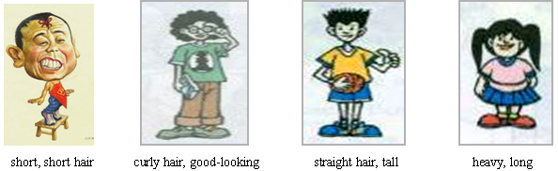
b. How can we describe the personality?
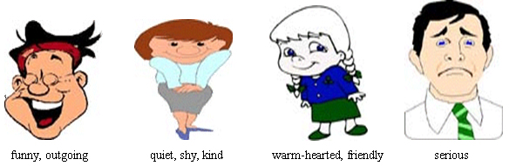
2. Presentation
Show students some photos in the past and now. Let students compare and practice to understand the target language "used to be" in spoken conversations.

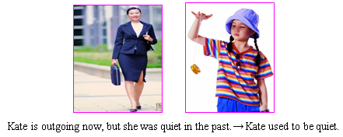
3. Explanation
When we talk about the things that have changed, we can use "used to".
e.g. Tom used to be short. Now he is tall.
She used to have short hair. Now she has long hair.
Mary used to like eating meat. Now she likes eating vegetables.
Step 2. While-listening
The activity will give students practice in understanding the target language in spoken conversation.
1. First listening
Bob is seeing some friends for the first time in four years. What did his friends use to look like?
a. Play the recorder and let the students listen and fill in the chart. (1b)
1. Mary used to short . He used to wear _glasses_ .
2. Amy used to be _tall . She used to have _short hair .
3. Tina used to have _red and _curly hair .
b. Pairwork
Let students have some more practice. The students look at the chart and make conversations in pairs. (1c)
Name | Sep.18, 2008 | Sep .18, 2000
Yang Lan | tall | short
Mary | long hair | short hair
Mrs. Liu | serious | funny

2. Second listening
Play the recorder and let the students listen and check the words they hear. (2a)
_______ shy | _______ serious
√ friendly | _______ funny
__√___ outgoing | √ quiet
3. Third listening
Play the recorder again and let the students listen and fill in the blanks with the words they hear. (2b)
Paula: Hey, Steve! Over here! Don't you remember me?
Steve: Oh, wow! You're Paula , aren't you？
Paula: That's right.
Steve: But you used to be really __quiet ，didn't you？
Paula: Yeah. I wasn't very outgoing .
Steve: No, you weren't. But you were always friendly . Wait a minute! Did you use to play the piano?
Paula: Yes, I did. But now I'm more interested in sports. I play soccer and I'm on the swim team.
Steve: Wow! People sure change.
Step 3. Post-listening
This activity is helpful to improve students' speaking skills. In this activity, we will introduce more words to students to extend their vocabulary and we will provide more oral practice to them using both the old and new target language. They make conversations about peoples' appearance and personality, and they can also talk about the peoples' hobbies.
1. Pairwork (2c)
Tell the students to practice the conversation in activity 2b. Then make conversations about themselves in pairs. They can use...
A: Hello! You're Zhu Guoming, aren't you？
B: Yes, you're right.
A: But you used to be really quiet, didn't you？
B: Yeah. I wasn't very outgoing.
A: No, you weren't. But you were always friendly. Wait a minute! Did you use to play the piano?
B: Yes, I did. But now I'm more interested in sports. I play soccer and I'm on the swim team.
A: Wow! People sure change....
2. Talk about their photos in pairs
Before class, let each student prepare two photos. One was taken in the past, and one is taken now. Now, let them take out their own photos and make conversations about their changes in pairs by comparing the two photos. Then ask some pairs to act their conversations out in front of the class. In this activity, students will practice the target language by listening and speaking. Encourage her/him not to be shy. "More practice, and you'll feel more confident." Help to build the students confidence.
3. Guessing games
In this activity, students will use the target language to get more detailed information of their classmates. Students are fond of such activities. So they are helpful to improve students' spoken English. From the game, let students find out the usages of used to and then summarize the usages of used to.
a. First the teacher plays the guessing game with the whole class as a modal. Saying "Can you guess what I used to be like?" Let students guess.
Student 1: Did you use to be thin?
Teacher: Yes, you're right. I used to be thin, but now I'm heavy.
Student 2: Did you use to have short hair?
Teacher: No, I used to have long hair.
Student 3: Did you use to like running?
Teacher: Yes, I used to like running, but now I have no time to run.
...
b. Ask three or four students to come to the front of the class and play the game with the whole class. Teacher will give them some help if they need.
Step 4. Summary
This activity will help students to summarize the usages of used to.As students say, teacher will write them on the blackboard.Students can say in Chinese.
Teacher: What have we learned today?
Student A: Today we have learned the statement of the usages of used to.
e.g. ---You used to be short, didn't you? --- Yes, I did. / No, I didn't.
Student B: And we have also learned the yes/no questions and short answers of the usages of used to.
e.g. --- Did Tony use to play the piano? --- Yes, he did. / No, he didn't.
Student C: And we have also learned the negative sentences of the usages of used to.
e.g.They didn't use to like tests.
Step 5. Homework
This activity will help students to consolidate the target language we have learned today. From students'homework, teacher will find out that what the students have mastered and what they haven't mastered and decide what will do in the future teaching.

Unit 2 I used to be afraid of the dark.

Appearance: tall, short, long hair, short hair,good-looking...
Personality: outgoing, funny, quiet, shy, friendly, kind, warm-hearted
Grammar Focus:
--- You used to be short, didn't you? --- Yes, I did. / No, I didn't.
--- Did Tony use to play the piano? --- Yes, he did. / No, he didn't.
She used to be really quiet.
They didn't use to like tests.
He used to have long hair.

