鄂州市2015年初中毕业生学业考试
英 语 试 题

学校： 考生姓名： 准考证号：
注意事项：
1．本试题卷共8页，满分120分，考试时间120分钟。
2．答题前，考生务必将自己的姓名、准考证号填写在试题卷和答题卡上，并将准考证号条形码粘贴在答题卡上的指定位置。
3．选择题每小题选出答案后，用2B铅笔把答题卡上对应题目的答案标号涂黑。如需改动，用橡皮擦干净后，再选涂其他答案标号。答在试题卷上无效。
4．非选择题用0.5毫米黑色墨水签字笔直接答在答题卡上对应的答题区域内。答在试题卷上无效。
5．考生必须保持答题卡的整洁。考试结束后，请将本试题卷和答题卡一并上交。
第一部分 听力测试
Ⅰ. 听力测试（共三节，20小题，满分25分）
第一节：听描述或对话, 选图画。听下面2段描述和3段对话。听完以后，从A、B、C三幅图画中选出正确的一幅。每段描述和对话读一遍。（共5小题，每题1分，计5分）
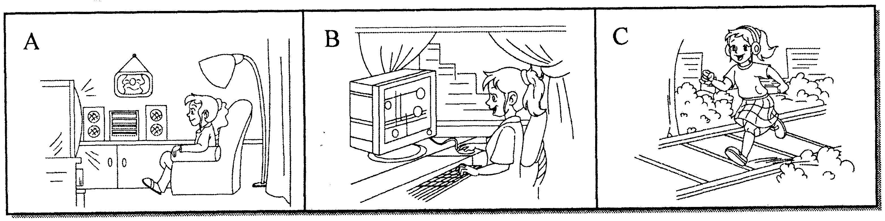

1.

2.

3.

4.

5.

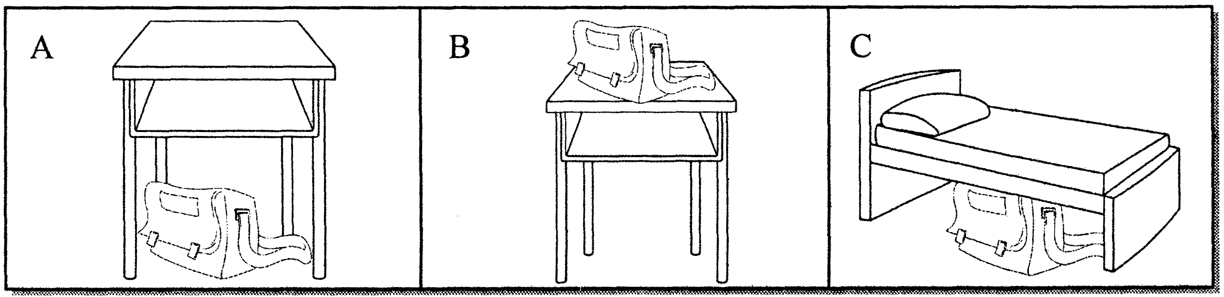

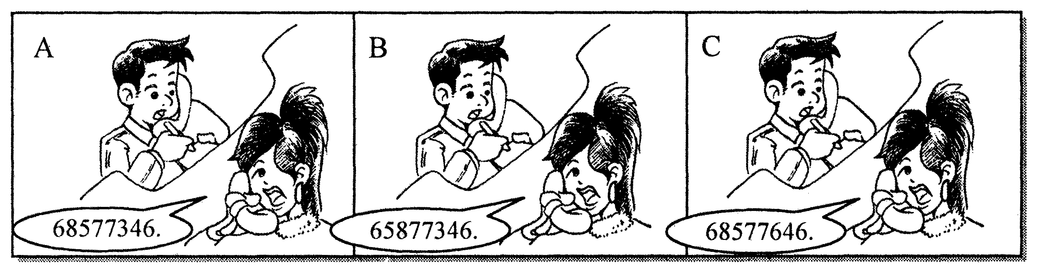

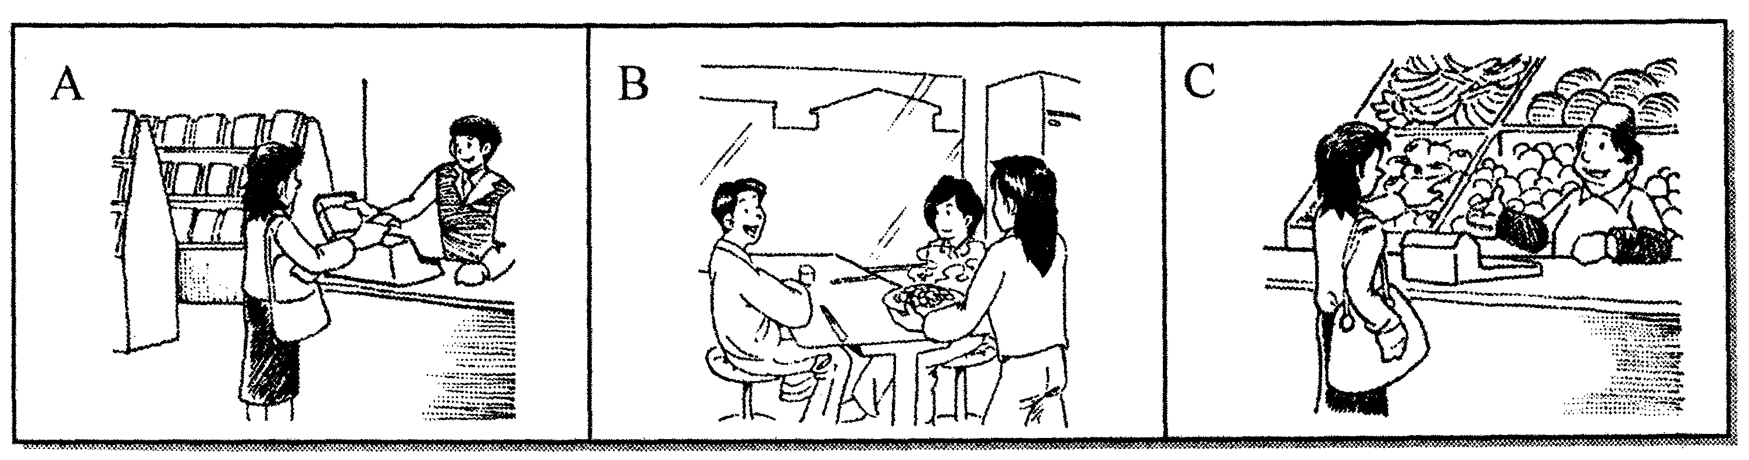

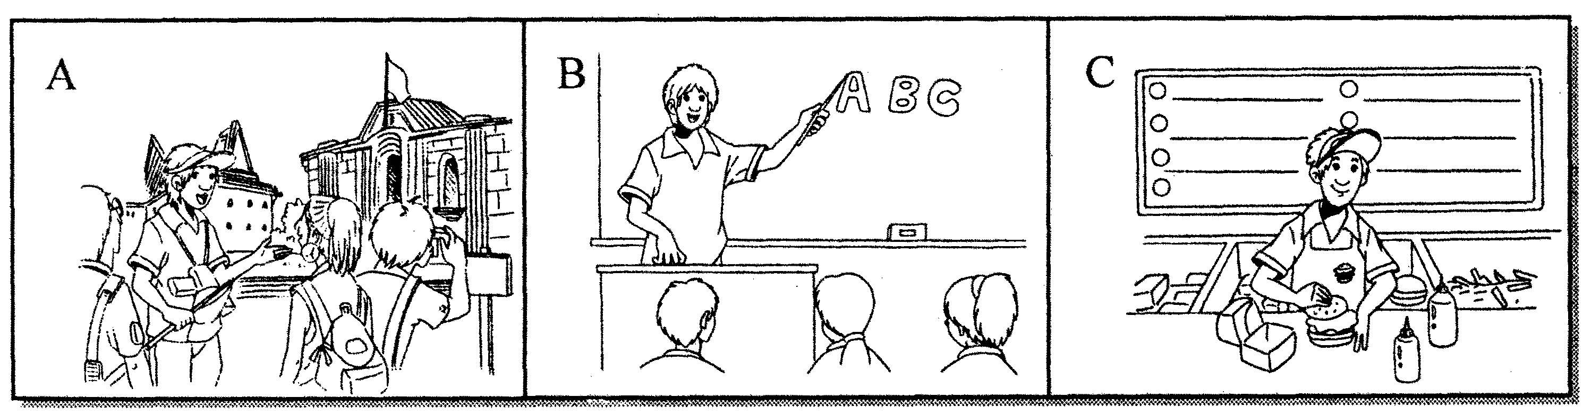

第二节：听对话，选答案。听下面4段对话。根据所提的问题，从A、B、C三个选项中选出最佳答案。每段对话读两遍。（共10小题，每题1分，计10分）
听第六段材料，完成第6、7小题。
6. What show is Paul watching?
A. A TV play. B. Music videos. C. A football match.
7. Why doesn’t Paul’s grandma sit down and watch?
A. Because she is tired. B. Because she has watched it.
C. Because she doesn’t like what Paul likes.
听第七段材料，完成第8至10小题。
8. Where will the two speakers go for the picnic?
A. In James’ house. B. In the mountain. C. In the park.
9. How will the two speakers go there?
A. By bike. B. By boat. C. By bus.
10. Who will go with the two speakers?
A. Jacky. B. Betty. C. James.
听第八段材料，完成第11、12小题。
11. Why doesn’t the man like his job?
A. Because he feels lonely. B. Because he has to work at night.
C. Because he meets all kinds of people.
12. Where does the man want to work?
A. At the Great Wall Hotel. B. At the Garden Hotel.
C. At the Golden Hotel.
听第九段材料，完成第13至15小题。
13. What time did Mr. and Mrs. Taylor get up yesterday?
A. At five. B. At six. C. At half past six.
14. What kind of farm work did Mr. Taylor do this morning?
A. Milked the cows. B. Collected the eggs.
C. Watered the vegetables.
15. How often does Mr. Taylor milk his cows?
A. Twice a day. B. Three times a day.
C. Once a day.
第三节：听短文，选答案。听下面一段短文。根据短文内容选出最佳答案。短文读两遍。（共5小题，每题2分，计10分）
16. When do some students take jobs in England?
A. After school. B. During the winter holidays.
C. During the summer holidays.
17. How old must the students be if they want to take jobs?
A. At 18 years old. B. At least 16 years old.
C. More than 16 years old.
18. Where do the students find jobs?
A. In business centers. B. In police stations.
C. In factories.
19. How long do the students work a day?
A. Five or six hours. B. Eight hours.
C. Both A and B.
20. Why can some students take jobs at that time?
A. Because many of the workers want to go abroad to spend their holidays.
B. Because many of the workers are tired and want to stay at home.
C. Because the students want to make money for their daily life.
第二部分 语言知识
Ⅱ. 单项选择 (共15小题，每题1分，满分15分)
从A、B、C、D四个选项中选出最佳选项。
- — Do you know _________ this iphone5 belongs to?
— Let me see. Oh, it’s __________.
A. whose; her B. whose; hers C. who; her D. who; hers
22. — I always get nervous when I start a(n) _________ with others.
—Take it easy. Believe in yourself.
A. expression B. introduction C. communication D. celebration
- — Would you please provide us _________ some information about the school
sports meeting?
— Sure. It’s said that it will start _________ the morning of September 20th.
A. for; on B. with; on C. for; in D. with; in
- — you come to my party on Sunday?
— Sorry, I’m not available. I study for the math test.
A. Can; must B. Must; can C. Need; may D. May; can
25. — China’s hot words, like tuhao, dama and renxing, ________ widely in the
western media (媒体) last year.
— Really?
A. use B. are used C. used D. were used
- — I hope to be a volunteer on weekends.
— You could help to ________ the city parks.
A. cheer up B. make up C. take up D. clean up
- — What do you think of lemon?
— Terrible. I like fruit ________ tastes sweet.
A. who B. what C. which D. when
- — What do you remember about Grade 7?
— I remember _______ a prize.
A. to win B. winning C. win D. wining
- — Is Tina ______ than Tara?
— Yes, but Tara is ________ in her class.
A. taller; the heaviest B. tall; heavy
C. taller; heavier D. the tallest; the heaviest
30. — What _______ Candy _______ just now?
— Sorry, I didn’t hear it. I _________ up the phone.
A. was...saying; was picking B. did...say; was picking
C. does...say; am picking D. did...say; pick
- — I’m sorry to have kept you waiting long.
— Never mind. I __________ here for only a few minutes.
A. came B. have been C. have come D. had come
- — What’s the secret of success, Dad?
— More time and effort, _________ you’ll make it some day.
A. or B. then C. but D. and
33. — Do you know the song Where has the time gone?
— Sure. It ________ beautiful. I like it a lot.
A. smells B. tastes C. sounds D. looks
34. — Be careful when you are driving, ________ in a rainstorm like this.
— Thanks. I will.
A. seriously B. exactly C. especially D. probably
35. — The light in his room is still on. Do you know _______?
— Maybe at midnight again.
A. what’s he doing B. why he stays up so late
C. if he is busy studying D. when he will stop working
III．完形填空（共10小题，每题1分，满分10分）
阅读下面短文，从A、B、C、D四个选项中选出最佳选项，使短文完整、通顺。
It was the first time that my wife and I had flown first class. As we boarded the plane, we felt as if (好像) we were 36 of a wealthy group. We were filled with a sense of pride at 37 with those important people.
We 38 that the stewardess (空姐) was working non-stop to make sure of the comfort of the first class passengers. She could not walk by a seat 39 being given an order. I thought she must love her job very much, since she gave each person such a big 40 .
As the stewardess 41 our seats near the end of the flight, I looked up at her and said, “Thank you and I hope you have a great night.” She stopped with a look of disbelief on her face, and said: “Excuse me?” I 42 my words and she smiled in a rather funny way. It seemed as if I had asked a question that she did not know how to 43 . A little later, as we were getting off the plane, the stewardess said to me: “Thank you very much, sir.” Then she said 44 : “You are the only passenger who has thanked me or said anything nice to me all night. I really appreciate your kindness.”
The sense of belonging to an elite(精英) group in first class 45 as soon as I heard those words. We were reminded that without kindness, there would be no first-class flying.
36. A.one B.part C.member D.sign
37. A.sitting B.driving C.getting D.taking
38. A.showed B.surveyed C.noticed D.looked
39. A.without B.while C.after D.for
40. A.excitement B.shyness C.smile D.sadness
41. A.passed B.walked C.crossed D.went
42. A.repeated B.spoke C.talked D.wrote
43. A.decide B.answer C.discuss D.consider
44. A.loudly B.suddenly C.sadly D.quietly
45. A.remained B.appeared C.disappeared D.continued

第三部分 阅读理解
IV.阅读理解（共20小题，每题2分，满分40分）
阅读下面四篇材料，根据其内容，选择正确答案或完成阅读任务。
A
MARS— The Red Planet
“MARS—The Red Planet!” is one of our Early Reader Space books. It has surprising facts and photos explaining all about Mars. Aiming mainly at kids aged 7—10, it’s an interesting way for readers to find out more about the red planet.

The Weather
“The Weather” is one of our Early Earth books for boys and girls aged 13—15. This is a fun and fantastic way for readers to find out more about the weather on our earth. It offers information in a fun way—mixing facts, photos, and even has a web page with video clips explaining more about the information in the book.

Horses
Kids Book of Fun Facts & Amazing Pictures on Animals in Nature — A Perfect Horse Book for Kids Aged 5—8.
The book written by Kate describes the most noble animal on the planet for early readers. The book is packed with beautiful and clear pictures that help your child to understand the (fun) facts about this animal. It also includes anatomy(解剖) of horses.

46. If your sister wants to know more about the space, she can choose ________.
A. MARS —The Red Planet! B. The Weather
C. Horses D. The Earth
47. “The Weather” is one of our Early Earth books for boys and girls aged ________.
A. 5—8 B. 13—15 C. 7—10 D. 8—13
- “Horses” is about ________.
A. the most noble animal on the planet
B. the weather on our earth
C. the red planet
D. a web page with video clips
49. Which is true according to the ads(广告) above?
A. The Weather is about the Moon.
B. Horses was written by Kate.
C. MARS—The Red Planet! is about the most noble animal.
D. Horses is a perfect book for kids aged 7—10.
50. The subject of the three books is on ________.
A. history B. geography C. science D. math

B
One morning, Wu Liang discovered that her classroom had changed. She found that the desks were no longer in rows, but pushed together to make eight bigger desks. She was so excited about it for the first two days that she couldn’t listen to the teachers carefully. But soon she and her classmates got used to this new classroom arrangement (安排). “Now our class is quieter,” said Wu. “What’s more, we can come up with our own ideas and learn more through discussion. It’s a better way to study.”
Li Yu liked it, too. “Group members first discuss,” he said, “and then present to the whole class. It makes us believe in ourselves.” This was part of a reform (改革) at Li’s school. The school made this reform because they wanted to offer students easier ways to study and more chances to discuss. “Our school hopes to improve students’ abilities to study by themselves and work in groups.” said Zhang Ming, an English teacher.
However, the reform has demanded more from teachers. Now they have only 15 minutes to give a lesson that would have been taught in 45 minutes before. It is difficult to teach in such a short time. The teachers have to find better ways to teach more effectively.
“The reform demands more, but I’m sure it is helpful.” added Zhang Ming.
51. It was easier for Wu Liang to _____ in class after the new classroom arrangement.
A. discuss with other students B. sit in the classroom
C. push desks together D. teach a lesson
52. The school made the reform in order to offer students ______ to study.
A. larger space B. easier ways C. more seats D. better classrooms
53. The Chinese meaning of the word “effectively” in Paragraph 3 is ______.
A. 简单地 B. 明确地 C. 有效地 D. 认真地
54. Which of the following sentences is wrong?
A. Wu Liang and her classmates like the new classroom arrangement.
B. The desks are no longer in rows now.
C. The reform has demanded more from teachers.
D. It’s easy for teachers to give a lesson in 15 minutes now.
55. The best title of this passage may be “______”.
A. Discussion in Class B. New Look in Class
C. Students’ Friendship D. Teachers’ Hope
C
Wonder why you can get angry so easily while your friend smiles all the time? (56) _________
Personality(性格) is also about how people think, behave, and react(反应) to everything around them from day to day. So what makes people think and behave in certain ways?
(57) _________A baby gets its blood type, genes (基因) and other physical things when it’s still inside its mother. These things may help decide what the baby will be like.
(58) __________ Family life, school learning and life experiences can also make you the person you are. This doesn’t mean it’s impossible to change your personality. You can always try to make yourself better. Don’t get too worried about your shortcomings (缺点). Just accept them. This is a good way to start making changes.
If you don’t know how to make friends, find out why. (59) ____________Tell yourself to smile at people. Start talking to people using warm greetings.
Don’t give yourself a hard time about it all. (60) ____________ Keep working at it. One day you’ll see that you can turn over a new leaf and be a new you.
A. Part of the reason is that people are born like this.
B. It’s not easy to change lifelong habits in one night.
C. But one’s personality doesn’t stop here.
D. It’s probably because you both have different personalities.
E. Is it because you’re too shy?

D
“The Chinese Dreams” is a hot topic these years. (61)Many Chinese people are inspired by the Chinese Dreams. They give us courage and confidence to keep us going through difficulties.
People could realize the importance of dreams and know that dreams give meaning to life. Every great achievement has been the result of years of dreaming. Teenagers and young people should be encouraged to dream. (62)Older people should also believe that it is never too late to dream and that human mind is never too old to make dreams turn into reality.
Here are some advice on how to realize our beautiful dreams.
Never giving up is the key to make our dreams come true. We may fail from time to time, but we can learn from failure, correct our mistakes and try again until we achieve our goals. Our life is like a long journey which is not all roses. (63)It sometimes has wind and rain. We believe rainbows will appear after storms.
Cooperation is also necessary. Everyone likes a person who is good at cooperating with others. Besides, in our society most problems can’t be solved by one person alone. (64)合作正成为人们解决问题的最重要的方法之一，especially for people living in the developing society.
At the same time, we should learn to examine our abilities because it helps us know our advantages and disadvantages as well as get a full control of ourselves. Then we may be confident enough to face challenges.
Follow the suggestions above, and our dreams are sure to come true.
任务一: 将61处英文翻译成汉语。
任务二：将62处英文翻译成汉语。
任务三：写出63处It 所指代的内容。
任务四：将64处汉语翻译成英文。
任务五：（65）给该文段拟写一个标题。
第四部分 语言综合运用及写作
V．完成句子（共9小题，每题1分，满分9分）
根据括号内的英（汉）语提示，完成句子。
- James will phone you as soon as he ______ (get) the tickets to the art exhibition.
67. Each time I listen to the piece which is played on the erhu, I’m______ (感动) .
68. In many countries, it is often not polite to ask very ______ (direct) questions when you meet someone for the first time.
69. He lost his ipad last ______ (星期五). He was very sad.
70. — Foreigners can hardly ever avoid ______ (buy) Chinese products.
— Yeah. “Made in China” is seen all over the world now.
71. A number of useful ______ (invent), such as smartphones，have changed our lives.
72. She gets tons of ______ (关注) everywhere she goes.
73. Children under 18 ______ (not allow) to watch this show without their parents.
- To celebrate grandfather’s ______ (八十岁) birthday, children are going to hold a big party.
VI．补全对话（共3小题，每题2分，满分6分）
阅读对话，根据横线后所给标点符号的提示，在横线上填写适当的句子，使对话完整。
A: You look sad, Katie. 75 ?
B: Well, I found Holly using my crayons yesterday. She took my new toy bear on the
desk.
A: Hmm... That’s not very nice. Did she give it back to you?
B: Yes, but I’m still angry with her. 76 ?
A: Well, I guess you could tell her to say sorry. But why don’t you forget about it so
that you can be friends again? Although she’s wrong, it’s not a big deal.
B: You’re right. 77 .
A: No problem. Hope things work out.
VII．书面表达（满分15分）
端午节是中国的传统节日。吃粽子是中国的一种传统习俗。每年农历五月初，中国百姓家家户户要浸糯米、洗粽叶、包粽子。请根据以下提示，描写制作粽子的过程。
要求：1、制作过程必须包括以下的五个环节；
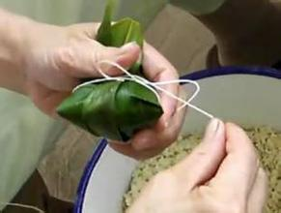
2、词数80词左右（开头的首句已给出，不计算在总词数内）。
Ingredients (材料)
糯米(glutinous rice): one kilo 粽叶(reed leaves)
牛肉: half a kilo 红枣(red dates)
盐: two spoons 线 (strings)

蒸粽子
steam...
浸糯米，切牛肉
put...into the water
拢粽叶
shape...by hand
填充馅料
fill...with
扎粽子
tie...with

How shall we make Zongzi?
To make this special food, we need to have ____________________________

鄂州市2015年初中毕业生学业考试
英语试题参考答案及评分标准
听力测试：（1-15每题1分，16-20每题2分，共25分）
1—5 BCBCB 6—10 BCCAB 11—15 ABAAA 16—20 CBABA
单项选择：（每题1分，共15分）
21—25 DCBAD 26—30 DCBAB 31—35 BDCCD
完形填空：（每题1分，共10分）
36—40 BACAC 41—45 AABDC
阅读理解：（每题2分，共40分）
46—50 ABABC 51—55 ABCDB
56. D 57. A 58. C 59.E 60. B
61.许多中国人受中国梦的鼓舞。
62.老年人也应该相信梦想永不太晚。
63. Our life
64. Cooperation is becoming one of the most important ways for people to solve
them (problems).
65. How to realize our (beautiful) dreams.
完成句子：（每题1分，共9分）
66. gets 67. moved 68. direct 69. Friday 70. buying
71. inventions 72. attention 73. aren’t allowed 74. eightieth
补全对话：（每题2分，共6分）
75. What’s wrong? 76. What should I do? 77. Thanks for your advice.
书面表达：（共15分）
How shall we make Zongzi?
To make this special food, we need to have one kilo of glutinous rice, half a kilo of beef, some red dates, two spoons of salt, some reed leaves and some strings.
How to make Zongzi? First, put the glutinous rice into the clean water and keep it for two hours. At the same time, wash some reed leaves and cut the beef into pieces. Next, shape the reed leaves by hand. Then, fill them with the glutinous rice and beef pieces. Add some red dates if you like. And then, tie Zongzi with strings. Finally, steam them.
第一档（13—15分） | 所写内容与提示的语言信息吻合，要素齐全；能正确使用表示顺序的连词完整描述操作过程；语言结构正确，层次清楚；无单词、语法错误；书写规范、整洁。
第二档（9—12分） | 所写内容与提示的语言信息相符，层次较清楚；能使用表示顺序的连词描述操作过程；句子结构正确，表达较通顺；有少许语法错误；书写规范。
第三档（5—8分） | 所写内容与提示的信息基本相符；能描述部分操作步骤，且结构基本完整、正确；有单词拼写和语法错误；书写欠规范。
第四档（0—4分） | 所写内容与提示的信息多数不符；只有个别句子可读，且单词拼写、语法错误较多；书写潦草。
评分标准：

