Ten reasons to travel in July


Most of us don’t need much of an excuse to travel in July – it’s the busiest month of the year for Britain’s airports. But what if you don’t want to follow the crowds to the Mediterranean resorts or Britain’s most popular holiday spots? Here is a selection of more offbeat or happening places for next month.

Chichester – for the festivities
Chichester has one of the longest-established festivities programmes and one of the best regional theatres in the country. It also has a very busy summer. The festival (www.chifest.org.uk) runs until July 10 with a full programme of classical music, rock and literary highlights.
The Pallant House Gallery (www.pallant.org.uk) is holding a retrospective exhibition of works by Mexico’s most famous artists (and lovers) – Frida Kahlo and Diego Rivera – from July 9 until October 2.
Sir Ian McKellen’s run in The Syndicate – one of several productions at the Minerva and Festival Theatres (www.cft.org.uk) – has sold out, but there may be returns. There’s lots happening on the Downs on the nearby Goodwood Estate (www.goodwood.co.uk): the Festival of Speed, which styles itself as “the largest motoring garden party in the world”, takes place from July 1-3, and the annual horse races at Glorious Goodwood will run from July 26-30.

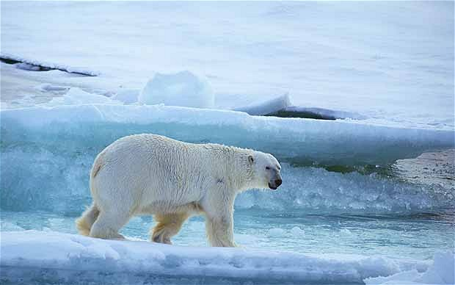
The North Pole – for the trip of a lifetime
Fed up with the summer heat? It sounds a little alarming from the point of view of climate change, but it is now possible, in high summer, to reach the North Pole (90 degrees north) on an icebreaker. Steppes Travel (www.steppestravel.co.uk) offers a two-week trip via Helsinki and Murmansk, returning via Franz Josef Land.
The journey time to the Pole is unpredictable: depending on conditions, it can take between five and eight days. It’s too late for the 2011 itinerary, but you may want to book for 2012 (June 25 to July 8) – if you can afford it, that is.
Prices start at £14,250 per person sharing a twin cabin and includes all flights, two nights in a Helsinki hotel, 12 nights on board the ice breaker, excursions and most meals.
Picture: Alamy
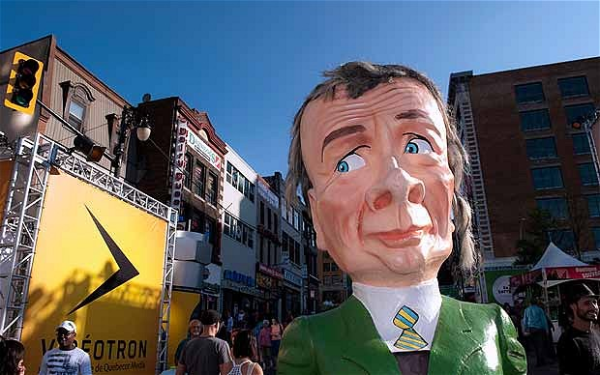
Montreal – for the festival
“One city, four weeks, 11 festivals” is how Montreal promotes its manic series of events and festivities during July. They cover the visual arts, film, fashion, music, circus and comedy – from the Just for Laughs comedy festival to the Nuits d’Afrique International Festival of African music.
Full dates and details are on www.montrealfestimania.com/en/home. Prestige Holidays (01502 567 222; www.prestigeholidays.co.uk) is offering a week’s stay in Montreal in July from £1,540 per person, based on two sharing a deluxe room in the four-star Château Versailles, including return flight.
Picture: Alamy
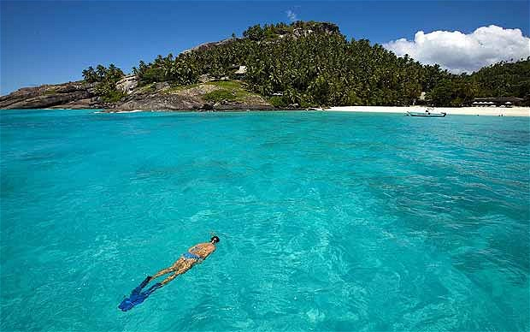

The Seychelles – for the climate
Will and Kate chose a good time to visit the powder-white beaches of the Seychelles. May to August are by far the driest months in the archipelago: July, for example, has five times less rain than January. You will always risk a few heavy tropical showers in the late afternoons, but with seven hours of sunshine a day and top temperatures about 80F (27C), they shouldn’t worry you too much.
Which island you choose will depend on your budget and preferences – see our recent guide. But to get the best deal, try one of the big tour operators such as Kuoni (www.kuoni.co.uk), which offers a wide variety of resorts and regular holiday offers. Currently, for example, it is offering seven nights’ half board in early July at Le Meridien Barbarons from £1,346 per person, based on two sharing and including return flight from London.
Picture: AP
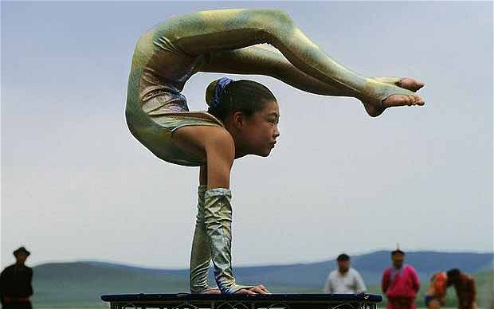

Mongolia – for Naadam
This is a long way to go for a festival, but if you are planning a trip to Mongolia – perhaps as a stopover on the Moscow-Beijing Central Kingdom Express – mid-July is an excellent time.
Naadam (which this year is held from July 11-13 in Ulan Bator; dates vary slightly for events in other parts of the country) is the major national festival and features traditional wrestling, long-distance horse racing (including children’s events) and archery. Contact Trailfinders (www.trailfinders.com) for flights (from £1,639) this July, or plan ahead for July 2012 and consider a London-Moscow flight, rail to Beijing and return flight to London.
Picture: Photolibrary.com
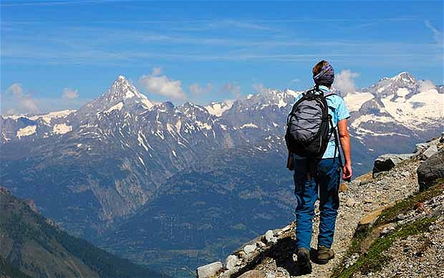

The Alps – for the scenery
While hundreds of thousands of us head to the Alps in winter, far fewer enjoy this spectacular landscape at this time of year. If anything, for active families there is more to do in summer than winter – rafting, hiking, riding, paragliding.
If you prefer gentler outings, you can use the ski lifts to get you up hill and enjoy the walk back down.
Erna Low (www.ernalow.co.uk) offers a holiday based at Residence Aiglon in Morzine in the French Alps, where a three-bedroom apartment sleeping up to eight costs from £1,096 from July 9-16, accommodation only.
Morzine is an hour from Geneva; book flights with British Airways (www.ba.com), Swiss (www.swiss.com) or easyJet (www.easyjet.com).
Picture: Alamy
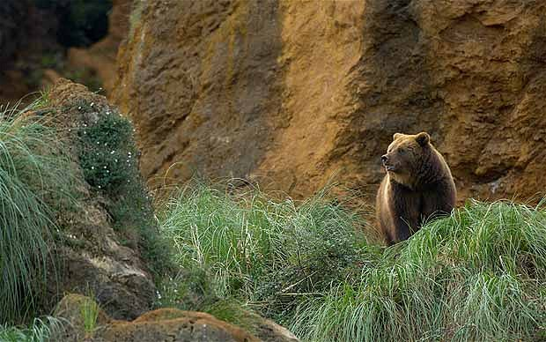

Spain – for the bears
Want something different from the Costas? How about bear-watching? Naturetrek (www.naturetrek.co.uk) arranges an exploration of the remote western end of Spain’s Cantabrian Mountains, which are home to bears and wolves, as well as a wide variety of birds (including golden eagle, goshawk and Alpine chough) and wild flowers.
The trip is based in a village in the high Somiedo Natural Park, where, in July, the small population of brown bears (about 130 still survive in Spain) ventures out into pastures to graze on spring grass, giving you the best chance of spotting them in the wild. The eight-day trip, departing on July 1, costs from £1,095 full board, including flights.
Picture: Alamy
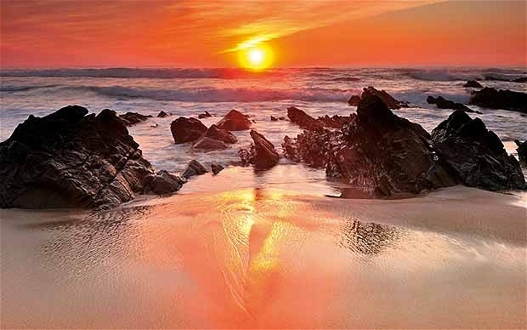

8 Portgual – to escape
It is peak season, of course, but if you avoid the Algarve, you can still find quiet, unspoilt areas and good value in Portgual. A new airport in Beja and direct flights from London have opened up the Alentejo region, a sizeable slice of the country to the north of the Algarve and south of the River Tagus. The area includes a stunning Atlantic coastline and the UNESCO World Heritage city of Évora.
Sunvil (020 8758 4722; www.sunvil.co.uk) has good availability next month - for example rooms at the Casa da Eira in a village on the coast cost from £557 per person (two sharing) including breakfast, direct flights to Beja and transfers.
Picture: Alamy
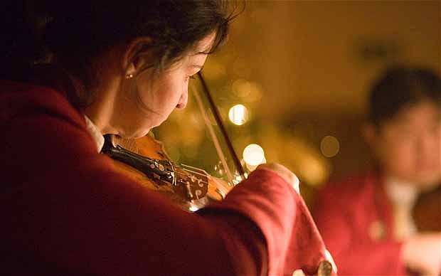

Salzburg – for the festival
The famous arts and music festival doesn’t begin until July 27 (ends August 30), but if you want tickets to the major productions (there are some still available for the opening nights), you should get yourself organised now.
In all there are 185 musical and theatrical performances in 14 venues. Highlights include new opera productions (Verdi’s Macbeth, Richard Strauss’s Die Frau ohne Schatten , and Janacek’s The Makropulos Affair) as well as several concerts by the Vienna and Berlin Philharmonics and the Chicago Symphony Orchestra.
Tickets and details at www.salzburgerfestspiele.at; accommodation bookings at www.salzburgerland.com; direct flights from Britain with easyJet, Ryanair (www.ryanair.com), British Airways and Austrian Airlines (www.austrian.com).
Picture: Alamy

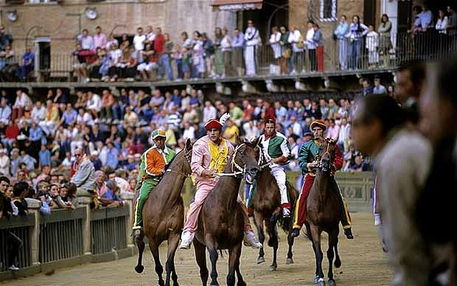
Siena – for the Palio
The most famous and spectacular survivor from the competitive pageantry of Italy’s medieval past is Siena’s Palio, which over the centuries has developed from a mass brawl to jousting, then bullfighting and finally to the great 90-second bareback horse race around the Piazza del Campo in the historic centre of the city (www.ilpalio.org).
The first race takes place on July 2, but if you miss that, there is another on August 16. The race happens in the evening, but you will need to turn up at least two or three hours in advance to be sure of a good view.
For a good choice of reasonably priced accommodation in the region, try Traditional Tuscany (www.traditionaltuscany.co.uk).

