2011年普通高等学校招生全国统一考试
英语（北京卷）
本试卷共16页，共150分。考试时长120分钟，考生务必将答案答在答题卡上，在试卷上作答无效，考试结束后，将本试卷和答题卡一并交回。
第一部分：听力理解（略）
第一节（共5小题；每小题1.5分，共7.5分）
听下面5段对话。每段对话后有一道小题，从每题所给的A、B、C三个选项中选出最佳选项。听完每段对话后，你将有10秒钟的时间来回答有关小题和阅读下一小题。每段对话你将听一遍。
例：What is the man going to read?
- A newspaper.
- A magazine.
- A book.
答案是A。
- What color T-shirt does the man plan to order?
A．Red. B．Blue. C．Green.
2．Which section does the man like to read?
A．News. B．Sports. C．Entertainment.
3．What job will the man probably take in summer?
A．Lifeguard. B．Tour guide. C．Swimming coach.
4．Where does the woman want to go on holiday?
A．Turkey. B．Canada. C．Italy.
5．What are the two speakers talking about?
A．Shark. B．Camera. C．Movie.

第二节（共10小题，每小题1.5分，共15分）
听下面4段对话或独白，每段对话或独白后有几道小题，从每题所给的A、B、C三个选项中选出最佳选项。听每段对话或独白前，你将有5秒钟的时间阅读每小题。听完后，每小题将给出5秒钟的作答时间。每段对话或独白你将听两遍。
听第6段材料，回答第6至7题。
6.What test are the speakers going to take on Friday?
A.Science B. History C.Music
7.Why does the woman speaker make the phone call?
A. To discuss her maths problems.
B. To seek help with her English reading.
C. To ask about the homework for tomorrow.
听第7段材料，回答第8至9题。（给力英语网 http://www.171english.cn）
8.What does the man think is the cause of the woman’s illness?
A.Last night’s dinner. B. The hot weather. C.Bottled water.
9.What is the probable relationship between the two sprekers?
A.Husband and wife. B.Doctor and patient. C. Guest and receptionist.
听第8段材料，回答第10至12题。
10. What is the manm doing?
A.Making an invitation.
B.Offering information.
C.Asking for permission.
11.What time is the woman going to see the dentist this Saturday?
A.10.:30a.m B.12:30p.m C.4:30p.m
12.What is the woman going to do after seeing the dentist?
A.Clean the house.
B.Take a walk by the lake.
C.Help Jim with his science project.
听第9段材料，回答第13至15题。
13.What makes shoppers tired?
A. Queuing for electrically-driven cars.
B. Looking for what they want to buy.
C. Carrying shopping around.
14.What is the peoblem for building moving walkways in the store?
A.The space B.The redsign. C. The technology.
15. Where will the computer system send the things shoppers buy?
A.To the exit
B. To the shelf
C. To the shoppers’ homes.
第三节（共5小题；每小题1.5分，共7.5分）
听下面一段对话，完成第16至第20五道小题，每小题仅填写一个词，听对话前你将有20秒钟的时间阅读试题，听完后你将有60秒钟的作答时间，这段对话你将听两遍。
Minssing Person Report Form
Time last seen | About 16 0’clock in the afternoon
Place last seen | At the 17 section of the store
Name | 18
Age | Five
Appearance | Dark 19 hair,thin and small
Clothing | Blue 20 ，a pink T-shirt,a hat

第二部分：知识运用（共两节，45分）
第一节 单项填空（共15小题；每小题1分，共15分）
从每题所给的A、B、C、D四个选项中，选出可以填入空白处的最佳选项，并在答题卡上将该项涂黑。

例：It’s so nice to hear from her again. ,we last met more than thirty years ago.
A. What’s more B. That’s to say
C. In other words D. Believe it or not
答案是D。
21. Experiments of this kind in both the U.S. and Europe well before the Second World War.
A. have conducted B. have been conducted
C. had conducted D. had been conducted
22. Barbara Jones offers to her fans is honesty and happiness.
A. Which B. What C. That D. Whom
23.Tom in the library every night over the last three months.
A. works B. worked C. have been working D. had been working
24.—I don’t really like James. Why did you invite him?
—Don’t worry. He come. He said he wasn’t certain what his plans were.[来源:学|科|网Z|X|X|K]
A. must not B. need not C. would not D. might not
25. It’s important for the figures regularly.
A. to be updated B. to have been updated C. to update D. to have updated
26. Mary was much kinder to Jack than she was to the others, , of course, made all the others upset.
A. who B. which C. what D. that
27. —That must have been a long trip.
—Yeah, it us a whole week to get there.
A. takes B. has taken C. took D. was taking
28. —Where are the children? The dinner’s going to be completely ruined.
—I wish they always late.
A. weren’t B. hadn’t been C. wouldn’t be D. wouldn’t have been
29. volleyball is her main focus, she’s also great at basketball.
A. Since B. Once C. Unless D. While
30. Maybe if I science, and not literature then, I would be able to give you more help.
A. studied B. would study C. had studied D. was studying
31. The shocking news made me realize terrible problems we would face.
A. what B. how C. that D. why
32. —Bob has gone to California.
—Oh, can you tell me when he ?
A. has left B. left C. is leaving D. would leave
33. Sit down, Emma. You will only make yourself more tired, on you feet.
A. to keep B. keeping C. having kept D. to have kept
34.The employment rate has continued to rise in big cities thanks to the efforts of the local governments to increase .[来源:ks5u.com]
A. then B. those C. it D. that
35. With new technology, pictures of underwater valleys can be taken color.
A. by B. for C. with D. in

第二节 完形填空（共20小题；每小题1.5分，共30分）
阅读下面短文，掌握其大意，从每题所给的A、B、C、D四个选项中，选出最佳选项，并在答题卡上将该项涂黑。

I used to hate being called upon in class mainly because I didn’t like attention drawn to myself. And 36 otherwise assigned（指定）a seat by the teacher, I always 37 to sit at the back of the classroom.
All this 38 after I joined a sports team. It began when a teacher suggested I try out for the basketball team. At first I thought it was a crazy 39 because I didn’t have a good sense of balance, nor did I have the 40 to keep pace with the others on the team and they would tease me. But for the teacher who kept insisting on my “ 41 for it”, I wouldn’t have decided to give a try.
Getting up the courage to go to the tryouts was only the 42 of it! When I first started 43 the practice sessions, I didn’t even know the rules of the game, much 44 what I was doing. Sometimes I’d get 45 and take a shot at the wrong direction—which made me feel really stupid. 46 , I wasn’t the only one “new” at the game, so I decided to 47 on learning the game, do my best at each practice session, and not be too hard on myself for the things I didn’t 48 “just yet”.
I practiced and practiced. Soon I knew the 49 and the “moves”. Being part of a team was fun and motivating. Very soon the competitive 50 in me was winning over my lack of confidence. With time, I learned how to play and made friends in the 51 — friends who respected my efforts to work hard and be a team player. I never had so much fun!
With my 52 self-confidence comes more praise from teachers and classmates. I have gone from “53” in the back of the classroom and not wanting to call attention to myself, 54 raising my hand— even when I sometimes wasn’t and not 100 percent 55 I had the right answer. Now I have more self-confidence in myself.
36. A. as B. until C. unless D. though
37. A. hoped B. agreed C. meant D. chose
38. A. continued B. changed C. settled D. started
39. A. idea B. plan C.belief D. saying
40. A. right B. chance C. ability D.patience
41. A. going B. looking C. cheering D. applying
42. A. point B. half C. rest D. basis
43. A. enjoying B. preparing C. attending D. watching
44. A. less B. later C. worse D. further
45. A. committed B. motivated C. embarrassed D. confused
46. A. Interestingly B. Fortunately C. Obviously D. hopefully
47. A. focus B. act C. rely D. try
48. A. want B. do C. support D. know
49. A. steps B. orders C. rules D. games
50. A. roles B. part C. mind D. value
51. A. process B. operation C. movement D. situation
52. A. expressed B. improved C. preserved D. recognized
53. A. dreaming B. playing C. relaxing D. hiding
54. A. by B. for C. with D. to
55. A. lucky B. happy C. sure D. satisfied

第三部分：阅读理解（共两节，40分）
第一节（共15小题；每小题2分，共30分）
阅读下列短文，从每题所给的A、B、C、D四个选项中，选出最佳选项，并在答题卡上将该项涂黑。
ks5u.com
A
“I Went Skydiving at 84!”
As a young girl growing up in the 1930s, I always wanted to fly a plane, but back then it was almost unheard of for a woman to do that. I got a taste of that dream in 2011,when my husband arranged for me to ride in a hot air balloon for my birthday. But the experience turned out to be very dull. Around that time,I told my husband that I wanted to skydive. So when our retirement community（社区）announced that they were having an essay competition and the topic was an experience of a lifetime that you wanted to have, I decided to write about my dream.
In the essay, I wrote about my desire to skydive, stating George Brush Sr. did it at age 80. Why not me? I was just 84 and in pretty good health. A year went by and I heard nothing. But then at a community party in late April 2009, they announced that I was one of the winners. I just couldn’t believe it. Inspired by this.I deeided to realize my dream,even though some of my family members and my doctor were against it.
On June 11, 2009, nearly 40 of my family and friends gathered in the area close to where I would land while I headed up in the airplane. My instructor, Jay, guided me through the experience. The plane was the noisiest one I had ever been in, but I wasn’t frightened—I was really just looking forward to the experience. When we reached 13,000 feet, Jay instructed me to throw myself out of the plane. When we first hit the air, the wind was so strong that I could hardly breathe. For a second I thought, “What have I gotten myself into?” But then everything got calmer. We were in a free fall for about a minute before Jay opened the parachute（降落伞）, then we just floated downward for about five minutes. Being up in the clouds and looking at the view below was unlike anything I have ever felt—much better than the hot air ballon. I was just enjoying it.[来源:学#科#网Z#X#X#K]
Skydiving was really one of the greatest experiences of my life. I hope other people will look at me and realize that you don’t stop living just because you are 84 years old. If there’s something you want to experience, look into it. If it’s something that is possible, make it happen.

56. What happened to the auther in 2001?[来源:高考资源网KS5U.COM]
A. She flew an airplane
B. She entered a competition
C. She went on a hot air balloon ride
D. She moved into a retirement community
57. The author mentioned George Bush Sr. in her essay to .
A. build up her own reputation
B. show her admiration for him
C. compare their health conditon
D. make her argument persuasive
58. How did the author feel immediately after she jumped out of the plane?
A. Excited B. Scared C. Nervous D. Regretful
59. What did the author enjoy most when she was skydiving?
A.The beautiful clouds B. The wonderful view
C. The company of Jay D. The one-minute free fall

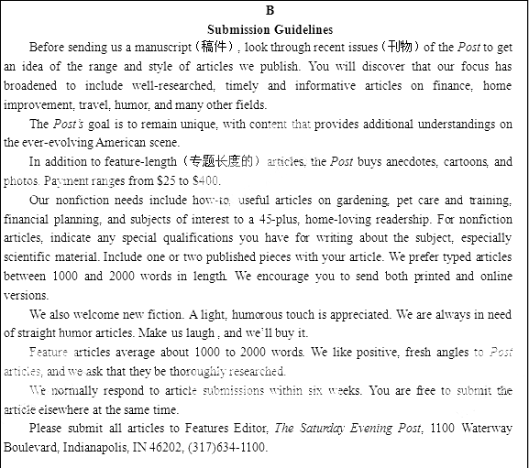
60. Before sending a manuscript to the Post, a contributor is advised to .
A. get a better understanding of American issues
B. find out the range of the articles in the post
C. increase his knowledge in many fields
D. broaden his research focus
61.to submit nonfiction articles，a contributor must_____.
A. provide his special qualification
B. be a regular reader of the Post
C. produce printed version
D. be over 45 year old
62.From the passage we can learn that the Post .
A. allows article submission within six weeks
B. favor science articles within 2,000 words
C. have a huge demand for humorous works
D. prefers nonfiction to fiction article

C
Students and Technology in the Classroom
I love my blackberry—it’s my little connection to the larger world that can go anywhere with me . I also love my laptop computer ，as it holds all of my writing and thoughts .Despite this love of technology ,I know that there are times when I need to move away from these devices（设备） and truly communicat with others.
On occasion, I teach a course called History Matters for a group of higher education managers. My goals for the class include a full discussion of historical themes and ideas .Because I want students to thoroughly study the material and exchange their ideas with each other in the classroom ,I have a rule —no laptop ,iPads ,phones ,etc .When students were told my rule in advance of the class, some of them were not happy .
Most students assume that my reasons for this rule include unpleasant experiences in the past with students misusing technology . There’s a bit of truth to that. Some students assume that I am anti-technology . There’s no truth in that at all . I love technology and try to keep up with it so I can relate to my students.
The real reason why I ask students to leave technology at the door is that I think there are very few places in which we can have deep conversions and truly engage complex ideas. Interruptions by technology often break concentration and allow for too much dependence on outside information for ideas . I want students to dig deep within themselves for inspiration and ideas. I want them to push each other to think differently and make connections between the course the material and the class discussion .
I’ve been teaching my history class in this way for many years and the evaluations reflect student satisfaction with the environment that I create .Students realize that with deep conversation and challenge , they learn at a level that helps them keep the course material beyond the classroom .
I’m not saying that I won’t ever change my mind about technology use in my history class, but until I hear a really good reason for the change ,I’m sticking to my plan. A few hours of technology-free dialogue is just too sweet to give up.

63.Some of the students in the history class were unhappy with____
A. the course material B. others’ misuse of technology
C. discussion topics D. the author’s class regulations
64.The underlined word “engage ”in para.4 probably means ____
A. explore B. accept C. change D. reject
65.According to the author ,the use of technology in the classroom may ____
A. keep students from doing independent thinking
B. encourage students to have in-depth conversations
C. help students to better understand complex themes
D. affect students’ concentration on course evaluation
66.It can be inferred from the last paragraph that the author ____
A. is quite stubborn
B. will give up teaching history
C. will change his teaching plan soon
D. values technology-free dialogues in his class

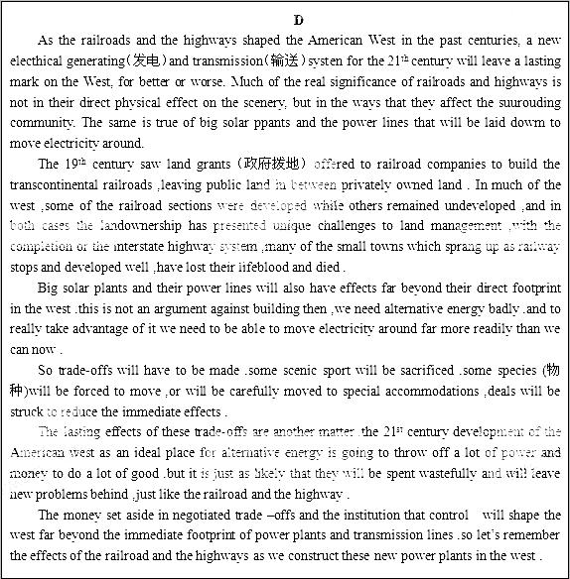
67.What was the problem caused by the construction of the railways ?
A. Small towns along the railways became abandoned.
B. Some railroad stops remained underused.
C. Land in the West was hard to manage.
D. Land grants went into private hands.
68.What is the major concern in the development of alternative energy according to the last two paragraphs ?
A. The transmission of power. B. The use of money and power.
C. The conservation of solar energy. D. The selection of an ideal place.
69.What is the author ‘s attitude towards building solar plants ?
A. Cautious B. Approving C. Doubtful D. Disapproving
70.Which is the best title for the passage ?
A. How the Railways Have Affected the West
B. How Solar Energy Could Reshape the West
C. How the Effects of Power Plants Can Be Reduced
D. How the Problems of the Highways Have Been Settled

第二节（共5小题；每小题2分，共10分）
根据短文内容，从短文后的七个选项中选出能填入空白处的最佳选项，选项中有两项为多余选项。
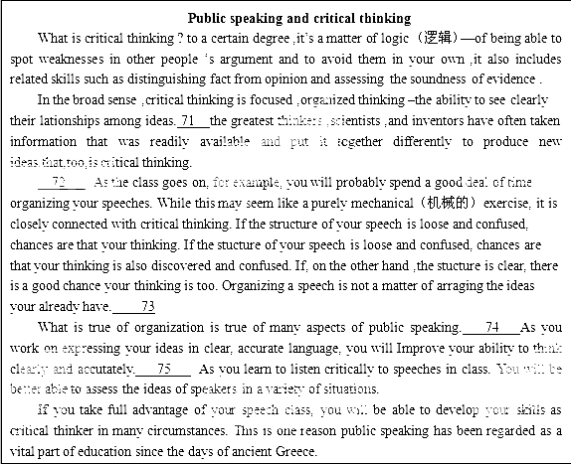
A. Rather, it is an important part of shaping the ideas themselves.
B. This may seem like a lot of time, but the rewards are well worth it.
C. It may also help you to know that there is no such thing as a perfect speech.
D. It has often been said that there are few new ideas in the world, only reorganized ideas.
E. If you are wondering what this has to do with your public speaking class, the answer is quite a lot.
F. The skills you learn in your speech class can help you become a more effective thinker in a number of ways.
G. As you study the role of evidence and reasoning in speechmaking ,you will see how they can be used in other forms of communication as well.

第四部分：书面表达（共两节，35分）
第一节 情景作文（20分）（给力英语网 http://www.171english.cn）

假设你是红星中学高二（1）班的学生李华。下面四幅图表述了近期发生在你们班的一个真实故事，请根据图片的先后顺序，为校刊“英语园地”写一篇短文，词数不少于60。
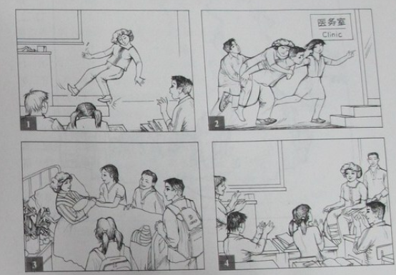
（请务必将情景作文写在答题卡指定区域内）

第二节 开放作文（15分）
请根据下面提示，写一篇短文。词数不少于50。
In your spoken English class, your teacher shows you the following picture. You are asked to describe the picture and explain how you understand it.
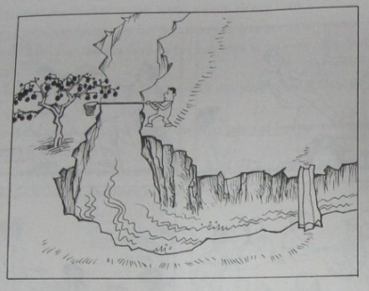
（请务必将开放作文写在答题卡指定区域内）

2011年普通高等学校招生全国统一考试
英语（北京卷） 参考答案
