牛津英语7B Unit 5-6 单元检测
班级__________ 学号___________ 得分____________
听力部分
I．根据所听句子，选出相应的图片（5%）。
A B C D E
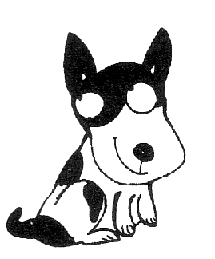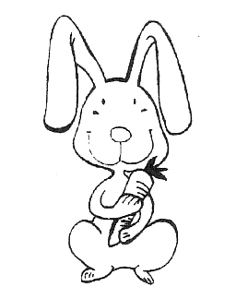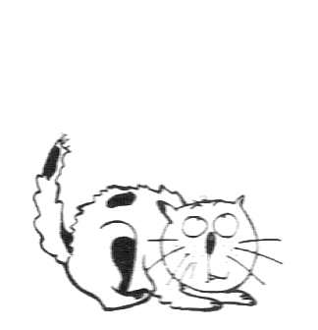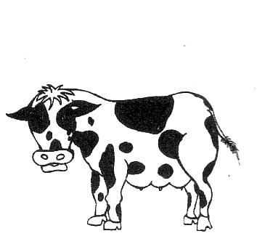
1._______ 2. _______ 3. _______ 4. _______ 5. ________

II．根据所听问题，选择正确答案（5%）。
( )1. A. Very much. B. Twice a day. C. Small and short. D. Cat food.
( )2. A. My. B. My brother’s. C. Me. D. Mine.
( )3. A. Kind. B. Light. C. Wide. D. Trick.
( )4. A. Clever B. Noisy C. Shy D. Friendly.
( )5. A. 2 kilograms B. 20 kilograms C. 5 grams D. 100 kilograms

III．听短文，填入所缺单词 ( 10%)。
One day, Miss Moppet, my_________, __________ a __________. She thought she
__________ she __________ make __________ of the mouse. She tied(系) __________
up in a duster, and threw it up _________ a ball. But she _________ that hole in the duster. When she _________ it---- there was __________ mouse!

笔试部分
一、给词的适当形式填空：
    - The clever girl can work out the problem______________(easy).
    - Can you find the ____________(different) between the twins.
    - Daniel becomes___________(interest) in pets.
    - Kitty is ____________(busy) than Amy.
    - Panda is a kind of _____________ (love) animal, I like watching it eat bamboos.
    - There’re two small ____________ (mouse) in the box.
    - It’s not polite ____________ (sneeze) before people.
    - Our team is much _____________ (strong) than ____________ (they).
    - ____________ (bring) that coat to me. I’m cold.

二、单项选择
1. I think dog is ____________ animal in the world.
A. very kind | B. very clever | C. the kindiest | D. cleverer
  - You can’t play with your rabbit ____________ you finish your homework.
  - ----What’s wrong with you?
----I feel very ____________. I heard a ____________ noise just now.
A. frightening, frightened | B. frightening, frightening
C. frightened, frightening | D. frightened, frightened
  - The room is big enough for ten people ____________.
A. to live | B. live | C. living | D. to live in
  - One of the boys suggested ____________ and we were happy about this.
A. go camping | B. going camping | C. to go camping | D. go for camping
  - ____________ exciting news it is!
A. How an | B. What an | C. How | D. what
  - What house ____________ he ____________?
A. do, live | B. does, live in | C. do live in | D. does, live
  - She ____________her tortoises, it moves_____________.
A. like, slow | B. love, slowly | C. likes, slower | D. loves, slowly
  - Please ____________ your name _____________ you finish _____________ it.
A. sign, before, saying | B. sign, after, reading
C. write, before, reading | D. write down, after, having a look
  - We know it ____________. It enjoys the music____________.
A. very well, very well | B. very much, very much
C. very well, very much | D. very much, very well

三、下列句子中各有一处错误，请指出并改正:
( )__________1. He doesn’t wonderful tricks any more.
A B C D
( )__________2. She didn’t stop until she gets to the end.
A B C D
( )__________3. She oughts to drive to work.
A B C D
( )__________4. Don’t afraid of that dog. It’s very kind.
A B C D

( )__________5.You must be carefully. You made a lot of mistakes.
A B C D
( )__________6. The twins look the same but their hobbies are different from.
A B C D
( )__________7. Simon couldn’t play football outside because his homework.
A B C D
( )__________8. Must I get someone to help her? No, you mustn’t.
A B C D
( )__________9. How many is your telephone number?
A B C D
( )__________10. Not be late again next time.
A B C D
- 句型转换：
  - It’s cold out side. I’ll watch TV at home. I won’t go out.(改为同义句)
it’s cold out side. I’ll watch TV ____________ ____________ ____________ out.
  - He forgot to bring his football boots to school. (改为否定句)
He ____________ ____________ ____________ bring his football boots to school.
  - You asked me to your party. Thanks. (改成一句)
Thank you ____________ ____________ me to your party.
  - We must learn English well. （改为同义句）
It’s ____________ ____________ ____________ us ____________ learn English well.
  - Everyone should help each other. （划线提问）
____________ ____________ ____________ ____________?
  - It’s a lovely baby.（改为感叹句）
____________ ____________ lovely baby!
____________ ____________ lovely the baby is!
- 完成句子：
  - 即使天下雨的时候，他也练习打篮球。
He ____________ ____________ basketball even when it _____________.
  - 他们轮流打扫教室。
They ____________ ____________ ____________ ____________ the classroom.
  - 我们必须是孩子们远离河和湖。
We must ____________ children ____________ ____________ rivers and lakes.
  - 知道长颈鹿用舌头清洁耳朵是有趣的。
____________ is ____________ ____________ learn that giraffes clean there ears with their ____________.
  - 你上次考试太粗心了，下次应该更仔细些。
You were too ____________ in your ____________ exam, You ____________ ____________ be ____________ _____________ next time.

- 完型填空：
John is a famous writer now. But he said that he was not a ___1_____student when he was young. He was often late for ___2_____ and didn’t like doing his homework. Sometimes, he slept in class while the teacher was teaching. He didn’t understand much, ____3____ he always thought he understood everything. One day the teacher ____4____ the students a question, “when Jack was ten years old, ____5____ brother Bob was twenty. Jack is fifteen now and ____6____ is his brother Bob?” John said, “That’s easy. Bob is twice as old as Jack, so he is now thirty.”
Another time, the ____7____ in a science class asked, “when it thunders(打雷), ____8____ do we always see the light before we ____9____ the sound?”
“But, Miss,” said John quickly, “don’t you ___10_____ out eyes are in front of our ears?”
( ) | 1. | A. good | B. tall | C. rich | D. fat
( ) | 2. | A. sleep | B. lunch | C. class | D. play
( ) | 3. | A. so | B. and | C. or | D. but
( ) | 4. | A. sent | B. asked | C. told | D. found
( ) | 5. | A. your | B. my | C. his | D. her
( ) | 6. | A. how many | B. how old | C. what | D. who
( ) | 7. | A. teacher | B. farmer | C. nurse | D. policeman
( ) | 8. | A. what | B. when | C. where | D. why
( ) | 9. | A. break | B. make | C. hear | D. smell
( ) | 10. | A. read | B. hope | C. study | D. know

- 阅读理解：
Scientists are trying to make the deserts () into good land again. They want to bring water to the deserts, so people can live and grow food. They are learning a lot about the deserts. But more and more of the earth is becoming desert all the time. Scientists may not be able to change the desert in time.
Why is more and more land becoming desert? Scientists think that people make deserts. People are doing bad things to the earth.
Some places on the earth don’t get much rain. But they still don’t become deserts. This is because some green plants are growing there. Small green plants and grass are very important to dry places. Plants don’t let the hot sun make the earth even drier. Plants don’t let the wind blow the dirt away. When a little bit of rain falls, the plants hold the water. Without plants, the land can become a desert much more easily.
- Deserts ______________.
A. get very little rain
B. never have any plants or animals in them
C. can all be turned into good land in the future
D. both A and C
- Small green plants are very important to day places because ______________.
A. they don’t let the sun make the earth even drier
B. they don’t let the wind blow the earth away
C. they hold the water
D. A, B and C
- Land is becoming desert little by little because ______________.
A. plants can’t grow there
B. there’s not enough rain
C. people are doing bad things to the earth.
D. scientists know little about desert
- Which is the main idea of the first paragraph?
A. Scientists know how to change land into good land.
B. Land is becoming desert faster than scientists can change it back into good land.
C. If scientists can bring water to the desert, people can live there.
D. More and more places are becoming deserts all the time.
- After reading this, we learn that ______________.
A. plant can keep dry land from becoming desert.
B. it is good to get rid of (清除) the grass in the desert
C. all places without much rain will become deserts
D. it is better to grow crops on dry land than to grow grass

A 50-year-old American officer (官员) came back to his school. The teacher asked him to give a talk to the small boys and girls there. The talk was about the love of their great country. All the little ones were sitting in a large meeting-room. The old officer went up and began speaking. He said, “boys and girls, I studied in this school forty years ago. When I was your age, we were not as happy as you are today. Think about it and answer me, why are you so happy now?”
No sound came from the children. The old man waited for a long time. Then a short boy in front put up his small dirty hand. “Good boy! Please answer me, dear.” Said the officer.
With a big smile on his face, the boy stood up and said, “if you speak long enough, we won’t have maths and biology (生物学) lessons this morning.”
- The old man came back to school ______________.
A. to listen to a talk
B. to have lessons
C. to give a talk
D. to see his children
- The officer studied in this school when he was ______________.
A. fifty | B. ten | C. twenty | D. children
- The children were ____________ before.
A. as good as | B. as well as
C. as happy as | D. much happier than
- The short boy in the front ______________.
A. didn’t understand the question and answer it
B. told the truth
C. wanted to make others laugh
D. wanted to make the officer angry
- After reading the last part of the story, we know that ______________.
A. the short boy liked the talk very much
B. all the children likee the talk
C. the short boy didn’t studying his lessons
D. some of the children liked to listen to a funny story
八、写作
那只叫Bob的狗是Simon的。Simon虽然整天忙于学习， 但仍然花了许多时间陪Bob。Simon知道如何照顾好一只狗。他一天喂它三次。有时还带它出去散步。Bob就像Simon的兄弟。Simon很喜欢这只狗。（80词左右）
____________________________________________________________________________________________________________________________________________________________________________________________________________________________________________________________________________________________________________________________________________________________________________________________________________________________________________________________________________________________________________________________________________________________________________________________________________________________________________________________________

牛津英语7B Unit5-6 单元检测答案
I．根据所听句子，选出相应的图片（5%）。
Key：1. We should drink her milk every day.( E )
2. He is quiet and always bubbles.( A )
3. If she is hungry, she will miaow.( D )
4. He is a good doorkeeper.( B )
5. She has a short tail and likes carrots very much.( C )
II．根据所听问题，选择正确答案（5%）。
Key:1. How often does Amy feed her cat Poppy?( B )
2. Who does the dog belong to?( C )
3. Which word’s last syllable makes the same sound as the word “fight”?( B )
4. She seldom talks to others and her face turns red when she speaks. How is she?(C)
5. How heavy is this cat?( A )
III．听短文，填入所缺单词 ( 10%)。
Key: One day, Miss Moppet, my cat, caught a mouse. She thought she could make fun of the mouse. She tied him up in a duster, and threw it up like a ball. But she forgot that hole in the duster. When she opened it----there was no mouse.

笔试部分：
- 用所给词的适当形式填空：
1. easily; 2. differences; 3. interested; 4. busier; 5. lovely; 6. mice; 7. to sneeze; 8. stronger, theirs; 9. bring
- 单项选择:
CCDBB DBDBC
三、下列句子中各有一处错误，请指出并改正：
1. A doesn’t do 2. D got to 3. B ought to 4. B be afraid of 5. B careful
6. D different 7. C because of 8. D needn’t 9. A What 10. A Don’t
- 句型转换：
1. instead of going
2. didn’t forget to
3. for asking
4. is necessary for;to
5. What should everyone do?
6. What an ; how lovely
- 完成句子：
1. practices playing; rains
2. take turns to clean
3. keep; away from
4. it; interesting to; tongues
5. careless, last, ought to; more careful
- 完型填空：
ACDBC BADCD
- 阅读理解：
DDCBA CBDBC

