2007年中考英语模拟试卷（四）
第Ⅰ卷（选择题 共60分）
一、听力（每小题1分，共20题，满分20分）
第一节
每小题你将听到一个对话，从A、B、C三幅图中找出与你所听内容相符的选项。每段话读一遍。
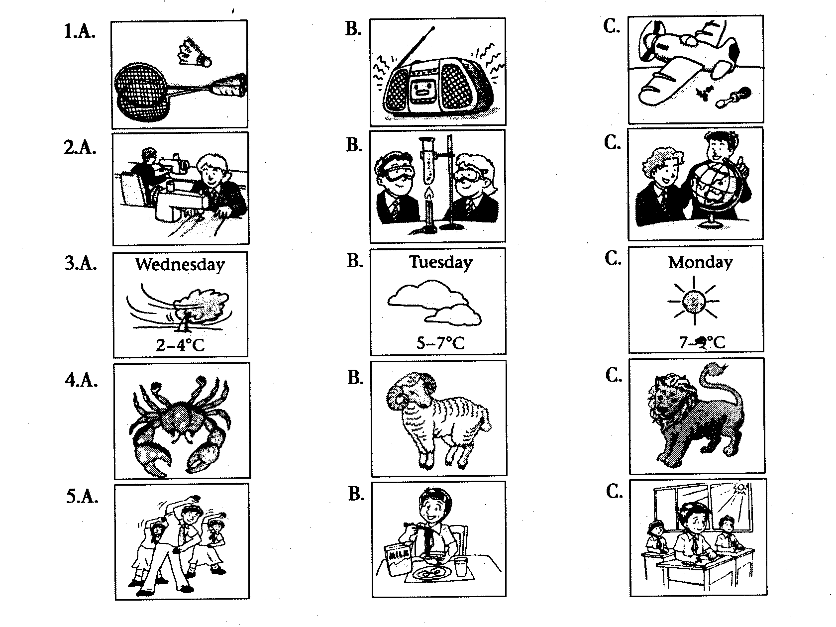
第二节
听下面的对话，根据你所听到的内容，从所给的A、B、C三个选项中选出最佳选项。每段对话读两遍。
听第6段材料，回答第6~8题。
6. When is Alice’s birthday?
A. The next day. B. The day after next. C. The day they had the talk.
7. What will the man and the woman buy for Alice?
A. A record. B. Some flowers. C. A box of chocolates.
8. Where are they going to buy for Alice’s birthday present?
A. To the food shop B. To the flower shop. C. To the music shop.
听第7段材料，回答第9~11题。
9. What is the man from the Golden TV interviewing on?
A. People’s viewing habits B. Students’ favourite subjects C. Teenagers’ problems
10. What is the student’s first choice?
A. News Channel B. Discovery Channel C. Film Channel
11. Why does his mother often forget to cook dinners?
A. Because she is always forgetting things.
B. Because she is tired and does not want to.
C. Because she is deeply moved by the nice film.
听第8段材料，回答第12~15题。
12. What are Jane and Ben talking about?
A. Computer science. B. Their plan for the weekend. C. Buying computer
13. Which museum would Jane like to visit?
A. The History Museum. B. The Palace Museum. C. The Science & Technology Museum
14. What’s going to be held in the museum?
A. A lecture on stars. B. An exhibition of computers. C. A charity show.
15. What is Ben going to do first?
A. To buy the tickets. B. To go there at once. C. To wait in lines.
第三节
听第9段材料，从题中所给的A、B、C三个选项中选出最佳选项。本段材料读两遍。
16. ________ are good seasons for outdoor activities.
A. Autumn and winter B. Summer and autumn C. Spring and autumn
17.It is important that you should take ______ in order to give simple medical treatment to someone in great need as soon as possible.
A. a tent and sleeping bags B. a first-aid box C. food and drinks
18. When hiking in a group, young people have a good chance to ______ .
A. enjoy the beautiful view B. learn team spirit C. know how to cure a snake bite
19. If you see a snake nearby during the hiking, you should ______ .
A. run away as fast as possible B. fight with it C. wait quietly for it to go away
20. You should ______ to stop the poison from spreading to other parts of the body if you or someone else is bitten. Then you should send for help.
A. move the victim to a hospital B. wash the wounded（受伤的）part C. tie something round the bite
二、单项填空（共15小题；每小题1分，满分15分）
从A、B、C、D四个选项中，选出可以填入空白处的最佳选项。
21. My grandfather has sent me _____ e-dog as my birthday present.
A. a B. an C. / D. the
22. --Which would you like, a cup of tea or a glass of milk?
-- ______. I think I'll just have a glass of water.
A. Both B. Neither C. None D. Either
23. –Which do you think is ____ important, air tank, space suit or digital camera for an astronaut?
--I think the digital camera.
A. less B. the most C. more D. the least
24. Do you know ____ will repair the robot that went wrong?
A. whether B. where C. who D. why
25. Amy prefers ____ at home to ____ out at the weekends.
A. staying; going B. stay; going C. staying; go D. stay; go
26. ---Why not come and join us in the game, Linda?
--- __________, but I have something to discuss with Mr Smith at his office now.
A. Let's go B. I'd like to C. Yes, please D. It's a pleasure
27. I don’t know if it ____ tomorrow. If it ____, we’ll go out for a picnic.
A. will rain; won’t rain B. rains; doesn’t rain
C. rains; won’t rain D. will rain; doesn’t rain
28. --I do a lot of exercise, eat___ vegetables and ____ _meat than I did last year.
--That’s why you’re getting thinner.
A. fewer; more B. more; less C. less; more D. many; much
29. When I came inside the office, they ____ a party for the coming festival.
A. planned B. were planning C. plan D. have planned
30. It is impossible ____ her ____ the work in half an hour.
A. for; finish B. of; finish C. for; to finish D. of; to finish
31. I wanted to help those homeless children in the flooded areas, ____ I donated my pocket money that I had saved for two months.
A. so B. because C. since D. for
32. Audrey Hepburn ____ dancing and focused on acting after her first successful movie.
A. gave in B. gave off C. gave out D. gave up
33. --Could you tell me _____ to visit Dr Sun Yatsen’s Mausoleum（陵墓）?
--The day after tomorrow, I think.
A. when will you go B. when you will go
C. when would you go D. when you would go
34. Don’t forget to turn ____ the lights before you leave the office.
A. down B. off C. on D. up
35. The man made such a _____ speech that all the audience at the meeting felt _____.
A. boring; boring B. boring; bored C. bored ;boring D. bored ;bored

三、完形填空（共10小题；每小题1分，满分10分）
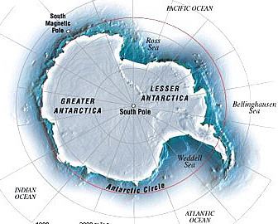
Antarctica is the continent which is the most southern area of land on the Earth and is mostly covered with ice. This is one of the driest and 36 in the world. But people from all over the world come to 37 there. Near the South Pole, three thousand people live together in a place 38 Amundsen-Scott Station.
The station has libraries, cinemas, shops, sports rooms, canteens and laboratories（实验室）. There is electricity（电）, and they have 39 -- the system that they use to have a conversation（交谈）with someone in another place. And they have 40 -- electronic machines that stores information and uses programs to help them find, organize, or change the information.
. But the people here 41 travel by car, or train, or bus, because there aren’t any roads or railways near the station. They travel by ship, helicopter, plane, or snow tractor, or 42 dogs.
There aren’t 43 trees or flowers there, but there are hundreds of different birds and other animals.
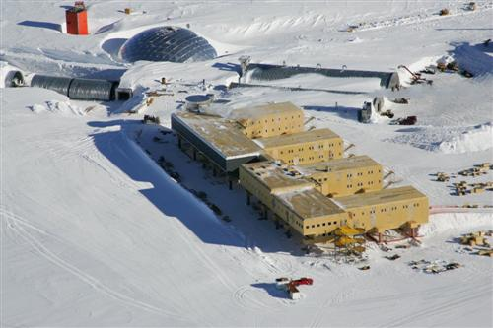
Most of the people here are 44 . They study plant and animal life and how ice moves. The ice can tell us about changes in climate. Ray Kingman is an expert at Amundsen-Scott Station, telling us on the phone, “This is my second year here. It’s a very interesting and beautiful place, but life is very hard 45 . In the summer we can go swimming in hot pools of water. We welcome newcomers here for further study of the continent!”
36. A. warm areas B. coldest places C. cool areas D. hottest places
37. A. travel B. go sightseeing C. work D. enjoy themselves
38. A. called B. call C. calls D. calling
39. A. telephones B. radios C. televisions D. record players
40. A. printers B. icons C. mouses D. computers
41. A. don’t B. didn’t C. weren’t D. aren’t
42. A. with B. instead of C. on D. in front of
43. A. much B. any C. many D. either
44. A. teachers B. scientists C. doctors D. workers
45. A. during the autumn season B. in the springtime
C. in all weathers D. in the winter
四、阅读理解（共15小题；每小题1分，满分15分）
A) 阅读短文，判断下列句子的正（A）误（B）
Imagine the year is 1666 and we can see a student called Isaac Newton. He’s away from his university for a holiday and at home with his family. Isaac Newton continues to study at home. He enjoys physics and thinking about the mysteries of the world.
On a day when there is rain and sun at the same time he sees a beautiful rainbow in the sky. It has many different colours, he is told that there are five. Newton wants to have his own rainbow because he wants to look at it closely. He decides to do an experiment. On a sunny day he goes inside a small room and he makes the room very dark. Then he makes a small hole and the sun comes inside, it’s a small ray of light. It’s white. Newton takes a prism and holds it up to the light. The ray of light goes through the prism, but it isn’t white now – there are many colours. The prism has split up（分解）the white light into different colours: Newton has a rainbow.

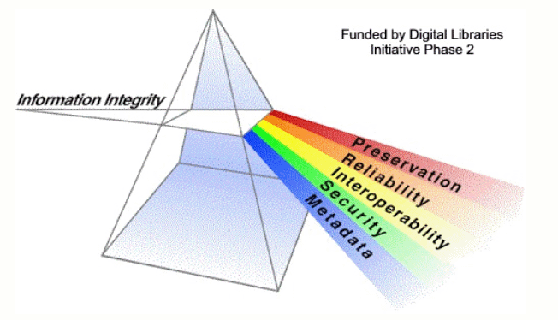
Newton looks at his rainbow carefully. He can see more than five colours, he can see seven. He says the colours are: red, orange, yellow, green, blue, indigo and violet.
But Newton is a scientist and he’s always very interested in how things work. He has his rainbow but he wants to know more. So he takes another prism and holds it up to the rainbow. The rainbow goes through the second prism, but it isn’t colourful now – it’s white again. The prism has joined up the colours back into white light. Newton is the first person to understand that light is a combination of all the rainbow colours together.
Newton also understands how we can see colour. Imagine a leaf in the sunshine. All the rainbow colours fall on the leaf but it absorbs all these colours. The only colour that is reflected（反射） is green, so the leaf looks green. Different objects reflect different colours. And perhaps Newton’s favourite fruit is an orange – but what came first, the name of the fruit or the name of the colour?

46. In 1666 Isaac Newton was a university student learning physics.
47. Newton was told that there were five colours in a rainbow and he believed it.
48. Newton used a prism（棱镜）to split up the white light from the sun.
49. Newton understood that light was a combination（复合）of all the rainbow colours together.
50. The great man’s favourtie colour was orange because he liked orange fruit.
B) 阅读下列短文，从每题所给的四个选项（A、B、C和D）中，选出最佳选项。
Have you ever stayed in a hotel? Most Chinese hotels often provide guests with things like disposable (一次性的) toothbrushes, toothpaste, shampoo and slippers. Many guests like the idea because they don't have to bring their own. But, if you travel to Beijing, remember to bring your own things. Starting from June, some hotels in Beijing will no longer provide guests with these disposables. They want to ask people to use less disposable things.
Many disposable things are made of plastic. People throw them away after only using them once. It is a waste of natural resources (资源) and is very bad for the environment. Do you know, one Chinese person makes as much as 400kg of waste a year! Most of that waste comes from disposable things. In Beijing, people throw away about 19,000 tons of plastic bags and 1,320 tons of plastic lunch bowls every year! Plastic can take between 100 and 400 years to break down. So the less plastic we throw out, the better. So, wherever you travel, bring your own things and use them again and again.
Back at home and school, you can also do something to make our world a better place. Try to do these things in your daily life: Use cloth shopping bags, not plastic ones. After using a plastic bag, wash it out and let it dry. Then you can use it over and over again. Do not use paper cups. At your school canteen（食堂）, use your own bowl and chopsticks instead of disposable ones.
51. Why do many hotels provide guests with some disposable things?
A. Let their guests be convenient during their travelling.
B. Hope their guests use less disposable things.
C. Wish their guests to save money.
D. Want their guests to use more disposable things.
52. Some Beijing hotels will no longer provide guests with ____.
A. cheap food and drink B. disposable things
C. good service D. free TV programmes
53. Which of the following is NOT true?
A. Many disposable things are made of plastic.
B. Throwing disposable things away is a waste of natural resources.
C. Plastic is very bad for the environment.
D. Plastic breaks down easily.
54. What can we do to make our world a better place at home and school?
A. Use shopping bags made of plastic. B. Do not throw away paper cups.
C. Use disposable plates, bowls and chopsticks. D. Do not forget to reuse daily necessities（日用品）.
55. We can tell from the story that ____.
A. people don't like disposable things at all
B. we can't use paper or plastic bowls at school
C. we should use less plastic things and protect our environment
D. hotels won't provide disposable things because they want to save money

C) 阅读下列短文，从每题所给的四个选项（A、B、C和D）中，选出最佳选项。
Have you ever noticed an advertisement which says “Learn a foreign language in six weeks, or your money back! From the first day your pronunciation will be excellent. Just send…” and so on? Of course, it never happens quite like that. Anyone who learns a foreign language would think that it is not true.
The only language that is easy to learn is the mother tongue. What is the mother tongue? It is the first and main language that you learnt when you were a child. And think how much practice that a child gets!
Before the Second World War, people usually learned a foreign language in order to read the literary（文学的）works of the country. Nowadays, speaking the foreign language is what most people want. Every year many millions of people start learning one. How do they do it?
Some people try at home, with books and tapes; some use radio or television programs; others go to evening classes. If they use the language only two or three times a week, learning it will take a long time, like language learning at school. A few people try to learn a language fast by studying for six or more hours a day. It is clearly easier to learn the language in the country where it is spoken. However, most people cannot afford this, and many language learners need the language in order to do their work better. For example, scientists and doctors mainly need to be able to read books and reports in the foreign language. Machines and good books will help, but they cannot do the student’s work for him. Whether the language is learned quickly or slowly, it is hard work with a lot of training in reading, listening, speaking, and writing.
56.In the advertisement it is possible for a person to learn a foreign language ________. In fact, everyone who learns English would think it is not true.
A. more than a century B. half a week C. six years D. less than two months
57. Before the Second World War, people wanted to learn a foreign language in order to .
A. speak to each other B. write the literary report of the other country
C. read something they didn’t know D. listen to the radio
58. The easiest way for us to learn a foreign language is .
A. using the language six or more hours a day
B. learning the language at school
C. studying the language in the foreign country
D. reading the foreign stories as many as possible
59. Nowadays most people now learn a foreign language to .
A. read books and reports in a foreign language B. communicate（交流）with foreign friends
C. go to the other country for further study D. try their best to work better
60. The passage tells us that .
A. the more time you spend, the quicker you’ll learn the language
B. it is possible for you to learn a foreign language in six weeks
C. it is not good to learn a foreign language by yourselves
D. the quicker you learn a foreign language, the more you may pay for it

第Ⅱ卷（非选择题 共50分）
五、填空与改错（共20小题；每小题1分，满分20分）
A) 根据括号中所给的汉语写出单词，使句子意思完整正确。
61. Lily doesn’t like wearing the blue sweater. Lucy doesn’t like it, ________ （也）.
62. Just go ________ （一直）along the road, and you’ll see the bookshop on your left.
63. –What would you like to ________ （点菜）, madam?
--A hamburger and a cup of coca cola.
64. Many young people are ________ （着迷的）about the noisy rock and roll music.
65. They are so kind to help us ________ （解决）many problems when we are in trouble.

B) 根据句子意思，用括号中所给单词的适当形式填空。
66. Jim is happy to live on the ________ （twelve）floor because he enjoys the scene out of the windows.
67. The girl practices _______ （play）the piano for two hours every day.
68. Do you know if there is any ________ （different）between “see” and “look at”?
69. The boy tried to open the juice can with a opener but ________ （fail）.
70. The life in a middle school isn’t ________ （real）boring.

C) 下列各句A、B、C、D中有一处错误，请在不改变句子意思的前提下，将正确答案写在题后的横线上。
71. I don’t know what to wear. Could you give me some advices?
A B C D ( )__________
72. He would not mind do extra work for his school.
A B C D ( )__________
73. Mary felt happily because her aunt gave her a present.
A B C D ( )__________
74. Do you know how much colors there are in a rainbow?
A B C D ( )__________
75. A year is dividing into 12 different star signs.
A B C D ( )__________

D)从下面方框中选择适当的词语填空，注意改变部分词语的形式，使句意完整正确。
in order to; look after; be not satisfied with; look forward to; at least

76. Liu Ying did not come to school. She has to___________ her sick father at home.
77. I expect to buy a vacuum cleaner that will last for ________ five years.
78. You are welcome to let us know what you ____________ our restaurant at any time.
79. He is ____________ his journey to Japan with his uncle.
80. ____________ have more free time, we often have takeaway food for lunch.

六、阅读短文（共15小题；第81~85小题每小题2分，第86~95小题每小题1分，满分20分）
A) 根据短文内容，按要求答题。

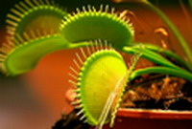
Can plants eat people? Probably not, but there are many plants that eat meat. Some of them are big, and they can eat small animals. One famous meat-eating plant is the Venus flytrap.
The Venus flytrap is a very strange plant. It grows in dry parts of the United States. Its leaves are like the pages of a book. They can open and close very quickly. Inside the leaves, there are three small hairs. If an insect touches one of the hairs, the leaf closes quickly. The insect cannot get out. In about half an hour, the leaf presses（挤压）the insect until it is dead. Then, the plant covers the insect with a special liquid（液体）. Slowly, the plant eats the insect.

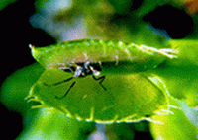
Plants are living things that have leaves and roots and grows in earth. Most of them get energy from the sun, the air, and the ground. In some places, the ground is very poor. It doesn’t have all the important things that plants need, especially nitrogen（氮）. Animal meat has a lot of nitrogen, so some plants eat meat to get what they need. Let’s hope that some of the bigger plants don’t get the same idea!

81. Where does the Venus flytrap grow?
_______________________________________________________________________

82. What does the meat-eating plant look like?.
_______________________________________________________________________

83. What’s inside the leaves of the plant?.
_______________________________________________________________________

84. What do most meat-eating plants get for their food?
_______________________________________________________________________

85. In some places, why do some plants get energy from animal meat?
_______________________________________________________________________

B) 根据短文内容及首字母提示，填写所缺单词，将答案按序号填入下面表格内。
Many teenagers have problems that worry them. Some do not learn their school subjects well. Some are good at learning and do well in exams, but they are doing so poorly in sports that their classmates call them ‘bookworms’. So many teenagers suffer from stress. The good news is that there are some simple ways to d___86___ with stress.
Firstly, eating a h___87___ diet, getting enough sleep and doing exercise are very important. How can we be happy if we are not fit?
For school work, planning ahead can help. Making a l___88___ of the things they need to do and planning when to do them can help students o__89___ their time. If you are weak in a subject, studying hard and asking a teacher for a___90___ can help.
Students should pay n___91___ attention to people who laugh at them. I___92___ , they should think about the things they are good.
Then students should also make e___93___ time for their hobbies. Playing sport, reading and watching films help them r___94___ .
F___95___ , it is suitable for teenagers to share their problems with their friends and parents.

86. 87. 88. 89. 90.
91. 92. 93. 94. 95.

七、书面表达（满分10分）
一、你认为在青少年生活中，哪些方面是特别重要的？哪些方面是不怎么重要的？请有下列表中做出选择（√），并且增补表中尚未提及的方面。

Your choice | very important → not important
- a lot of friends  - long school holidays  - a lot of thins to do outside the house  - time to watch television  - trips to other places or countries  - a lot of interesting books to read  - doing sports  - _____________________________________  - _____________________________________  - _____________________________________ | □ □ □ □  □ □ □ □  □ □ □ □  □ □ □ □  □ □ □ □  □ □ □ □  □ □ □ □  □ □ □ □  □ □ □ □  □ □ □ □
二、写一篇题目为“A Good Life For Teenagers”的书面表达，参考上面表格，选择适当的要点，特别要提到你自己补充的内容，表明自己的观点。要求词数100词左右，语句通顺，用词得当。

A Good Life For Teenagers

____________________________________________________________________________________
____________________________________________________________________________________
____________________________________________________________________________________
____________________________________________________________________________________
____________________________________________________________________________________
____________________________________________________________________________________
____________________________________________________________________________________
____________________________________________________________________________________
____________________________________________________________________________________

听力原稿
（1-5）
1. Little Tommy likes to make model planes after school.
2. Daniel has his opinion on different school subjects. He thinks Geography is the most interesting of all.
3. The weather will be windy. The temperature is going to drop a little. It is between 2ºC and 4ºC.
4. Born under the star sign of lion, a person is believed to be strong, confident and generous.
5. The students are not in the classroom, and they are doing morning exercise out on the playground.
（6-8）
A: Millie, I have something to tell you. Tomorrow is Alice’s birthday.
B: Are you sure? I think it should be the day after tomorrow.
A: Well, let me see. Oh, I’m sorry. You’re right. It is the day after tomorrow. Shall we buy her a present?
B: Yes, of course. Shall we give her some flowers?
A: Flowers are lovely. But I think it’s better to buy her a box of chocolates
B: Alice doesn’t like sweet things. Didn’t you know that?
A: Er… I know. We can give her a record. She loves music.
B: That’s a good idea. Let’s go to the music shop and choose one for her.
（9-11）
A: Excuse me, I am a member from Golden TV. Could I ask you some questions on the viewing habits of your family?
B: Yes, of course.
A: There are many kinds of TV programmes every day. As you are a student, what’s your favourite programme?
B: I want to find out the secrets of nature. So my first choice is Discovery Channel. When I have time, I’d like to watch programmes about wild animals or the environment.
A: What about your father? Does he like the same channel as you?
B: Yes, but his favourite is News Channel.
A: And your mother?
B: I think most women like films. After she finishes the housework, my mom usually turns on TV to watch Film Channel. It’s a good way to relax herself. Sometimes when she is watching a nice film, she is attracted by the film and even forgets to cook the dinner for us.
A: Oh, I see. I hope you enjoy your TV viewing every day. Thank you very much.
（12-15）
A: Hello, Jane. What are you going to do this weekend?
B: I’m going to a museum.
A: Which museum would you like to visit?
B: The Science & Technology Museum. There is going to be a special exhibition.
A: What kind of exhibition?
B: Computer science. It will introduce the latest development in computers.
A: Great! I’m interested in computer programming. Shall we go there together, Jane?
B: Fine, but I’m afraid there will be too many people on Saturday.
A: It’s OK. I’ll buy the tickets first.
B: Thanks, Ben. Please phone me when you get the tickets.
A: Sure. Good-bye!
（16-20）
Spring and autumn are good seasons for outdoor activities. If you like to go hiking, you must visit Zijin Mountains in the eastern part of Nanjing. Walking and climbing are fun, and you can enjoy the beautiful view of the country parks. But it is important to plan each of your activities very carefully.
Think of safety first. You should always take a first-aid box whenever you go hiking.
Then you had better take something with you, such as food and drinks, a tent, sleeping bags, a map and so on.
You should never hike alone. When you are in a group, you should support and help each other. Hiking is a good chance for young people to learn team spirit.
You might meet snakes when you hike so you should always wear long trousers. If you see a snake, you should not move, keep quiet and wait for it to go away. If you or somebody else has been bitten by a poisonous snake, you should not move the victim. You should tie a piece of cloth round the bite to stop the poison from spreading to other parts of the body. Then you should send for help as soon as possible.

参考答案

1-5 CCACA 6-10 BACAB 11-15 CBCBA 16-20 CBBCC 21-25 BBDCA 26-30 BDBBC 31-35 ADBBB

36 -40 BCAAD 41-45 AABBD 46-50 ABAAB 51-55 ABDDC 56-60 DCCBA

61 either 62 straight 63 order 64 crazy 65 solve

66 twelfth 67 playing 68 difference 69 failed 70 really

71 D. advices 改为advice 72 B. do改为doing 73 B. happily改为happy
74 A. how much改为how many 75 B. dividing改为divided

76 look after 77 at least 78 are not satisfied 79 looking forward to 80 In order to

81. In the dry parts of the United States. 82. They look like the pages of a book. 83. Three small hairs. 84. Insects and small animals. 85. They need nitrogen.

86. deal 87. healthy 88. list 89. organize 90. advice 91. no 92. Instead 93. enough 94. relax 95. Finally

书面表达（略）

